Data Transfer Time Calculations

Patrick Reilly

Date: October 25, 2004

In short, this report focuses on calculations for time costs associated with transferring the different-sizes of data sets, considering different transfer rates based on the amount of bandwidth we may be able to reserve. The last item addressed is one more immature alternative, satellite transfer.

I. Calculations of time based on size and transfer rates
We are hoping that the long-term networking solution for this project will be either Internet2 or NLR, with the former being more likely. While we are going through the process of trying to get things worked out with connecting Internet Archive to Internet2, we should be concerned with the size of our current connection to Internet2. Cornell’s OC3 connection (155Mbps) to Internet2 travels to NYC, where larger-scale infrastructure is in place. There is a project “underway” to run a larger fiber network pipe down to NYC, but this will likely not be completed until April or May of next year. While this upgrade is likely to be considerable, (~OC48: 2500Mbps, ⁺15x current) the real completion date is unknown and we would like data before then.

Therefore we are limited by the current OC3, which is around 19 MB/s. The statistics from the traffic analysis shows that traffic seldom runs over 4MB/s, with average use of less than 15% of total bandwidth. Figure 1 shows a daily graph from Tuesday October 26. Figure 2 shows a similar graph for the most recent month.
Figure 1: Daily Graph for CU’s I2 Abilene connection to NYC (Max: 19 MB/s

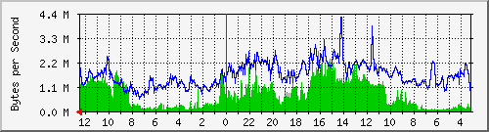
Max In: | 2752.3 kB/s (14.2%) |  | Average In: | 853.0 kB/s (4.4%) |  | Current In: | 1213.0 kB/s (6.3%)
Max Out: | 4266.6 kB/s (22.0%) |  | Average Out: | 1671.5 kB/s (8.6%) |  | Current Out: | 1343.1 kB/s (6.9%)

The red line represents midnight the previous night, and the red arrow at bottom left indicates that current time is going left (ie: the data on the right is older than on left).

Figure 2: Monthly Graph for CU’s I2 Abilene connection to NYC (avg in: 0.8 MB, avg out: 1.5 MB)
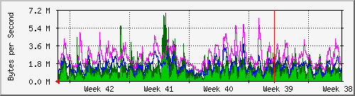
Max In: | 6946.4 kB/s (35.9%) |  | Average In: | 804.9 kB/s (4.2%) |  | Current In: | 1425.9 kB/s (7.4%)
Max Out: | 6367.9 kB/s (32.9%) |  | Average Out: | 1501.1 kB/s (7.7%) |  | Current Out: | 1725.1 kB/s (8.9%)

On the other side of the coin, the Internet Archive’s traffic analysis is shown in Figure 3 (daily) and Figure 4 (monthly).
Figure 3: Daily Graph for IA’s gigabit Cogent connection (FYI: 200 Mbps ~ 23 MB/s)

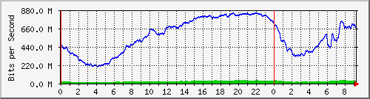
Max In: | 50.6 Mb/s (5.1%) |  | Average In: | 33.4 Mb/s (3.3%) |  | Current In: | 45.1 Mb/s (4.5%)
Max Out: | 854.7 Mb/s (85.5%) |  | Average Out: | 582.9 Mb/s (58.3%) |  | Current Out: | 770.7 Mb/s (77.1%)

Figure 4: Monthly Graph for IA’s gigabit Cogent connection

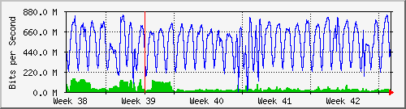
Max In: | 155.0 Mb/s (15.5%) |  | Average In: | 47.0 Mb/s (4.7%) |  | Current In: | 42.1 Mb/s (4.2%)
Max Out: | 842.2 Mb/s (84.2%) |  | Average Out: | 533.3 Mb/s (53.3%) |  | Current Out: | 679.2 Mb/s (67.9%)

The time representation for IA’s traffic analysis is slightly different, as the red arrow at bottom right indicates current time extends to the right (ie: older data is to the left).

The Internet Archive’s connection is more than six times as large as CU’s, with the following conversions to megabytes per second: IA ~120 MB/s, CU ~18.5 MB/s. Based on the traffic analysis, IA’s “off-peak” hours are from around 11pm – 10am PDT (2am – 1pm here).

Depending upon the agreement we will theoretically arrange with CIT to schedule “off-peak” hours for our use of I2, the amount of bandwidth we are able to secure on this end will likely be the primary influence on the transfer rate. Table 1 shows time calculations for different transfer sizes and rates.
Filesize
TB's | MB's | Xfer Rate | Transfer Rate per Hour (MB) | Hours for Transfer | Total days *straight*
40 | 41943040 | 6 MB/s | 21600 | 1941.81 | 80.91
30 | 31457280 | 6 MB/s |  | 1456.36 | 60.68
8 | 8388608 | 6 MB/s |  | 388.36 | 16.18
2.5 | 2621440 | 6 MB/s |  | 121.36 | 5.06
40 | 41943040 | 10 MB/s | 36000 | 1165.08 | 48.55
30 | 31457280 | 10 MB/s |  | 873.81 | 36.41
8 | 8388608 | 10 MB/s |  | 233.02 | 9.71
2.5 | 2621440 | 10 MB/s |  | 72.82 | 3.03
40 | 41943040 | 14 MB/s | 50400 | 832.20 | 34.68
30 | 31457280 | 14 MB/s |  | 624.15 | 26.01
8 | 8388608 | 14 MB/s |  | 166.44 | 6.94
2.5 | 2621440 | 14 MB/s |  | 52.01 | 2.17
40 | 41943040 | 25 MB/s | 90000 | 466.03 | 19.42
30 | 31457280 | 25 MB/s |  | 349.53 | 14.56
8 | 8388608 | 25 MB/s |  | 93.21 | 3.88
2.5 | 2621440 | 25 MB/s |  | 29.13 | 1.21
Table 1: Time calculations based on size and speed of transfer

- Alternative 4: Satellite Transfer

This alternative was recently proposed based on the uniquely unidirectional transfers that the project involves. Satellite transfers are undesirable for applications where data regularly flows both ways, but is allegedly good for one-sided transport. After talking with Dean Eckstrom, I have contacted Kevin Feeney of CIT Networking and hope for a response providing information about the feasibility of this alternative.

