CS631 : Multimedia System Spring‘98

Computer Science Department, Cornell University

ASSIGNMENT : 3D Morphing
Shape Topological Transformation

WEBPAGE: www.cs.cornell.edu/suwatch/3Dmorph1.html

BY: Suwat Chitphakdibodin
Glen C. Chang
Thibet Rungrotkitiyot

COURSE ID: 983-781

Table of contents

1. ABSTRACT 3
2. INTRODUCTION 3
3. FUNDAMENTAL CONCEPTS 4
4. SHAPE TRANSFORMATION ALGORITHM 5
5. ESTABLISHING CORRESPONDENCE 6
5.1 PROJECTION STATE 6
5.2 WEILER’S ALGORITHM 7
6. FACE TRACING 9
6.1 FACE TRACING ALGORITHM 9
6.2 FACE ADJUSTMENT 9
6.3 TRIANGLE-ONLY CLUB 9
7. ADDED MODIFIED TOPOLOGY 10
8. POLYGON INTERPOLATION 11
9. APPLICATIONS 12
10. SOURCE CODE DISTRIBUTION 13
11. FUTURE RESEARCH 13
12. CONCLUSION 14
13. REFERENCES 14

ABSTRACT
The previous two-dimensional shape transformation technique, feature-based morphing, has been widely used in computer animation industry. The effect and variation of the techniques have gained popularity and been used for producing special effects in commercial and entertainment. The algorithm works by specifying a function that maps pixels from a source image into pixels on the destination image. The intermediate frames are created by interpolating a point between the two objects. When the intermediate frames are views in sequence, it produces an animation of image transformation.

This project presents another way in creating animation of object transformation. The provided technique transforms polygon-based three-dimensional objects instead of the conventional two-dimensional image. This project presents one of the possible techniques used in transforming polyhedral 3D objects. This technique utilizes topological and geometric information obtained from the original 3D models in establishing intermediate object’s vertices, edges, and faces. This three-dimensional shape transformation technique is useful in producing the more complex type of special effect animations than the one obtained from two-dimensional morphing algorithm. They could be used in virtual reality application such as 3D-computer games and entertainment world.

Furthermore, this project explores a few variations in obtaining different morphing scheme such as objects' center selection and non-linear non-symmetric polygon interpolation. All results can be found later in this paper and in application section.

Keywords : Computer Animation, Polyhedral Object Model Construction, OpenGL Computer-Aided Geometric Design, Shape Topological Transformation and Interpolation.

INTRODUCTION
In order to transform a three-dimensional object into another, two intermediate models must be constructed, such that it contains both topological and geometric information from both source and destination object. The two intermediate models will have the same amount of vertexes, edges, and faces. Each vertex, edge, and face of the source model uniquely corresponds with vertex, edge, and face of the destination model. This part of constructing two merge topological models is called establishing correspondence problem. After the correspondences have been created, the actual transformation can be created by interpolating each corresponding pair of vertex, edge, and face. The part of the problem is called interpolation problem. Figure 1 below shows the two intermediate models created from topological information of both original three-dimensional objects. It also shows the interpolation phase after the two intermediate models are created.

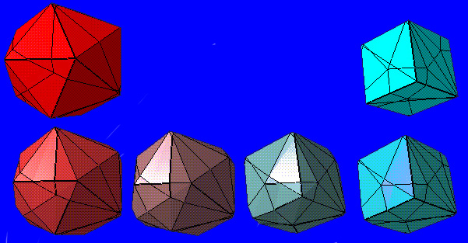
Figure 1 : Shape Topological Transformation

This paper presents an algorithm that can automatically establish the correspondences by Weiler in [1]. It can easily transform two three-dimensional polygon-based objects by transforming the two generated intermediate models that have each of their vertexes, edges, and faces, one-to-one associated to each other. There are limits to this algorithm which will be discussed later in this paper along with some of the possible solutions used in breaking the limitation and handling some other types of specific cases.

FUNDAMENTAL CONCEPTS
There are some essential terms discussed throughout the paper. It is useful to describe and define a few of these key concepts. The term object represents an entity whose surface is a set interconnected polygon that forms a 3D surface geometry. The shape of an object is the set of points in space that made up the object’s surface. Model is a complete description of the shape of an object. Topology refers to a network of vertices, edges, and faces of any objects. When vertices of a topology is specified in coordinate, it forms geometry. Two objects are topologically equivalent, or homeomorphic when a continuous one-to-one mapping function between points on each of the two object’s surface exist. That mapping function is called homeomorphism. Last, an object is Euler-valid if its topology satisfies Euler fomular:

V - E + F = 2 - 2G

Where V, E and F are, respectively, the number of vertices, edges and faces of the topological network, and G is the number of passages through the object (i.e. its genus).

An object is considered a star-shaped object if at least one polyhedron’s interior point, p, that sees all the other points on the polyhedron’s surface, exists. The interior point can see all the point on the objects’ surface if every constructed semi-infinitely long ray originating at the specified interior point, p, intersects other point on the surface exactly one time. Moreover, an object can be considered a convex-hull object if every interior point within the object sees all the other point on the object’s surface. The figure 2 below shows some example of these specific types of three-dimensional objects.

Figure 2 : Object Classes

It is quite simple to implement an algorithm identifying which object is convex hull, star-shaped, or non-star-shaped. For an object to be convex hull, each angle formed by two neighborhood faces must be less than or equal to 180 degree from perceptively to object’s interior. For an object to be considered a star-shaped, the angle can be greater than 180 degree but the sum of all the excess of 180 degree angle along the object’s surface edges must not exceed 180 degree. Any other objects that do not satisfy the above rules are non-star-shaped object.

SHAPE TRANSFORMATION ALGORITHM
As discussed earlier, the algorithm consists of two main parts, the correspondence establishment problem and the interpolation problem. Both parts are closely related. The interpolation phase relies on the output of the correspondence establishment. The result must be a one-to-one correspondence of each of topological elements of the two. The presented algorithm in this paper is only capable of transforming star-shaped objects. At the end of the paper, some possible solutions used in transforming non-star-shaped objects are also presented. The technique relies on the way to break up these non-star-shaped objects into a set of smaller pieces of star-shaped objects and individually transform each of them accordingly. The algorithm is working well with a curtain kind of non-star-shaped object transformation, such as the transformation of star-shaped objects with interior hole.

ESTABLISHING CORRESPONDENCE
The two intermediate models are constructed by adjusting the topology of original models by projecting topology of the original models on each other. Essentially, it clips surface from the first original model and put it on the second original model and from the second original model on the first model.
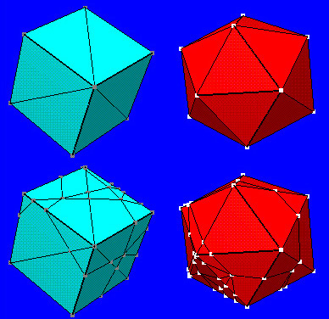
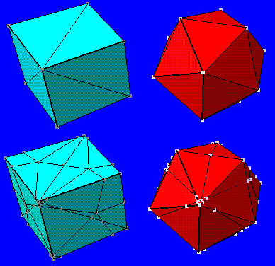
Figure 3 : Correspondence Establishment Figure 4 : Object’s Center Selection

Both constructed intermediate models contain identical topology information from both original models; however, the geometry is not yet similar. In the second phase, the interpolation algorithm smoothly adjust each correspondence pair of vertex, edge, and face in both constructed model until the geometry is entirely transformed from one to another. The figure 3 above shows the two original models, source object transformation and destination object transformation, and two constructed intermediate models. The figure 3 above shows the placement of object's center effects the geometry mapping.

5.1 PROJECTION STATE
Throughout the paper, the original polyhedral model will be referred as M1 and M2. V1 and V2 are the list of vertexes in the corresponding models M1 and M2. E1, E2, F1, and F2 are the list of edges and faces in the corresponding models. The algorithm works by projecting each model on the surface of a unit sphere. The projected model of M1 on the unit sphere is called PM1, and the projected model of M2 is called PM2. The projection algorithm is very simple. It can be done by constructing a ray from the center point, the point that is used as the center of the transformation, to each vertex. This center point must be an interior point that sees all the other point on the object’s surface in that case the transformation object is not a convex hull object. The vertex is moved in either positive or negative direction along this ray until the unit distance from the center point is obtained. Please noted that after all the vertex are moved to a unit distance away from the center point, object’s edge remain connecting the same two vertexes. However, it new projected edges are no longer a straight line but an arc connecting the same two adjusted vertexes that lies along the sphere surface. Figure 5 below shows an example of how topological elements, including vertexes, edges, and faces, of a star-shaped polyhedral three-dimensional object is projected on the surface of the unit sphere.

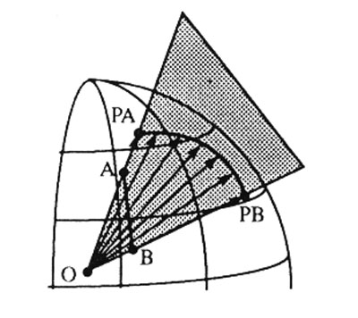
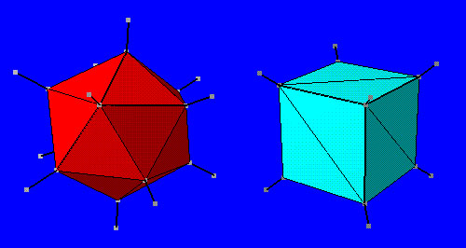

Figure 5 : Sphere Projection

5.2 WEILER’S ALGORITHM
After the projection, both PM1 and PM2 have sphere geometry with a different set of faces that form a complete cover of the unit sphere surface. Then each faces on either one of the projected models, PM1 and PM2, is clipped and pasted on the other model forming a common topology. The sphere is chosen as the common projection geometry because of its ease to implement; however, other types of geometry can be also used. For example, two-dimensional flat plane can also be used for model’s topological elements to be projected on. This paper discusses only the projecting on unit sphere technique.

Weiler’s polygon clipping algorithm is used for clipping the arc bound surface from one of the object to another. This algorithm is used in this project. Essentially, Weiler’s clipping algorithm is just an algorithm that adds new edges and vertexes from one of the projected model on the other and adjusts its topology according to the new edges and vertexes added. If projected arcs intersect, an extra vertex located at the intersection point is added to the topology. The edges involve that intersection point will also be spirited into to new projected arcs. These intersection vertexes are also located along on the sphere’s surface with unit distance from the center point. The algorithm is repeated until all the edges and vertexes from PM2 are mapped on the surface of PM1 or vice versa. There is a simple way to calculate the location of the intersection points. We know that the intersection point is also located on the surface of the unit sphere. We define a plane P and Q according to the figure 7 below.

Read in the Topology and Geometry of Each Model

For Each Edge of Each Model
Project the Edge onto the Unit Sphere

(Modified Weiler Clipping Algorithm)
For Each Projection Edge (Arc) of Model 1
For Each Projection Edge (Arc) of Model 2
Calculate Arc/Arc Intersection Point
If Arcs Intersect
Subdivide Arcs at Intersection Point
Adjust Edge Topology

For each Projected Vertex, PV
If PV is not an Original Vertex of Model 1
Map PV to Model 1's Surface
If PV is not an Original Vertex of Model 2
Map PV to Model 2's Surface

Figure 6 : Psuedocode for the Correspondence Algorithm
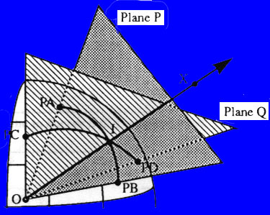

Figure 7 : Weiler's Correspondence Algorithm

PA and PB are the projected points of the vertex A and B of the first original model, M1. PC and PD are the projected points of the vertex C and D of the second original model, M2. PC and PD and the edge PC-PD of the PM2 are clipped on the PM1 to create the common model. The intersection point is simply a point along the ray OX that has a unit distance from the center point, O.

FACE TRACING
The edges can be adjusted in real-time when adding new vertexes and the related edges are divided if necessary. However, the face information is lost after the process. Although a topology can be described only by the network of vertexes and edges, the face information comes to handy when implementing the algorithm on popular graphic libraries, such as OpenGL. This project uses OpenGL as the main resource for constructing the visual interface, so a special algorithm is created to reconstruct the entire face lists from the set of vertexes and edges provided after the PM1 and PM2 are merged on the common model with the Weiler’s algorithm.

6.1 FACE TRACING ALGORITHM

For Each Edge
Use an iterative deepening search to find
the minimum number of edge required to
form a polygon face.
Repeat if desired (until each edge is
marked exactly twice)

Figure 8 : Psuedocode for Face Tracing Algorithm

This is an abbreviated version of the actual algorithm. Some special cases need to be considered, such as a polygon forming inside another polygon with same number of edges. Breadth-first search can be used instead of iterative deepening search. It’s faster at the cost of memory space required.

6.2 FACE ADJUSTMENT
For rendering purposes, we would like to have the normals of all faces facing outward. We use the right-hand rule (counter-clockwise) to determine the direction of the normal. Using the vertices of one of the mapped model, we can calculate the normal of a polygon face and the vector from the center of the model to the face. Calculate the dot product of the two, we can determine if the polygon is facing outward or inward. If the polygon is facing inward, we simply reverse the order of the vertex list of the polygon face.

6.3 TRIANGLE-ONLY CLUB
We need to make sure all polygon faces are triangles since a triangle is always flat. This is done for rendering purpose also. We used a very simple method of reducing polygon to triangles. Take any vertex of a face and draw a line to the rest of the vertices. We can use this method since we are guaranteed to have convex polygon faces.

ADDED MODIFIED TOPOLOGY
After the common topology is obtained, it will be used to produce both original models with the other model topology mapped on its surface. As shown in the figure 6 below, by casting rays from the center point to each vertex on the common model, the intersection points between these rays and the original model, M1, locates the added vertex points of clipping face of M2 on the surface of M1.

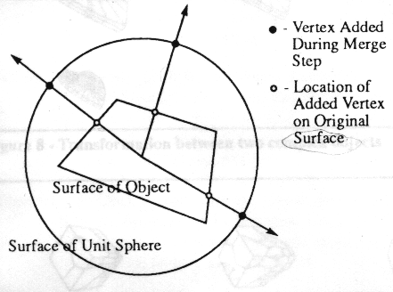
Figure 9 : Locating added vertexes

Vice versa, we can also locate the added vertexes points on the original model M2 by similar method. At last, we obtain the two models that have a topology information of both original models, such that the one-to-one correspondence between each topology elements of the two exist. The interpolation process is now possible.

8. POLYGON INTERPOLATION
Once all correspondence is established. Both objects will have the same number of vertices and faces. Faces in PM1 are mapped to faces in PM2 one-to-one. The next step is just to interpolate from one to the other. We explore 3 schemes of interpolation.

- Linear Symmetric Interpolation. This is the simplest scheme. The coordinates X, Y and Z are linearly interpolated from PM1 to PM2 with the same rate. The result is similar to putting the air to one object and it inflates to become the other.
- Non-Linear Symmetric Interpolation. The variant of this scheme is that the coordinates X, Y and Z are non-linearly (exponentially) interpolated from PM1 to PM2, but still with the same rate. The result is similar to putting the air to one object and it inflates to become the other. The different is that the object morph slowly at the beginning and fast at the end.
- Non-Linear Non-Symmetric Interpolation. The variant of this scheme is that the coordinates X, Y and Z are not interpolated with the same rate. The result is non-symmetric transformation.

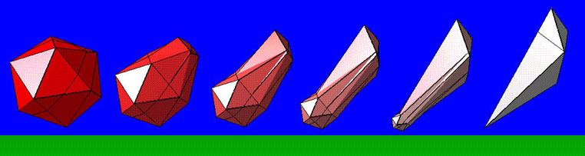
Figure 10 : Linear Symmetric Interpolation
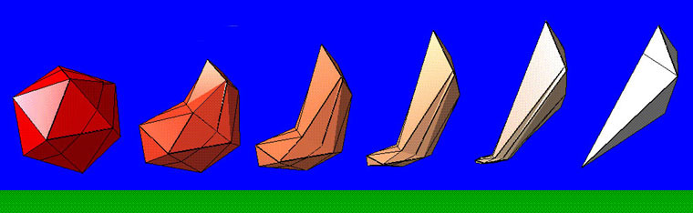

Figure 11 : Non-Linear Symmetric Interpolation

9. APPLICATIONS
All examples can be downloaded from the web page. The following keys are needed to activate the morphing. Press "O" to indicate the object. Press "F" to forward the morphing sequence. Press "R" to reverse the morphing sequence.
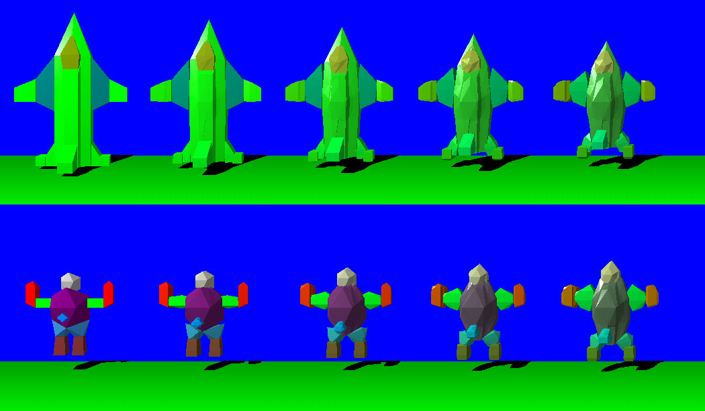

Figure 12 : Complex Object Morphing

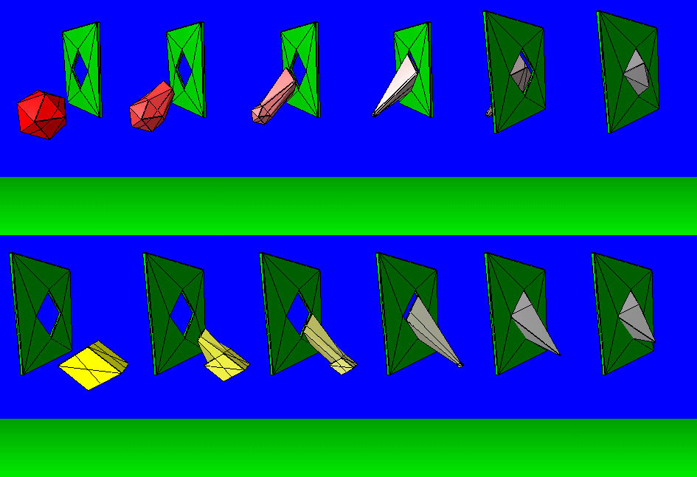
Figure 13 : Morph Across Window

10. SOURCE CODE DISTRIBUTION
White Paper version can be downloaded from 3DMorph.doc file. All sources are stored in 3DMorph.zip file. They are tested on WinNT4.0 and Win95 platform. OPenGL1.0 which usually come with WinNT and Win95 is needed for graphic library. Although Microsoft Developer Studio VC++ version5 is used, any C compilers such as GNU or BORLAND should be able to use and developer platform.

11. FUTURE RESEARCH
Future research need to be done to develop projections for general concave polyhedra with holes. The new algorithm which can work under discontinuity of object surface need to be explored. The idea would be that the desired projection of the objects and subsequence polygon mapping could be carried out for the objects with the same number of holes.

The future study that is very interesting is how to automatically decompose a non-star-shaped object into a set of star-shaped objects for the purpose of morphing. It is quite simple to decompose a non-star-shaped object, however, the difficulty is the part that after the source object is decomposed and the decomposing information has to be mapped on the destination object. Extra edges added to the source object must some how be added to the destination object to maintain one-to-one correspondence between each decomposition object. Moreover, each edge added to the destination object must satisfy the rule that the divided objects must be non-star-shaped. Last, the edge added must maintain seminar neighborhood decomposition objects, such that the two objects that share those breaking up edges must also be maintained on the decomposed destination object in order to produce a realistic morphing process without showing the side effect of object being decomposed. It is quite simple to morph from a non-star-shaped object to a convex hull object, since dividing edges created of the source object can be easily mapped on the destination object which also satisfy all the rules discussed. Simple way to break up a non-star-shaped object is to get the list of all vertex that can be seen by the center point and form the object from it by adding edges if not existed previously in the original model. The vertex and the edge list are then spited into two or more list for each decomposed object. The two vertices and the spiting edge added are then copy on the rest of the object’s edge and vertex lists. The process keeps spiting the object until all the vertices are visible by each decomposed object’s center point. While decomposing the object a tree contain information about how the object is spited is also created and used as one of mapping tools.

12. CONCLUSION
This project is a part of Multimedia class - CS631 at Cornell University. Any comments on the paper will be very much appreciated. For more information, please contact the author.

13. REFERENCES
[1] Weiler, K. Polygon Comparison Using a Graph Representation. Proceedings of SIGGRAPH '80 (Seattle, Washington, July 1980). In Computer Graphics 14, 3, (Aug. 1980), 10-18.

[2] J, R. Kent, W. E. Carlson and R. E. Parent, Shape Transformation for Polyhedral Objects. In Computer Graphics (SIGGRAPH'92 proceedings), volume 26, pages 47-54, July 1992.

[3] Kent, J, Parent, R. and Carlson, W. Establishing Correspondences by Topological Merging: A new Approarch to 3-D Shape Transformation. In Proceedings of Graphics Interface '91 (Calgary, Alberta, June, 1991) 271-278.

[4] Foley, J., A. van Dam, S. Feiner and J. Hughes, Computer Graphics - Principles and Practice, Addison-Wesley Publishing Company, Inc., Reading, Massachusetts, 1990.

[5] Neider, J., Davis, T. and Woo, M. Polygon Construction and Rendering Scheme. In OpenGL Programming Guide, The Official Guide to Learning OpenGL, Version 1.1, Addison Wesley Public Company, January 1997.

