
Keshava
Sung to Que Sera Sera
Computer Science going-away party for
Professor Keshav Pingali
31 May 2006

When I was one of those young PhDs,
I asked my chairman, David J Gries,
“Will I be famous, will I be wise?”
Here's what he said to me.

Keshava, you see,
You're only from MIT.
But Cornell looks right for thee.
In 6 years, we'll see.
Keshava, we'll see.

When I became an associate prof,
I asked my chairman, John E. Hopcroft,
“What should I do to
get fame like you?”
Here's how he sent me off.

Keshava, my son,
You must have some vision,
and data for decisions.
You have just begun.
It's a long, long run.

When to full prof I was finally grown,
I asked my chairman, Charlie Van Loan,
“Have I arrived, am I now in?”
Here's what he said with a grin,

Keshava, you're great!
For us a real soul mate.
Here's an India Chair to take.
Keshava you're great.
A real soul mate.
Keshava, I am reminded of the four great river watersheds that grace the Northeast. The Hudson, the Susquehanna … whatever. But your job is not to cogitate at the river's edge. Leave that to Charlie the Chair —me. Your job, Keshav, is to be part of the source of the river. You want to affect positively the quality of life downstream in this information age. So, continue out sourcing, Keshav. Continue your innovative teaching and research, and we’ll raise the quality of the river higher than it’s ever been!
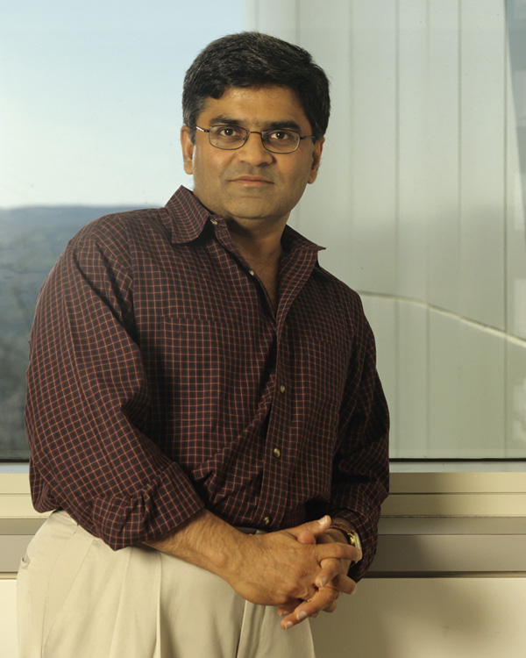

When I decided to leave Cornell,
I asked my colleagues to wish me well.
Austin did beckon, cold here made me ill,
But Gries did not take it well.

Keshava you fink!
So low did you have to sink?
You must have had too much to drink!
You should see a shrink!
Keshava, you fink.

Hartmanis, Constable stepped in,
Keshav Pingali, you are our friend.
We hate to lose you, our hearts do rend,
But all good things come to an end.

Keshava, our friend,
Please follow the Griesy trend.
He left to come back again.
You should do the same!
Please come back again!

Keshav, you have been a real force in this department and a real friend. You have given much. Our department will have a big hole in the place that you so comfortably filled, and we will miss you. Please come back again …

Charlie Van Loan’s monologue is a takeoff on his Chair’s message in a CS annual report.
Written and sung (to the tune of Que Sera Sera) by David Gries,
with piano accompaniment by Dexter Kozen.

