Searching the protein structure databank with weak sequence patterns and structural constraints

Inge Jonassen¹, Ingvar Eidhammer¹, Svenn H. Grindhaug¹, William R. Taylor^{1,2}
J. Mol. Biol. 304 (4), 597-617.

Protein families consist of many proteins that have a similar structure or function.
- A goal of this work is assigning proteins to various families
- Shared features can be described as a pattern that is used to predict new family members.

Statistical Patterns
- Require Threshold
- Hidden Markov Models (HMMs)
- Regular Expression
- Weight Matrix

Deterministic Patterns
- Outcome of matching a sequence against a pattern is a yes/no answer.
- Regular Expression
Structure Basics

- Amino Acid Structure
R

NH3 C COOH

H
Carboxypeptidase-A

Secondary Structure
- α-helix
- β- pleated sheet
Databases

SWIS-PROT
- A well-annotated database maintained by the Swiss Institute of Bioinformatics and the European Bioinformatics Institute.
- There is little redundancy and much information about function, domains, post-translational modification, etc.
Tr-EMBL
- Computer-annotated supplement of SWISS-PROT that contains all the translations of EMBL nucleotide sequence entries not yet integrated in SWISS-PROT.

PDB
- Database with structures of approximately 20,000 proteins.

PROSITE PATTERNS
- Identity positions
- Ambiguous positions
  - [allowed AA] or {disallowed AA}
- Variable length wildcards
  - x(n)
  - includes spaces
- Example
[DNSTAGC]-G-D-x(3)-{LIVMF}-G-A
- Average PROSITE pattern contains ~15 amino acids.

Work uses a restricted subset of PROSITE expressions for two purposes:

Classification
- Need few false positives and few false negatives

Elicitation of Biologically important information
- If pattern does not describe active sites or structurally important regions, it is likely to misclassify new sequences
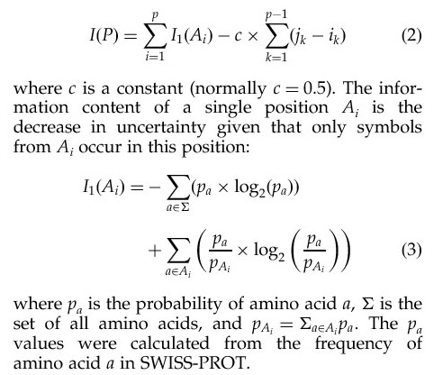
For PROSITE patterns, specificity is related to information content.

Statistical Parameters

- Sensitivity- ability to detect true positives
- TP/(TP+FN)

- Specificity- ability to reject false positives
- TN/(TN+FP)

- Positive Predictive Value
- Proportion of matches that are family members
- TP/(TP+FP)

- Correlation Coefficient
- Correlation between match set and set of chains in family
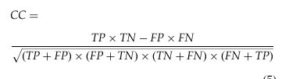

- Integrating Structure Information

If the 3D structure information of a protein is known, then that information can aide in classifying the protein.
- Attach to each PROSITE pattern P a structural probe T to make a combined pattern or ComPat (P,T).
- A protein matches the ComPat if its sequence matches the pattern P and the structure of the fragment matching P can be superposed on T with a Root Mean Square Deviation (RMSD) below a certain threshold.

- Softening Sequences

- Relaxing Constraints on the sequence (decreasing information content) can improve sensitivity while the structure information is used to retain specificity.
  - False negatives will decrease without a corresponding increase in false positives.

- Softening can be achieved by :
  - Extending the match set of identity and ambiguity positions
  - Substituting identity and ambiguity positions with wildcards
  - Extending length of wildcards
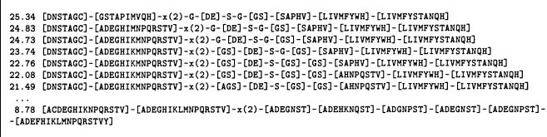
- Authors used the first approach by walking from left to right and letting each residue ‘bring in its friends’ where friendliness was defined by a PAM₁₂₀ matrix.
Root Mean Square Deviation (RMSD)
- α-carbon coordinates were subjected to rigid body superpositioning and distance was measured.

- Using residues matching non-wildcard positions and residues matching fixed length wildcards up to 3 spaces long gave better probe-probe and probe-random separation than not including the wildcards.

Results
- The threshold RMSD values were set by determining how well the probe-probe and probe-random histograms separated.
- Threshold was defined to exclude 99% of false positives.
- The predictive power of the probe alone varied with protein family and probe. For example, if the probe was in a common area (α-helix) it was not able to find homologies well.
- In general, using a ComPat probe gave greater specificity at a given information content that using the sequence information alone.
- The gap between these two curves is approximately 10 bits of information
SAP
- The authors also used the global pattern biased iterative SAP program for structure comparison, resulting in a SapPat
- In general, SapPats gave even greater specificity at a given information content than ComPats did.
- However, SAP is much more computationally expensive than the RMSD method. This lead the authors to propose using the RMSD method as a filter to select certain sequences to analyze with SAP.

Reversed Sequence

The authors reversed the sequence when they scanned the databank.
The reversed sequence still preserved important features like chirality.
