Weill Cornell Medical Library’s eResources Reorganization Task Force Proposal
last updated December 13, 2007



Task Force Members
Paul Albert
Svetlana Oziransky
Kevin Pain
Michael Wood
Antonio Ramos

Table of Contents
Executive Summary 4
General Background and Wish List 5
From the Task Force's Charge 5
A Problem Described 5
Necessary Features and Functionalities of an eResource Reorganization 5
Desired Features and Functionalities of an eResource Reorganization 6
Proposed Implementation: What Will the Interface Look Like? 7
Proposed Implementation: A Schematic Overview 8
Proposed Implementation: Phase I 9
Relying on the Catalog 9
A. Obtain/create MARC records for online databases. 11
B. Obtain/create MARC records for eJournals. 11
C. Obtain/create MARC records for eBooks and websites. 12
D. Purchase scope, "Weill Cornell Medical – eResources," to subsume all bibliographic records for (WCMC only) eBooks, online databases, eJournals, and websites. 12
Proposed Implementation: Phase II 13
What is Solr? 14
On the Feasibility and Timing of Implementing Solr 15
A. Set up recurrent data export of bibliographic records into Solr-parsable XML. 16
B. Install instance of Solr. 16
C. Install web interface for Solr. 16
Proposed Implementation: Phase III 17
A. Develop discipline-specific webpages. 17
B. Develop canned alerts for eResources. 17
C. Install an electronic resource management system. 18
On the Alternatives 19
Federated Search 19
Social Tagging 20
WorldCat 20

Executive Summary

This Task Force was presented with the goal of proposing a reorganization of the Library’s eResources. We propose a three-phase plan to make the Library's eResources more findable for users and more manageable for staff.

In the first phase, the existing Millennium ROCKU database is better used as a catalog for presenting records for eResources including eBooks, websites, online databases, and eJournals. Up until now, the Library has been cataloging a number of eResources, but not in the comprehensive and systematic way we envision. All such records will be included under an additional scope we propose to purchase, "Weill Cornell Medical -- eResources."

The second phase of this implementation is the creation of an "overlay" interface, one that takes advantage of Solr technology. This interface, which will be located on the library.med.cornell.edu domain will allow users to search for an item across a variety of resource types including the Library's webpages. Including bibliographic records from the catalog will be a matter of setting up a routine export of these records and then converting them into an XML-based index, which Solr in turn queries when search requests come in. As technologies go, Solr is both powerful and versatile. Results are typically retrieved quickly and allow for easy "faceting", or sorting according to category. Additionally, Solr allows an administrator to easily customize the look and display of the results set.

The third and final phase lists a series of tasks, such as the acquisition of an electronic resource management system, though not mission critical, would be of benefit to the Library and its users all the same.

The implementation of this plan will truly be a team effort. (Page eight visually represents how different departments of the Library would interact with each other and the technology we propose to use.) EResources will need to be thoroughly described by Information Access and Education & Outreach. Records for eResources will need to be added to the catalog quickly and regularly. And, Computer Services and the Digital Services Librarian (and perhaps a consultant) will need to code the interface and back end for a java-based search server.

Generally speaking, these phases are proposed with the idea that they be implemented chronologically, however, certain action items such as phase III’s task “Develop canned alerts for eResources” can definitely be done simultaneously or even prior to previous phases.

General Background and Wish List

From the Task Force's Charge
...The scope of the plan should include, but is not limited to:
- suggestions about a technical framework
- content inclusion and description
- considerations of how the proposed scheme relates to the III catalog and SFX
- requirements for updating and maintenance
- ways the content can be searched
- output or presentation of the resources/descriptions for their easy discovery and use by users at Weill Cornell and our CU colleagues elsewhere.
The Task Force should comment on the feasibility of its proposal, either through purchasing or programming, but is not responsible for the technical implementation of the plan.

A Problem Described
Anecdotal evidence, subjective judgment and some usage statistics suggest that our electronic resources are not discovered as easily or used as often as they could be. While patrons seem to find it relatively easy to find an eJournal given the pervasiveness of the GET IT button and a prominently featured search box for finding eJournals, even librarians know very little about those eBooks to which we have access. One medical student recently told a librarian that she didn't even know a particular pediatrics textbook was available online until a week before her course ended, and that frustrated her a great deal.
Even without listing individual eBooks, the current eResources page with its 180+ list of databases is unwieldy to say the least. Finding the most relevant database on even the best of library sites is a challenge, but is made prohibitive when using the eResource page we offer our patrons. This does our patrons a great disservice, the majority of whom would undoubtedly agree that eResources are the “mainstay” of their scholarly information diet.

Necessary Features and Functionalities of an eResource Reorganization
While we found no shortage of prominent medical libraries that organize their resources in a confusing and counterintuitive manner, some library sites did "get it right"-- at least in some respects. Our two favorites were Stanford's Lane Medical Library and UCLA Libraries. Based on those sites and others, we listed those features and functionalities for which we aspired for our eResource reorganization.
1. The reorganization will organize and describe all eResources: online databases, eJournals, in house web pages, external websites, and eBooks.
2. EResources will have titles and descriptions as well as all as a range of other fields including: Title; Author; Publisher/Provider (multiple entries for one field); Holdings/Coverage; Availability (free/restricted); Keywords; Description; ISSN; ISBN; link; generic notes.
3. EResources will be searchable across all fields. It would be helpful if a searcher could readily see or, better yet, sort is the resource type of each hit.
4. Users will have the option of sorting search results by format, date and relevance.
5. EResources, particularly online databases and webpages, will be thoughtfully annotated. We imagine that annotation of no more than 50 words would strike the appropriate balance between staff time and adequate metadata. Annotations should cover some of the significant terms a user would associate with the subject covered by that eResource.
6. Service alerts will be posted quickly and prominently when resources are inaccessible.
7. The amount of time needed for a member of the Library staff to add/index records with standardized rich metadata should be kept to an absolute minimum.
8. Users will have the option to browse resources by category/subject/specialty. The group was unable to determine the optimal way to do this, but agreed this merited further investigation.

Desired Features and Functionalities of an eResource Reorganization
1. Users will be able to see recently viewed pages and/or recently conducted searches.
2. Staff will have listed a range of licensing/acquisitions/troubleshooting information about each resource including how to access usage statistics, and whether ILLs can be supplied for a particular product.
3. Users will have the "Did you mean" option in cases of misspellings as popularized by Google or an autosuggest feature, both of which would draw from an XML file containing medical terms.
4. Users will have the option of quickly and easily communicating: if a resource is inadequately described; the suggested purchase of additional resources, etc.

Proposed Implementation: What Will the Interface Look Like?

What follows is a quick and dirty mockup of what the end users would see when they searched for “cancer.” Note:
- the text, which accompanies a record is specific to the format type
- users who want additional information can click on the info button to be taken to that particular item’s record in the catalog
- a lock, closed or open, indicates if a record is freely available to all users or only to WCMC users
- users can choose to sort by relevance or alphabetically
- not shown here is an option to browse eResources alphabetically

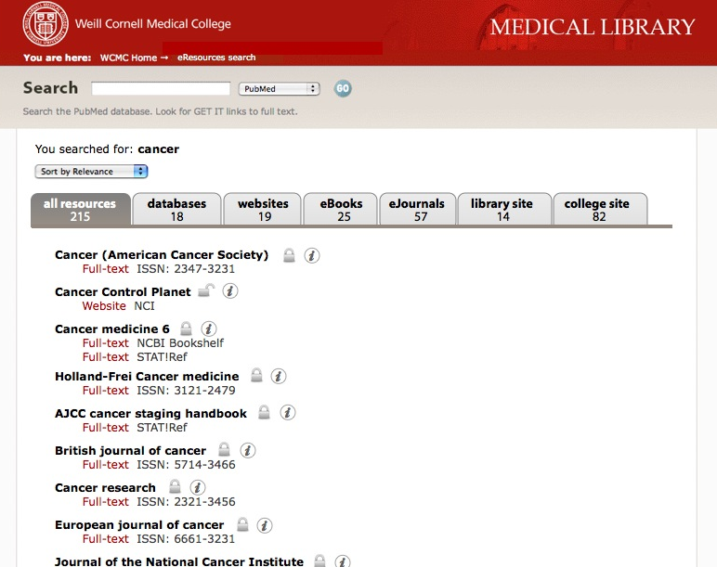

Proposed Implementation: A Schematic Overview

What follows is a visual representation of how different departments and technologies will interact once everything is in place. For details on how the Task Force proposes to get to this point, see the multi-phased implementation on subsequent pages.

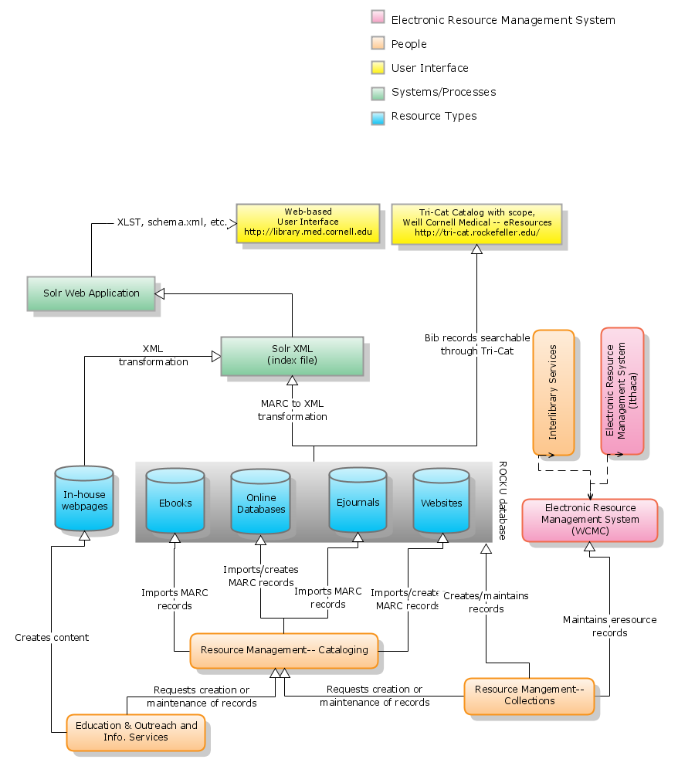
last revised December 10, 2007

Proposed Implementation: Phase I

In Phase I, every eResource judged to be appropriate and relevant for users will be cataloged using MARC in the ROCKU database and under the “Weill Cornell Medical – eResources” scope.

Relying on the Catalog

To paraphrase one William Carlos Williams, so much depends on a catalog, and this proposal is decidedly catalog-centric. Given that the ROCKU database will function as the staging point for all records for eResources, it is important that complete records (especially for purchased resources!— they deserve priority) be added– and, when necessary, updated– quickly.

Are the existing cataloging procedures, workflows, and manpower sufficient to accomplish this goal? If indeed the catalog is to be the centerpiece of this proposal, it would seem not. We cannot get this done with existing people and practices.

The idea that the catalog can remain "forever pure," is one that deserves serious reconsideration. Even with the smallest of cataloging backlogs, we simply cannot fail to include full records that lack Medical Subject Headings (MeSH).

Stepping back for a moment, we see two potential reasons why records with MeSH may be superior to records containing subject terms of only the LC variety:
1. Medical Subject Headings could be more consistent with what users are searching for, and more likely to give users a complete set of results.
2. Those doing a keyword search or browsing using MeSH terms in Tri-Cat will get a more complete set of results the more often records contain MeSH terminology.

For the Task Force, neither of these reasons is sufficiently compelling to justify the failure to catalog an item either because that item lacks a corresponding record with MeSH or because one’s energies are spent elsewhere in doing original cataloging. In our interaction with users, the Task Force has observed that Tri-Cat’s MeSH subject search is used only lightly. Instead, it has been our observation that users have fully embraced the Google mindset and conduct most of their searching by keyword.

The choice to be too discriminating about the provenance of bibliographic records is the choice to put off cataloging certain items, or to fail to catalog them entirely. Right now, we have a backlog of items needing to be fully cataloged including 1,700 eBooks and 1,800 eJournals, which was Michael’s best estimate. (One could also include the 180 databases and websites from our eResources page.) According to Vergie, original cataloging using MeSH takes about 30 minutes per record, and, according to Michael, downloading and importing an existing record takes but 3-5 minutes per record. No originally cataloged record with full MeSH descriptors is worth as much as to our users as any six full records that lack MeSH descriptors. Besides, there are a number of second-tier resources including various research libraries and the Library of Congress offering perfectly serviceable MARC records.

In the presence of a cataloging backlog, we believe it becomes necessary for the Library to sharpen its cataloging priorities. Here’s how we would prioritize which bibliographic records need attention:

1. Get best available existing full records for purchased resources where no record exists.
2. Get best available existing full records for purchased resources where brief record exists.
3. Get best available existing full records for freely available resources where no record exists.
4. Get best available existing full records for freely available resources where brief record exists.
5. If and only if, items one through four are complete, bring the existing records "up to code"– that is, swap out certain records for those that have a superior provenance and/or subject terminology.

Indeed it’s the case that a record that’s not quite perfect is much better than no record at all.

Getting to a point where most of our records are satisfactorily cataloged even with non-MeSH subject terminology may require extra manpower. Administration may wish to consider hosting several MLS interns instead of one (with or without a stipend) that are interested in cataloging; or hiring additional temporary staff (such as MLS students); or having existing staff spend more time obtaining records. Also, it may be worth “deputizing” additional staff with the appropriate training to grab records for the catalog. Whatever it takes to have a catalog, which most accurately reflects the Library’s electronic holdings.

By way of guidance, here are some, if not all, of the fields that a reasonably complete record for an eResource may have:

- Title
- Link
- Author
- Publisher/Provider
- Holdings/Coverage
- Availability (free/restricted)
- Description (~50 words)
- Staff-only Notes
- Subject Taxonomy

We don’t claim that this section of the proposal can definitively answer all questions regarding the most effective way to catalog eResources. One way or the other, problems with the current cataloging policy and workflow will need to be resolved. Otherwise, this proposal quickly becomes untenable.

And, now, the action items for Phase I. Please note that any direct questions, which follow function as rhetorical devices. They touch on areas where further (not necessarily administrative) discussion and exploration is warranted.

A. Obtain/create MARC records for online databases.
Online databases will be described using MARC and, when possible, with existing records. Certain fields such as the URL, availability, and description may need to be added to every new record.

B. Obtain/create MARC records for eJournals.
At least as it applies to the end user experience, the group thought it wise to include with each eJournal’s bib record that journal’s holdings and provider information as well as direct links to individual providers. However, we concluded, at least for now, that option would either take too much programming fanciness or require manual entry. Unless and until providers and holding data can be maintained easily and programmatically, we would recommend tabling this idea. Instead, we suggest that each outbound link to an eJournal takes the end user to the SFX menu of services or, in cases where there’s a single provider, directly to the provider.

The ROCKU database currently consists of about 7,000 records for eJournals. A portion of these records are brief. We recommend full bibliographic records represent all biomedical eJournals. Links to the SFX menu of services will be added manually.

Successfully finding eJournals will depend on good metadata, the kind that comes from well-structured MARC data, so this task takes on certain urgency. The Task Force sees this as a top priority and recommends making whatever changes to the workflow necessary to have each eJournal represented by a full MARC record. The assistant head of Resource Management indicated the work on upgrading brief MARC records with full records has started and will resume in the coming year.

The Task Force also considered the wisdom of purchasing bibliographic records from Ex Libris. Ex Libris sells an add-on service to SFX called MARCit! at the price of approximately $6,000 per year. The MARCit! service generates a current list of MARC records that describe a library's ejournals. From what we learned, these records do not contain holdings and provider information nor do they have direct links to the individual providers themselves. In addition, the original source and quality (especially appropriate MeSH headings) of these MARC records are unknown. The assistant head of Resources Management made a case that those records could be easily gathered, and everyone agreed that the extra initial cost and effort to get full records manually would more than offset the annual fee.

C. Obtain/create MARC records for eBooks and websites.
The Library and its patrons have access to thousands of eBooks, the full records for which already exist. Bibliographic records in the catalog will represent all appropriate and relevant eBooks.

To this end, we suggest the following:

- Obtaining and importing the MARC records of all eBooks available to the Library from OCLC or other sources.
- Listing all providers/vendors of eBooks.
- Identifying how these providers/vendors announce changes and updates for the eBooks they offer and in cases where no such announcements are made pressing the providers/vendors to start.
- Checking announcements of new titles on a regular schedule.
- Downloading and importing MARC records of new titles from OCLC or other sources.
- Adding an 856 field with the appropriate link.
Questions:
- Will there be a need now or in the future for discretion in which eBooks to add given the sheer numbers of eBooks available?
- Likewise will discretion need to be practiced because of “resource glut” (too many results for end users)?

D. Purchase scope, "Weill Cornell Medical – eResources," to subsume all bibliographic records for (WCMC only) eBooks, online databases, eJournals, and websites.
The application of a scope is a versatile way for end users to limit a search of the Web OPAC. In this case, we propose that all bib records with an 856 field and the “cumc” location be given the “Weill Cornell Medical – eResources” scope.

How do scopes work? Every bibliographic record in the ROCKU database has certain system-wide non-MARC fields unique to Innovative.

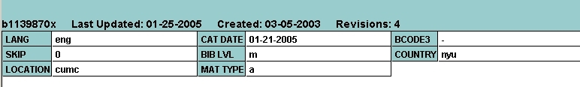
One possible scope field is BCODE3 (see above). In theory, if one wanted to have this bib record included in the scope, all one would have to do is mark “e” (a possible code to be assigned to the new scope) in the field of BCODE3.

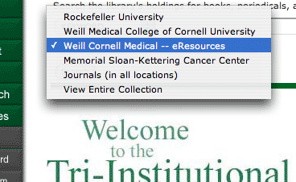
While catalogers at Rockefeller and MSK wouldn’t necessarily be blocked from using this designation, reports can be run to determine which non-cumc records have the designation.

For the end user, this means the record for a journal such as JAMA could show up in Four scopes: View Entire Collection WCMC, WCMC – eResources and Journals (all locations).

A quote of $1,950 was quoted for creating a scope, with no additional fee.
What the new scope would look like

Using a scope offers certain benefits. First, it allows visitors to the WCMC catalog to limit results to those resources that are available online in the WCMC collection, especially during Phase I. Second, it serves as an indication of exactly which records need to be included and thoroughly described in the recurrent export to the Solr index.

The Task Force also considered recommending the purchase of a separate Millenium database to house the eResource records there. This setup would be consistent with Cornell Ithaca’s Voyager catalog. Given the cost (quoted at $11,500 to $16,000) and lack of any clear and outstanding benefit, we decided against this option.

Proposed Implementation: Phase II
The second phase is all about implementing the software known as Solr. Before we go into the steps behind implementing Solr, we present background information including an overview of what Solr is; why we think Solr is a good fit; and some feasibility and timing issues surrounding the implementation of Solr.

What is Solr?
Solr-based faceted search is a kind of eResource organization practiced at Stanford's Lane Medical Library and is on display at University of Virginia's Project Blacklight and at Georgia Tech's library (the latter two are overlays—they sit on top of traditional OPACs). Faceted search is a way of classifying results that have already been returned into meaningful categories that are guaranteed to exist. Facets are used to help users narrow down search results in meaningful ways. You could even allow users to facet by first letter of a database, thus permitting browse functionality. However, users gravitate towards search, and we believe Solr is the most evolved of the search solutions out there. As a side note: the centrality of search is reflected in the proposed redesign.

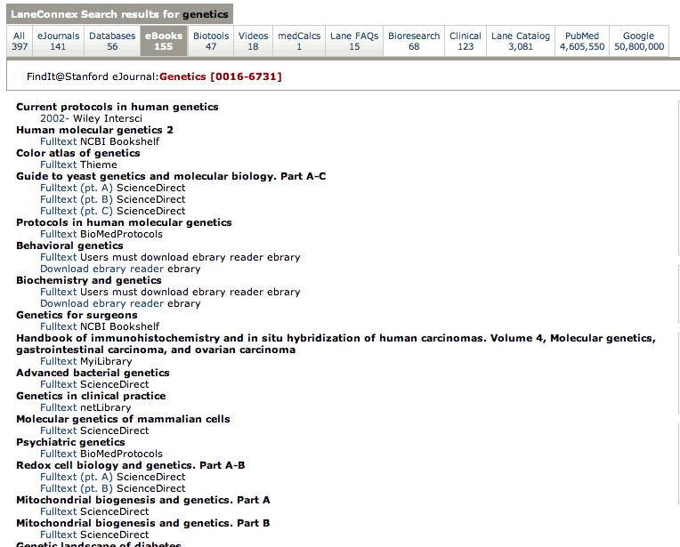
Solr is a darling among tech-savvy librarians for good reason. Solr is open source. It is enterprise-ready and rests on a Lucene-based search server that supports faceted searching, hit highlighting, caching, replication, a web administration interface, and multiple output formats including XML/XSLT and JSON. Solr utilizes XML and HTTP to index documents or to execute searches. Solr’s rich schema specification allows for a wide range of flexibility to deal with different document fields, and contains an extensive search plugin API to develop custom search behaviors.

Compared to Lucene, Solr is easy to install and configure. Given the Library's limited set of programming skills and resources, Solr would not be the easiest thing for this library to implement. However, an examination of the underbelly of MIT's Vera suggests the difficulty is marginal at best. And unlike a FileMaker Pro implementation, Solr allows the Library to use MARC records for eBooks, eJournals, and, presumably, databases as well as permits us to display staff-generated pages. Additionally, Solr is eminently forward compatible. Because Solr uses XML means it would be possible to make the Medical Center Archive's EAD finding aids available through a single unified search.
Lane Medical Library’s implementation of Solr

Solr’s vibrant and thriving developer community is available and easily accessible for support. Minimal, though certainly not no, programming is required to make Solr work. Solr, a subproject of Lucene, Apache's Java-based full-text search engine library, is rather young and was donated to the Apache network in 2006.

Why Solr?
While we considered using a database solution along the lines of the 4D software, which we already own and use for the active eJournals page, we believe the library's solution should be visionary and able to prevent us from being in the same position in the near future.
There is no question that Solr is “of production quality.” Solr/Lucene is being used to power search applications on several high traffic publicly accessible websites and some library sites including Columbia University's Archival Collections and Smithsonian's Cross Search. We believe, in some fashion or another, most good library websites will eventually give primacy to search and present results in faceted format. Our proposal offers users the benefit of searching for desired resources aided by well-structured metadata with the option to rapidly facet search results.

On the Feasibility and Timing of Implementing Solr
The eResources Reorganization Task Force had a relatively short period of time– only four months– to learn as much as possible about the promising programming solution that is Solr.
To be sure, a process of further discovery must take place before Solr can be implemented. The Library doesn’t exactly have dozens of extras programmers, so it may make sense to hire an outside consultant at a certain point in the development process.
Getting a bit of outside help may become even more important should the Library press ahead with its plan to implement a Content Management System.
All that said, we feel the realization of this plan is in reach. Much of Solr can be put in place and maintained with existing, in-house skill sets. The design of the Solr interface is within the capacity of the Digital Services Librarian. An HTTP-based interface makes for relatively straightforward administration. All changes to the bibliographic records themselves can be accomplished in the cataloging client.
How long will Solr take to be fully realized? That answer may depend on the status of the CMS and also whether funds are available if it’s determined that an outside consultant is needed.

In the meantime, users and staff can benefit from phase I of this proposal, in which records for all eResources are included in the catalog.

And, now, the action items for phase II.

A. Set up recurrent data export of bibliographic records into Solr-parsable XML.
Processing data the Solr platform understands is a matter of converting bibliographic data into Solr XML format. One option for generating XML records is to run a daily script using Terry Reese's program MARCedit. Making that conversion would appear, at least compared to the rest of these tasks, rather straightforward. A one-minute video here walks you through from the transition of .mrk to .xml.

Another apparent option is MARC4J, an “easy to use” Application Programming Interface (API) for working with MARC and MARCXML in Java. Tutorial here. Book here.

B. Install instance of Solr.
Solr, currently version 1.2 and soon to be 1.3, can be downloaded here. The only real special prerequisites for installing Solr, appears to be a freely available Java Development Kit 1.5+ and Tomcat, an open source application server. Setting up a test Solr instance is described here.
As a matter of practice, this step may be one of the first items on the list - executed for the purpose of better assessing the feasibility of this proposal.
Questions:
- What are the minimum server specifications for a Solr instance?

C. Install web interface for Solr.
Although Solr itself is a Java Application, all interaction with Solr is done by POSTing XML messages over HTTP (to index documents) and GETing search results back as XML, or a variety of other formats (JSON, Python, Ruby, etc...).

There are a number of options for a web interface for Solr. These include Ruby on Rails (SolRuby), PHP (SolPHP), Java (SolJava), and Perl (SolPerl). The choice of an appropriate interface may depend on any of the following considerations:
- ease of implementation
- ease of maintenance
- choice of CMS (Fatwire is Java driven)
- installer's (Octavio?) familiarity with interface's language

Part of the web interface will include A-Z title organization of databases. This can be accomplished, we believe, using facets as well.

Proposed Implementation: Phase III

The third phase of the implementation is less chronologically dependent than the previous two phases. It simply includes three tasks, none of which are exactly mission critical, but may add to the strength of this plan.

And now the action items for phase III.

A. Develop discipline-specific webpages.
While the group concluded search should have primacy, we also saw the merit of organizing resources according to certain disciplines such as evidence based medicine, alternative/holistic medicine, and psychiatry.

On 5-20 individual pages, resources will be dynamically organized according to object-specific fields, the metadata of which will accompany records indexed in Solr. For example, on a subject page devoted to pharmacology, MICROMEDEX would show up in the section entitled online databases and Human Pharmacology would show up in the section called eBooks. Other sections may include journals, reference tools, etc. Other subject-specific pages may include "Evidence Based Medicine", "Complementary Medicine Resources," etc. These resources will be harvested. This system is based on NCSU’s subject-based resource organization and requires special coding at the bibliographic record level.
Alternatively, flat HTML files could be created for disciplines or subject areas, which are being taught by librarians (for example, EBM).
In the absence of any forthcoming persuasive feedback, the Task Force concludes, a more comprehensive list of subject areas is ideal, but argues against making this an urgent priority.
In any case, these pages need to be developed as a team effort between members of the Information Services team and the Education & Outreach team.

B. Develop canned alerts for eResources.
One of the longstanding challenges of managing the Library’s eResources is communicating to users and staff when a resource is down. Staff members can learn an eResource is or will be not functional through various ways including user complaints, vendor announcements, and staff emails.

Whichever way they come, such news of outages should be actively solicited, funneled to appropriate staff members, and acted upon accordingly.

One way to catch wind of outages is to have the Assistant Head of Collection Development subscribe to the LIBIT-L listserv, the daily digest from Cornell University Libraries, which includes discussions of any eResources expected to have problems.
The current design of the Library website has an “Access Alerts” page, a popup window linked to from the eJournals search page and the eResources page. This Access Alerts page is the ideal place for nearly all announcements of medium or greater significance. If, for example, we know that users are having trouble accessing the archives for Cell, that’s where this announcement should go. The forthcoming design of the Library site also makes provision for these types of “access alerts” both on eResource-specific pages and the home page itself. In fact, one of the reasons why a content management system is being seriously pursued is so that a wider range of staff members can make such an announcement, thereby reducing response times.

In cases where a resource is of greater significance, PubMed or Tri-Cat for example, the announcement on the Access Alerts page is also to be accompanied by a home page announcement. When appropriate, the notice will direct users to other sources— if PubMed is down, an alert will note that the resource is unavailable, state the time of the notice, and advise the user to "Consider Ovid MEDLINE as an alternative."

Key to all this is the element of communication. First, anyone with direct interaction with users including members of Education & Outreach as well as Information Access need to know if and when eResources are down. Also, libweb should be contacted to fashion an access alert, a home page announcement, or both.

In an ideal world, how much advance notice do users deserve for planned downtime for eResources? We would say somewhere between two and five days sounds reasonable.

C. Install an electronic resource management system.
To meet certain "back of the house" needs such as usage statistics, contact history, payment history, and vendor contacts, we recommend the implementation and use of an electronic resource management system (ERM). Such a system allows Interlibrary Services to quickly verify any access restrictions of an item for loan or the Assistant Head of Collection Development to keep track of invoices. We would not use the ERM to interface with the catalog.

For the Task Force, getting an ERM up and running was not the top priority (hence its place here in Phase II), however, it certainly could help.

Given the fact that Cornell Ithaca uses Innovative's system, we believe it makes sense to see if we can make that system work for us. In an ideal world, we could share such a system and reduce the extra effort of entering access restrictions for instance.

The challenge of sharing a system is much of the data would be institution-specific: payment history, holdings information, provider information, etc. The "2007" version of Innovative ERMS, scheduled to be release in the first quarter of 2008, promises to allow for consortial relationships. In this system, we could share records for digital objects such as eJournals and databases, but have separate institution-specific info such as holdings patterns.

Questions:
- Would we be able to share Cornell Ithaca's license? If not, what additional fee would this software represent?
- Will this software be released on time?
- Will it work as promised?
- Will such an arrangement benefit all parties involved?

On the Alternatives

Federated Search
The group reviewed several federated search options including Cornell Ithaca's WebFeat installation and Qatar Distributed eLibrary's MetaFind installation. Generally speaking, we were underwhelmed. The technological skill required to perform a single query across dozens of databases not withstanding, we had trouble imagining any kind of user benefiting from "cross search." In our opinion, neither users who need a quick search nor users who require a comprehensive search would benefit from federated search.
The well-tuned and highly refined algorithm of the Google site produces what may be “the ultimate cross search.” As a result of Google’s configuration, most searches of reasonable quality produce desired results within the first page or two. We discovered federated search results may display 20 hits from a set of thousands with no apparent basis. The first hit from a federated search using CU Ithaca's WebFeat and including PubMed as a target database was a 1979 abstract of questionable relevance.
Some say federated search simply hasn't had enough time to evolve and new installations will reveal its promise. We investigated newer implementations of federated search. The most promising was Metalib paired with X-Server. Implementations of Metalib X-Server include Villanova's (no user or password available) and Xerxes. While we liked their cleaner interfaces, both of which were made possible because results were output in highly configurable XML, we found nothing to indicate some of the fundamental problems of federated search were addressed. It appears the simultaneous search of such different databases fails to return meaningful results. In the varying scenarios we conjured, we believe users would be best served by searching individual databases directly.

Social Tagging
The Task Force has not seen a single library catalog successfully implement social tagging. We have serious doubts if many of our users take the time to tag our eResources. While there may be such a thing as the "wisdom of crowds," we suspect most of our users would prefer hearing advice about eResources from expert searchers.

WorldCat
WorldCat Local is technologically impressive, especially as it is implemented at University of Washington Libraries, but we did not see any way this structure, faceted though it may be, could be successfully applied to our eResources. We feel patrons are blinded to anything resembling a traditional OPAC, therefore mixing eResource records among those for print books would effectively hide them from patrons. Further, we saw no way to integrate in house web pages with a set of results generated from WorldCat Local.

