Oct / 26 / 2020

Multithreading and SST-a case-study of using templates
- Threads give parallelism, coordination
Program starts from one thread in main, then spawn multiple threads
- std::thread class
  - Constructors: template<class Function, class… Args>
Explicit thread(Function&& f, Args&&... args);
  - Member function:
void join(); the program calling join wait until the thread finished
void detach(); when the program finish no tracing or waiting needed
Example: word count:
std::vector<std::thread> workers;
for( uint32_t i=0; i< num_threads; ++i ){
workers.push();
}
- Synchronization
  - Example.
Concurrent increment a shared integer
Result (with multiple threads, the resulting value is different when running the same program multiple times)
Without synchronization, it cannot guarantee atomicity, the result will be non-deterministic
Command line to check multiple threads on local computer: locate pthread
Locate libpthread.so
  - What can go wrong without synchronization?
Example.
Concurrent vector update
Std::thread worker([&integers, &num_elements](){
for()
}
The above implementation → Segmentation fault

  - Synchronization with std::atomic<>
    - int, boolean, float and their variant
    - Simple example: on C compiler explorer
Compiled machine code:
ldaxr (load exclusive), stlxr (store exclusive), cbnz(compare and branch if non-zero)
int main(){
std::atomic<int> x(5);
x += 7;
x -= 3;
x &= 4;
}
    - Sequential consistency with std::atomic<>
      - Is std::atomic<> enough for all synchronization requirements?
No, only few primitive types can be atomic, and std::atomic<> applies to just one variable
Example: atomic transaction
Transfer: account1 <-> account2
account1 += transfer_amount, account2 -= transfer_amount
Code:
std::atomic<uint32_t> account1(500);
std::atomic<uint32_t> account2(1500);
Const uint32_t total_money = account1 + account2;
std::atomic<bool> done(false);
Std::thread transfer([&] (){
while(account2 > 0 ){
// read account1 here
account1 += 1;
// account1 and account2 are both accessed from this point on other threads
account2 -= 1;
}
done exchange(true);
}
transfer.join();
    - Synchronization with std::mutex class
      - Critical section and mutual exclusion (Synchronization for multiple variables)
Race condition: when two threads access a critical section at the same time
Deadlock: want to access multiple resources in a single thread
      - Member functions
void lock()
void unlock()
bool try_lock() -- non-blocking, return false if mutex is ready
      - How to use an std::mutex
Avoid locking and unlocking directly
Use std::unique_lock<std::mutex> or std::scoped_lock<std::mutex>
RAII implementation - guaranteed to release mutex at destruction
Std::scope_lock if you never need to release the mutex manually
Why are C++ standard containers not thread-safe?
Most of the time user can define their mutex, anywhere concurrently execution will use mutex, and once acquired mutex, want no blocking
      - Example. Word-count program c++
function find_all_files(dir, pred) to gather all .c and .h file paths
Worker threads use an std::atomic<uint64_t> variable to get a unique file index
Uint64_t file_index;
//Increment global index variable
while( (file_index = gloabl_idex++) < file_to_sweep.size() ){
process_file( files_to_sweep[file_index], local_freq );
}
- Part II: SST - a case-study of using template
Question addressing:
How to use template? And how to process run-time arguments with C++ ?

A library to implement this below structure
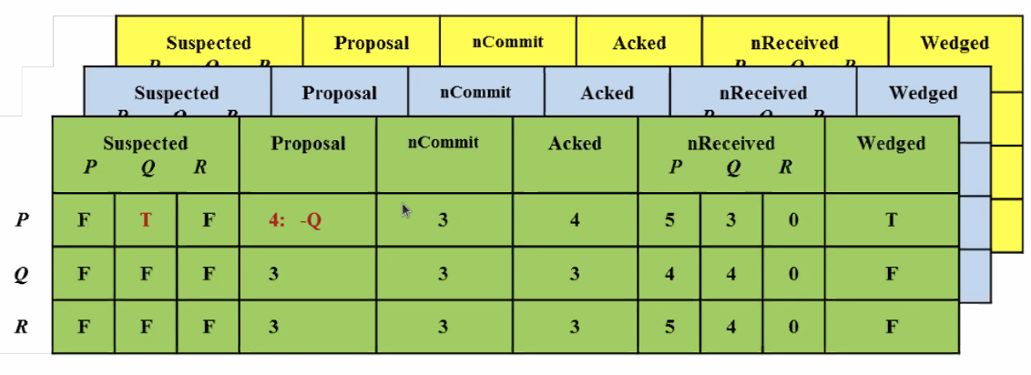
SQL: is not type-sage, not pre-checking if search query is valid
Requirements:
- user able to specify the table layout ; each row’s data stored contiguously in memory
- Support column vectors with fixed runtime size
  - First design
User deines the row layout as a struct, user can define number of rows
// elements in the class object are in contiguous location
class myRow{
int id;
bool processing;
// max_size is limited, since it must be known at compile time
bool suspected[max_size];
int msgs_count;
}
  - New design
Allocate memory for rows at runtime, Every element have a base address
Two new classes: SSTField<T> and SSTFieldVector<T>
Both derived from common class _SSTField
Access table.id[0] at address
Access table[1][1]
  - API
class mySST : public SST{
SSTFieldVector<message_id_t> seq_num;
SSTField<int32_t> vid;
SSTFieldVector<bool> suspected
SSTField<int> num_rows;
}
_SSTField is the super class of SSTField
  - How to find base address and row length?
    - The base address of a field ← # of fields to its left
    - Length of the row depends on the base
Implementation of SST::initialize_fields<T...>
//Initializer: goes through all the field and compute the length of all the field
Template <typename… Fields>
void SST::initialize_fields(Fields){
compute_row_length(fields...);
}
// recursion at run-time
template <typename DerivedSST>
template <typename Field, typename… Fields>
void SST<DerivedSST>::compute_row_length(Field& f, Fields&... rest){
row_length += padded_length(f.field_length);
compute_row();
}
// recurse on the number of arguments
template<typename DerivedSST>
template<typename Field, typename… Fields>
void SST<Derived>

    - All accesses are well-defined
// double indexing
template<typename T>
Volatile T* SSTFieldVector<T>::operator[]{
const size_t&
}

