Oct / 12 / 2020

Performance Optimization ( Sokoban Game ) and gprof
An np-hard puzzle to solve. 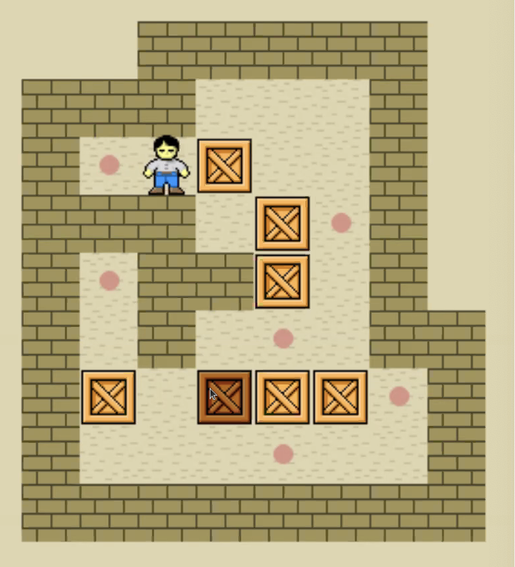

Optimize Sokoban Solver and Performance Analysis walkthrough:
Board Configuration:
- An intermediate Sokoban position
Partial game tree search:
- Explore the game options
- Constructing graphs in real-time

Version 1. Depth-First Search:
Move → recursive the next possible moves
Traceability: Track the move to reach the result
Performance: Slow, lost at high depths to find a solution, exponentially growing solutions

Version 2. Breadth-First Search:
Queue all the possible positions at each level : possible positions grow exponentially
Performance: too big memory consumption
After the first level : killed by Linux’s OOM Killer: Out of Memory Killer

Version 3. BFS & DFS:
Version 4. :

Further Optimization:
Remove dead states
Reachability analysis for finding one box moves

Question: thought process to go through gprof ?
Example:
Check what has been taken a lot of time, and reason about the most time consuming steps.

ret = func_call(args);
if (ret != 0){
}

