Robocup 2004: A Systems Engineering Project

Electrical Team Documentation
5/12/04

A design project report presented to the engineering division
of the graduate school of Cornell University in partial fulfillment
of the requirements for the degree of Mater of Engineering
in Electrical and Computer Engineering

Pranay Ahlawat
Cliff Gaw
Joe Golden
Karan Khera
Anthony Marino
Mike McCabe
Aaron Nathan
Nathan Pagel

Acknowledgements

The 2004 Electrical Team would like several people for the dedication and support they have shown the team. First, thank you to Professor Raffaello D’Andrea for his continued leadership and support of the team. Also, thanks to Dr. JinWoo Lee who’s soft-spoken recommendations were highly regarded by the team and who also played a major role in forming the 2004 team. Special thanks also goes out to Oliver Purwin who attended and contributed at every Electrical Team meeting. Oliver played a large role in forming the team and helping the team to get started. Finally, thank you to the Electrical, Mechanical, and Computer Science departments at Cornell University for their continued support.
Abstract

Master of Engineering Program
Cornell University
Design Project Report
Project Title: Robocup Systems Engineering Project 2004

Author(s): Pranay Ahlawat, Cliff Gaw, Joseph Golden, Karan Khera, Anthony Marino, Mike McCabe, Aaron Nathan, Nathan Pagel

Abstract:

RoboCup is an international event that focuses on improving robotics, feedback control, vision systems and artificial intelligence through the game of soccer. The goal of RoboCup is to be able to field a team of fully autonomous robots that can compete, and win, against the World Cup champion human soccer team.

The Electrical team for the 2004 Cornell Big Red RoboCup team had the challenge of learning the international championship system of 2003 and improving upon it.

The major goals this year for the Electrical Team were providing more sensor feedback to the Artificial Intelligence, changing to brush less motors, providing significant on-board processing power, improving the existing wireless communication, adding blue tooth inter-robot communication, and finding a better source of power for the batteries.

The team was in charge of designing, testing, and implementing all of these changes for the 2004 system, as well as integrating the Electrical system with the Mechanical and Artificial Intelligence groups.

The results this year show an improved system that outperforms the championship team of last year and should out perform many teams around the world.

Report Approved by

Project Advisor: _________________________Date:____________
Individual Contributions

Pranay Ahlawat

Pranay was a member of the wireless team this year. He tested out new modules that were being considered for use and worked to make the BiM modules work with the new system along with Cliff Gaw. He took on the responsibility for layout for both the transmit and receive boards and with the help of Cliff Gaw and Aaron Nathan he was able to successfully design, populate, and test those boards. Pranay worked primarily on the new boards and testing alternatives to the BiM modules

Cliff Gaw
Cliff was a member of the 2004 wireless team and worked primarily on implementing various encoding and decoding algorithms on the microcontrollers. He also assisted with the schematics necessary for the transmitter and receiver boards and made recommendations to the layout. Cliff primarily worked on improving the wireless system used last year and adapting it to the components used in this year’s system. Much of his efforts were focused on microcontrollers and BiM modules.

Joe Golden
Joe was the team leader of this year’s electrical engineering group. He was responsible for the Electrical team budget, purchases, and schedule. Joe attended the systems meetings as the EE representative and ran the weekly Electrical group meetings. He worked on improving the design of the kicking circuit from last year. He made schematics for the kicker circuit and did the layout for the kicker board that was made this year. He also did regulator schematics for DA Board and worked with Karan on batteries. He also assisted with board population and debugging.

Karan Khera
Karan was a volunteer to the team this year and was in charge of finding the best battery alternative for this year’s team. He also helped the team in other ways such as making connectors for the batteries and for other team members, by fixing 2003 kicker circuits, and numerous other things.

Anthony Marino
Anthony was responsible for the FPGA design and development. He tested and integrated the FPGA components and verified their operation with the hardware. Anthony also designed the necessary circuitry to support the FPGA. He was responsible for compiling the schematics for the prototype design and assisted with board population and debugging.

Mike McCabe
Mike was in charge of the sensors this year and worked hard to test, design, and implement the rate gyro, accelerometers, battery voltage sensors, and proximity sensing. He also took on the responsibility for laying out DA Board and the team commends him on a job well done. He also assisted both Joe and Pranay with the layout of other boards by offering advice and guidance.

Aaron Nathan
Aaron took over the responsibility of implementing the PC104 this year and building a platform that AI would be able to use. He also was in charge of implementing a Bluetooth network amongst robots on the field for inter-robot communication. He worked closely with both Anthony and the AI group because the PC104 was the main interface between the Electrical and AI groups. Aaron also solved countless other problems and, as the only returning member, helped to teach the rest of the group how the 2003 system worked.

Nathan Pagel

Nathan was in charge of implementing the new brush less motors this year. He designed, tested, implemented, and debugged a new motor control system. In addition, he did more board population than anyone else on the team. He also made all the motor schematics and assisted Mike with the creation of a digital battery sensor.

Table of Contents
- Introduction
  - Overview
  - Improvements
  - Systems Approach
- Management
  - Meetings
  - Software
  - Documentation
  - Sponsors
  - Communication
  - Online Data Storage
  - Ordering
  - Presentations
  - Scheduling
  - DA Board Population
  - Social Activities
- Kicking
  - 2003 Kicker
  - Improving this design
  - Solenoid Power Controller
  - 2004 Design
- On-Board Sensing

Infra-Red Ball Detector / Proximity Sensor
4.1.1 Overview
4.1.2 Circuit Implementation
4.1.3 IR Beam Configurations
4.1.4 Limitations of Proximity Sensing

Rate Gyro
4.3 Accelerometer
4.3.1 Summary
4.3.2 Testing

4.4 Low Battery Detection
4.4.1 Overview
4.4.2 Implementation
5.0 Motors
5.1 Why Change to Brushless?
5.2 Brushless DC Motor Control Theory
5.3 First Design Attempts
5.4 Final Working Prototype
5.5 Future Design
5.6 PWM frequency
5.7 Dribbler Motor
5.8 Dribbler Motor Encoder
6.0 Data Acquisition and Digital I/O
6.1 Overview
6.2 FPGA Selection
6.3 FPGA programming
6.4 FPGA functionality
6.4.1 Pulse Width Modulation (PWN) Generator
6.4.2 Brushless Motor Control
6.4.3 Encoders
6.4.4 Dribbler
6.4.5 Analog – to – Digital Conversion
6.4.6 IR beam interface
6.4.7 Kicker Control
6.4.8 Servo Motor Control
6.4.9 User Interface and debug I/O
6.4.10 PC104 Interface
6.5 FPGA development
6.5.1 Prototype
6.5.2 Hardware
6.5.3 Beta Load
6.6 FPGA challenges
6.6.1Voltage requirement and outputs
6.6.2 I/O pins high at startup
6.6.3 Startup
6.6.4 Noise on Servo Motor Signal

7.0: PC104 System
7.1 Overview
7.2 PC104 introduction
7.3 Advantages of the PC104 Implementation
7.4Tasks of the PC104 module
7.5 The Design of the PC104 System
7.5.1 Hardware
7.5.2 FPGA interface
7.5.3 The DIO Class
7.6 The Software Environment
7.8 Conclusion
8.0 Wireless Communication
8.1 Overview
8.2 Vision-to-Robot Communication
8.2.1 Performance Requirements
8.2.2 Preliminary testing
8.2.3 Design Considerations
8.2.4 Usability Consideration
8.3 Inter-Robot Communication
8.3.1 Experimental Section
8.3.2 Bluetooth
8.4 Alternative Modules
8.5 The DaughterBoard and DA Board Wireless Schematics
8.6 Transmitter Board
8.7 Wireless Monitoring
9.0 Batteries
9.1 Overview
9.2 Introduction
9.3 Finding the Right Battery
9.4 Digital Circuit Power
9.5 Purchasing
9.6 Charging
10.0 Layout
10.1 Overview
10.2 Splitting the Plane Layers
10.3 Minimum Feature Size
10.4 General Comments/Suggestions

Appendix :Schematics
Appendix: Wireless
Appendix: FPGA Code
Section 1: Introduction
  - Overview
The electrical engineering team of the 2004 Robocup Team was responsible for all designing, building, and testing of the circuit boards to be placed on the robots. We were also responsible for providing a reliable and efficient wireless communication system.

The diagram below shows how the electrical team was organized and how all the components came together to form the electrical system. The boxes in Blue represent systems that were incorporated this year. The system in gray was not able to be incorporated but a lot of research has been done.

CPU
Aaron
Data Acquisition & Digital IO
Anthony
Sensors
Mike
Motors/Kicker
Nathan/Joe
Wireless
Pranay, Cliff
PC104 Bus I/F
Camera
Sergei
Batteries
Karan

1.2 Improvements
Our goal this year was to improve on last year’s championship design. In order to do this, we worked closely with the Systems group to determine what would be needed. The obvious goals of making the robots lighter, faster, and cheaper needed to be broken down into requirements so that specific improvements were identified and defined. Five major areas of improvement for the new robots involved extensive EE work and these were the areas in which the team focused.

The first area of improvement was requested by the AI group and involved Sensors. Kicking accuracy was very dependent upon the position of the ball on the kicker. AI requested that two areas be improved. First, that the dribbler would automatically position the ball in the center of the kicker. The MechE group took this task. Secondly, they requested that there be a sensor that would allow AI to know the rough position of the ball on the dribbler. This solution called for new sensors and was implemented by the EE team

The second area of improvement was motors. Last year’s team used brushed motors and because the team continually drove them higher than specifications allowed, they burnt out easily. The decision was made to switch to brush less motors this year because of their smaller size, and better efficiency. Brushed motors are very simple to control from an EE standpoint while brush less motors required a great deal more work. However, the benefits a brush less motor could provide far outweighed the additional work and board space required to implement them and thus the EE team took on the challenge.

Our third area of improvement was on board processing. In order to make the move to local vision, as well as to reduce reaction time, a PC104 is being implemented on each robot this year. In year’s past, the AI was run on a computer next to the field and then the robots received their commands through a wireless transmission from the computer. This year, instead of vision sending date to a laptop, it will send data directly to the robots, each of which will do the AI computation on board. This ability saves reaction time by only sending one wireless transmission and also paves the way for local vision to be implemented in future years by providing a significant amount of on board processing power.

A lot of problems occurred in last year’s robots because of poor communication ability. The AI commands from the laptop had to be sent three times in the hope that once would be received without error. This year, work was done to improve the encoding and decoding of wireless messages. Also, in order to reduce noise, the team decided to separate the power and grounds of the digital and analog components. Separate batteries were used for power, and ground planes were connected by a inductor to eliminate noise on the analog plane from reaching the digital plane.

The final area of improvement was in batteries. The batteries used last year were NiMh batteries that were bulky and incredibly heavy. This year, we tested out Lithium Polymer batteries. Successful tests, plus a sponsorship from Bishop Power Products, have made this option our best choice. Lithium Polymer batteries are about the same physical size as the batteries used last year, but are 1/3rd the weight.

  - Systems Approach
The Electrical Team took a systems approach towards this project. Demands from the team leaders AI team, and Mechanical team were broken down into specific testable requirements that were then broken into tasks given to individuals. There was a lot of emphasis in the beginning of the project on communication between the AI, Mechanical, and EE teams in order to assure that the system as a whole would come together and that that interfaces were well defined.

Because of the systems approach, the team was able to provide new robots for the American Open, a first for the Cornell Big Red. Also, at the time of this report, the Electrical team is currently about 20% under budget.
Section 2: Management and Advice
  - Meetings
This year meetings were held once a week. Regular attendees included the EE team, Dr. JinWoo Lee and Oliver Purwin but were open to anyone who wished to attend. In addition regular weekly meetings, there was also weekly lab time on Sunday afternoons. Group lab time is strongly recommended for next year’s RoboCup team for several reasons. First, it allows the team to meet twice a week, which becomes incredibly important as robots are being built. Second, it serves as a motivation factor for the EE team members to come to lab because the team views it as a requirement rather than an option. Third, it allows EE system issues to be worked out and resolved.

Systems Meetings were also held once a week. Generally the systems meeting included the two overall leaders, Oliver Purwin and Michael Sherback, as well as Dr. JinWoo Lee, and the leaders of the Mechanical Group, Electrical group, AI group, and Vision. Once again these meetings were open to all and generally several members from each group attended. This year, Aaron Nathan and Joe Golden attended nearly every systems meeting and it worked out very well. Joe was able to answer questions regarding scheduling, budgets, and analog components while Aaron was able to answer questions about digital circuitry, software, and the AI interface.

  - Software
Software installation was difficult this year. The Altera software used for the FPGA code would not work. Finally, we gave up on the computer Zeus, and the software was installed successfully on Julie. Reasons why it did not work are still unknown. There were also problems installing the Orcad Layout Plus software in the lab and it was believed to be a licensing issues. Because of this, OrCad was done outside of RoboCup lab this past year. Dr. JinWoo Lee is working to obtain licenses for next year.

  - Documentation
The documentation left for this year’s RoboCup team did not offer much help, nor did it contain results of tests previously done. Because of this, the 2004 EE team has had much more emphasis on documentation. Weekly reports were due every week the first semester. Second semester was much more hectic and face time was very prevalent so weekly updates were not as necessary.

  - Sponsors
Sponsors have played a big role in providing money, support, and donations of parts. Microsoft gives us Windows CE.net for our robots as well as other benefits. Altera provides us free FPGAs. Bishop Power Products has agreed to give us 20% off our purchase of batteries. Fact is, many in industry are impressed with what the team is able to accomplish and they really find the project interesting. Someone will give you a discount or parts for free if you ask around enough. While specific numbers have not been calculated, it would be safe to say that the EE budget would easily double without discounts and donations. To give an idea, the Bluetooth modules and FPGAs that were donated for free would have cost well over $5000. Discounts of Board Fabrications saved over $2000. A list of sponsors and contacts can be found in the appendix.

  - Communication
In the beginning of the semester, a contact sheet was made for the entire team. This contact sheet includes AIM names, phone numbers, and email addresses. In addition, a list serve was set up. All of these have been incredibly useful. It is strongly recommended that the AIM names and phone numbers of the EE team, and the members of the MechE team which each team member will be working most closely with, be stored in memory.

  - Online Data Storage
A database was also set up through the http://robocup.mae.cornell.edu web page by MechE leader Patrick Dingle. This has been a very useful way of having weekly reports, design presentations, budgets, and documentation, schematics, and layout easily accessible to all who would need it.

  - Ordering
Ordering parts is very time consuming, especially when teammates try to order from non-english speaking contacts. Budgeting and accounting is also very important. Make sure to collect all packing slips and take them to the accounting office in Upson Hall. Also, it is a good idea for the team leader to keep a continuously updated excel spreadsheet of all purchases.

This year a DigiKey order was placed about once a week. Overnight shipping is expensive and needs approval by team leaders so planning ahead is important. When placing purchase orders, make sure to do them early and not delay. While the accounting office claims that purchase orders are sent out the next day and normally take three weeks, it is the experience of the EE team this year than an average purchase order takes between ten and twelve weeks.

  - Presentations
Chances are, the first presentation is not going to go well. The electrical team conceptual design review was organized into one PowerPoint presentation. The electrical team was scheduled to take 40 minutes. It ended up lasting closer to 90 minutes. These presentations are a chance for the entire team to see the current design and future goals, and to offer other suggestions. While the odds are that you will not have many answers, it is a great starting point and helps to focus your efforts early in the semester.

  - Scheduling
The 2004 EE team used the first semester to prototype and debug new ideas. All new ideas had to have a working prototype by the end of the semester in order for it to be included in the design and fabrication of the boards. Most of the team came back from winter break early to do schematics. Mike McCabe volunteered to do the actual Layout of the board was schematics were done.

Advice for next year would be to finish schematics and layout in December. The American Open was held in late April this year and it was the goal of the group to have the new robots in time for that competition. The 2003 team did not have robots for it and had to send 2002 robots instead. It was decided early on that the American Open should be a goal for the team this year because it was a great opportunity to test the system. While this goal was accomplished, it was only accomplished hours before the team had to leave for New Orleans. Because of this, the robots could not be thoroughly tested and many problems did arise. If there were more time, the EE issues could have been resolved prior to competition and AI would have had a much better chance of testing their system. The goal next year should be to finish the robots in late March so that the AI team can have at least a month to test their system before competition.

If team members work in the lab nearly non-stop once the boards have arrived, it takes about 3 weeks to populate and debug the major issues of 5 boards. It then takes about two weeks to change schematics and layout and then another two weeks to received the boards once they are sent out. All together, it takes almost two months from when the first revision is received until the second revision is received and it can not be emphasized enough the amount of hours needed for that to be accomplished. In order to have boards ready by late March, the first boards need to be received by late January and if at the very minimum schematics are not done and finalized before winter break, it is an impossible deadline.

Finally, early on someone should volunteer to learn OrCad Capture and Layout. Had someone on the team been familiar with the programs before they had to be used, a lot of time could have been saved. Have one person in charge of Layout and have that person begin learning the program early.

  - DA Board Population
Once the boards have been designed they need to be populated. This is no simple task. Most team members do not have extensive soldering experience and many of the parts on the boards will be very small. It is good to have two people soldering at the same time. This way one of them can get parts for both boards. A lot of time is wasted searching for the next part.

It is beneficial to make sure that the parts are not too small. A good guideline is 0805 or larger for resisters and capacitors. Anything smaller than this, while possible, is not worth the effort. It may be necessary to manually increase the size of some of the pads in OrCad in order to be able to solder them proficiently. For the first revision, soldering the dual motor fets were very difficult; however, for the second revision the pads were enlarged and they became very easy to solder.

The boards should be thoroughly ohmed out before any parts are added. This can not be emphasized enough. The 2004 team did connectivity checks between power pins and then between ground pins to ensure plains were connected. After doing this for the first three boards, the team was content believing the all boards worked. However, it turns out that one board which we populated had a flaw in is and the power pins on the left of the board did not connect to those on the right side of the board. And more so than this, power pins on the right side did not connect with out power pins on the right side. A lot of time and energy was wasted populating a deficient board.

Parts should be installed in size order. Smaller parts are harder to solder on, especially when large connectors were already soldered on next to them. Flux and de-solder braid are the two most important tools used in populating boards, use them.

  - Social Activities
As with any major project, the members of the team should enjoy what they are doing and should form a bond with their teammates to help encourage a positive work environment. In order to help do this, numerous out of lab activities were planned. The entire RoboCup team took a trip to play paintball during the first semester. In addition to this, there were numerous nights in lab where team members met to play computer games. Finally, several times during the year, team members met on Thursday nights to play poker. All of these activities significantly helped improve relations between team members.
3.0 Kicking
3.1 2003 Kicker
The kicking circuitry from last year is shown below:
DC
Converter
Solenoid
FET
Digital Board
Diode
220 ohm
1.8mF
1.8mF

The DC converter takes in the 15V supply from the batteries and then converts it to a 120V source. The resistor serves to provide the minimum load requirement of the DC converter. The two large capacitors are there to store charge that will be driven through the solenoid. The diode is a fly back diode and serves the purpose of keeping Vds of the FET below 100V, a requirement for proper functioning of the FET. The Fet serves as a switch. With the capacitors fully charged, this is basically an open circuit. When the Fet receives the signal to kick, it turns on, thus connection the 100V at the top of the solenoid to ground.

The solenoid creates a magnetic field that is dependent on the amount of current through the solenoid and the number of turns in the solenoid. When the command to kick is sent to this circuit, it demands that we provide the maximum instantaneous current in order than the kick occurs as soon as the command and that it provides the strongest possible kick. The DC converter, along with the charge holding capacitors, provides this instantaneous current. This circuit will provide a kick of about 4m/s

3.2 Improving this design
After speaking with a man named John from a solenoid manufacturer GWLisk, it appeared as though not much could be done to improve this circuit.. After giving John a brief description he stated “I would guess you’re about maxed out. You’re at the point of diminishing returns.” The team then consulted Carlos, the creator of this circuit, to ask about what tests had already been done and what he felt could be improved upon. His only suggestion was be to reduce the resistor and strain the DC converters minimum load requirement in order to have a faster charging time. But Carlos admitted that it would be a minimal gain. Testing was done on adding higher capacitance capacitors and it was proven that the higher capacitance improved the strength of the kick.

3.3 Solenoid Power Controller
Another possible option that was looked into was buying what is called a Solenoid Power Controller from Runton Engineering. While the DC converters and capacitors cost more than $120 per robot, this controller costs only $75. Specs on this say it has a recharge cycle of 0.25 seconds and can have a cycle rate up to 6 per minute. It is about the same size as the DC converter and would be a much more robust option to our current design. While this part only provides 24VDC, it is capable of outputting 40Amperes of current. On paper it appeared to meet all the specifications that the team set for the kicker. However, after speaking with some engineers there, this option did not seem to match our design criteria. The lower voltage was a serious concern and the 40 Amperes of current were only available under special conditions. There were also concerns over its reaction time. It was decided to again build our own controller circuit

3.4 2004 Design
After speaking with professional engineers who work with solenoids, and drawing on past experiences, it was decided that the design used last year was a very solid design and that slight improvements could be made to it. Some tradeoff analysis was done to calculate charge time vs. the maximum output of several smaller DC converters. Because kicking loose balls and rebounds into the net scores a lot of goals, a short recharge time was essential. The recharge time affects the type on DC converter that is used. The DC converter that was used is made by PicoElectronics and is the model IRF100S.
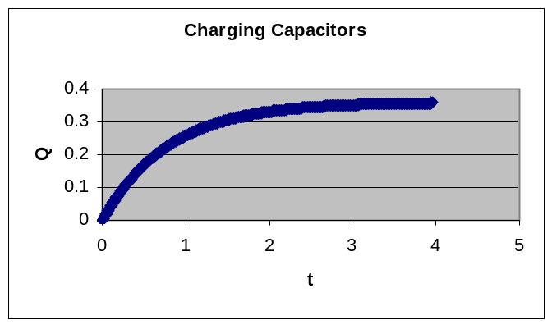

When the kick occurs, all of the power is dissipated through the solenoid. Thanks to modeling by Michael Sherback, the following graph is available to model the discharge.

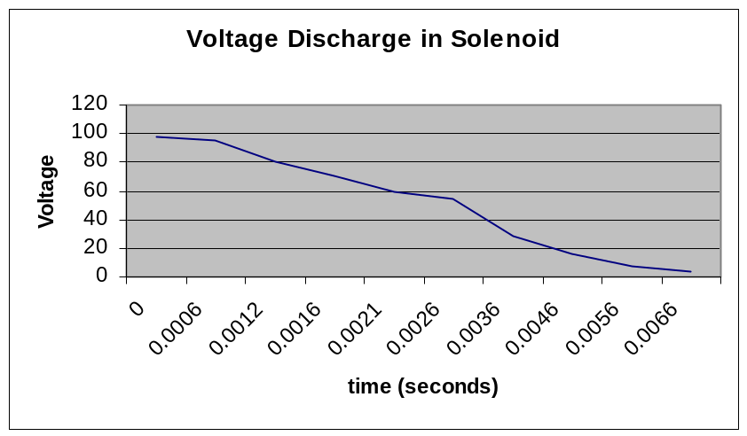

As can be seen, a full strength kick would take about 6ms to complete with most of the power dissipated within the first 4ms. This quick discharge rate allows for a very strong magnetic field almost instantaneously and allows the kick to be strong. To control the strength of the kick, the length of the kick signal is varied. This way, not all of the charge is allowed to pass through the solenoid and thus the magnitude of the magnetic field is limited. Please see the FPGA section for more details on how the kicker is controlled.

Adding more capacitance would slow down both the recharge time and the discharge rate. However, the added current would make the magnetic field more powerful. This way, a fully charged kick would have much more power.

Last year, discharge capability was added so that fully charged capacitors could be discharged. This was done with the use of a jumper. However, early this year the team noticed problems with this technique. When one person would discharge the capacitor, that person would not later go back and place the jumper on the correct setting. And hence, a new person would use the kicker expecting it to work, and instead of charging capacitors, was constantly wasting power by discharging at the same time the DC converter was trying to charge. This year, a pushbutton was used instead of a jumper. Now, when discharging, hold the button down for approximately 10 seconds and the capacitors will be discharged. The following graph shows this:
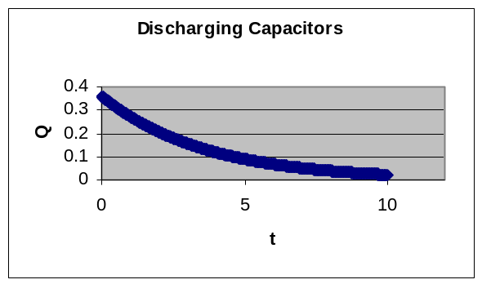

Discharge could occur faster using a smaller resistor. However, 100V discharged at a rate of .01A gives a power rating of 1Watt. Since 1-watt 1kohm resistors were readily available, this was the solution that was implemented.

Because the team this year was under budget, and because of new positioning of the board by the Mechanical team, it was decided that a nice kicker board with appropriate connectors should be created. Schematics for this board can be found on the internal RoboCup site as well as in the appendix. The layout files can be found on the internal web site as well.

One last change to the kicker circuit occurred when it was realized that at start up, nearly all FPGA pins are set to high. If the capacitors are charged still, and the robot is turned on, then the robot kicks immediately. Because people handle the robot daily, and the robots are sometimes in people’s hands when turned on, the kicker will soon be changed so that it is active low.

Section 4: On Board Sensor Subsystem
4.1 Infra-Red Ball Detector / Proximity Sensor
4.1.1 Overview
One of the key modules on every robot is the IR Ball Detector. This module allows the robot to know if it is in possession of the ball. This information is crucial for dribbling and kicking. Last year this was accomplished with a single IR beam on the front of the robot underneath the horizontal dribbling bar. This method, though effective and reliable, only gave a Boolean output as to whether or not the beam was broken. This year a system has been designed to detect the presence of the ball as well as the side of the dribbler that the ball is on. This system requires one transmit and receive circuit for each side. For simplicity only one side will be analyzed.

4.1.2 Circuit Implementation
In order to reduce sensitivity of the circuit to the amount of ambient light present a 5 kHz square wave was used to transmit the IR beam. Last year a transmitter circuit based around a 555 timer was designed. To simplify the design and layout, this circuit has been moved into the FPGA. This output of the FPGA and routed to a resistor before being broadcast by an infra-red LED.

The signal is then received on the gate of a phototransistor and inputted into the receiver circuit (shown below). The acquired signal is then passed through an RC high pass filter to remove the DC bias and any 60 Hz signal coming from the ambient lighting. The first op amp amplifies the signal for better resolution. The capacitor then rectifies the amplified signal. The final op amp compares this signal to the reference voltage, which has been set to 0.45 V. If the 5 kHz signal is received, the rectified signal will be greater than 0.45 V and the output will be a logical 0. If the received signal is not strong enough, the rectified signal will be below 0.45 V and the output will be a logical 1 and the LED will turn on.
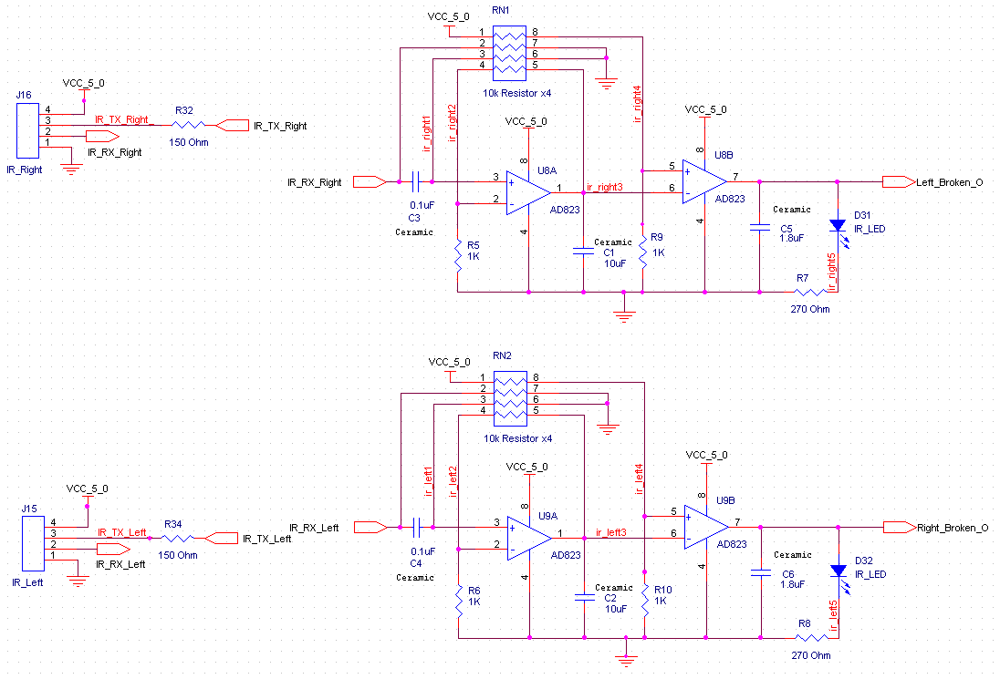
Figure 4.1 – IR Ball Detection Circuit

4.1.3 IR Beam Configurations
The simplest dual beam solution was to align the beams so that they made a crossing pattern underneath the dribbler. In this configuration if the ball was on the side of the dribbler, one beam would be broken and the other would be intact. If the ball was in the center of the robot, both beams would be broken. This configuration requires precision alignment and possibly changing the values of R5 and R6 after receiving the swing bar from Mechanical team. This setup is also aided by proximity sensing. By having an emitter-detector pair next to each other, it is possible for an object to break the beam and be close enough to the pair that the detector still receives a signal. This configuration produces an emitter receiver pair on both sides of the dribbler while preserving the previous IR detector functionality. The system will digitally output 00 when there is no ball and both beams are unbroken, 01 when the ball is on the left side and the right side beam is broken, 10 when the ball is on the right side and the left side beam is broken, and 11 when the ball is in the center. Should this system fail at competition, the connectors can be exchanged such that two parallel beams will be below the dribbler. By watching the front most beam, this system will behave identically to last years system.

4.1.4 Limitations of IR Location Detection
This system has two crucial boundaries for proper function. First, if not enough infra-red light is received while the ball is at the extreme ends of the dribbler, then this system gives us no data that the previous system would not have given. Second, if the ball is centered on the dribbler and yet the detectors are still receiving enough infra-red light, then the system will behave as if the robot did not have possession of the ball. This would entirely undermine the purpose of the circuit and must be avoided at all cost.

4.2 Rate Gyro 4.2 Rate Gyro
During competition, the wheels of the robot will skid causing the robot be out of position. This can be corrected through the vision system, but that has a large latency associated with it. If the robot were able to compare its commanded velocity with its actual velocity, this problem could be handled much faster. For this reason the 2003 EE team designed and tested a rate gyro circuit (shown below) that accurately measures the rotational velocity of the robot. The output of the Silicon Sensing CRS-03-11 rate gyro is an analog signal with DC bias of 2.5 V. This signal is filtered through a second order Butterworth filter. This filter requires a precise reference voltage, which was generated with an Analog Devices AD780.

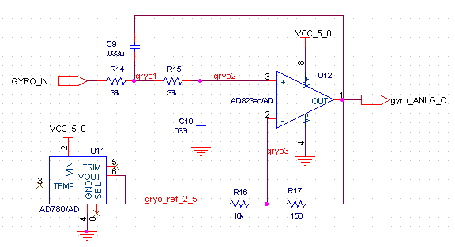
Figure 4.2 – Rate Gyro Low Pass Filter

The output characteristics of this filter are as follows
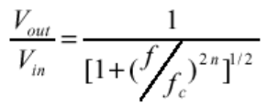 Eq 4.2.a
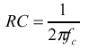 Eq 4.2.b

This circuit worked so well in competition, that alterations have been a low priority this year. For further documentation on this circuit, please see the 2003 EE documentation.

4.3 Accelerometer

4.3.1 Summary
Last year the EE team looked into using the Analog Devices ADXL210JE dual band accelerometer on the robots. This device outputs a PWM for the acceleration exerted upon it in the X direction and another for the Y direction. A duty cycle of 50% indicates that no acceleration is present in that direction. Last years team attempted to digitally sample these PWM signals to determine the robots actual accelerations. These values were then to be integrated in software to give the actual velocities, which could be compared with the commanded velocities. Unfortunately, sampling in such a fashion introduced to much noise into the system for it to be used in competition. This year, an analog based approach was taken using the Analog Devices ADXL311 dual band accelerometer. This accelerometer outputs an analog signal corresponding to approximately 0.3 V per g of acceleration. By sampling an analog input instead of a digital input, all timing constraints are removed for the sampling. This should allow for a more robust system with lowered noise. To reduce circuitry, the outputs of this circuit are passed to an analog-to-digital converter. The digital output is then sent to the FPGA for processing.

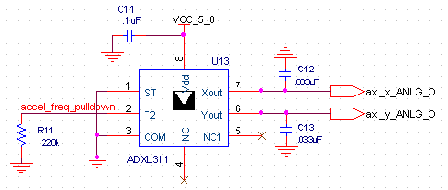
Figure 4.3 – Analog-Output Accelerometer Circuit

4.4 Low Battery Detection

4.4 Low Battery Detection

4.4.1 Overview
In order to prevent running on batteries that are running low and risk the chance of damaging the batteries by over use, two battery detection circuits have been added to the robot. The first is a simply voltage divider across the analog batteries. The output is converted to a digital signal by an ADC and then processed by the FPGA. The second is circuit inline with the digital battery connector, which has the capability of shutting off the robot.

4.4.2 Implementation
The analog voltage detector is simply a voltage divider with diodes attached to prevent a voltage spike from propagating onto the ADC. The circuit is shown below.
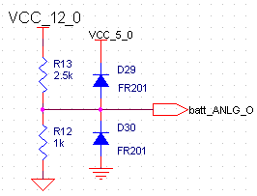
Figure 4.4.1 – Analog Battery Voltage Detector Circuit

The digital voltage detector is a comparator with the negative input connected to the output of a voltage divider across the digital batteries. The positive input is connected to a Zener diode that holds a fixed voltage at 2.4 V. This creates an output that is low only when the output of the voltage divider is higher than 2.4 V. Thus once the batteries have drained to a certain amount the output will transition from low to high. By connecting this signal the gate of a PFET, whose source is connected to digital power and whose source is connected to the digital switch. A digital switch is added before the physical switch so that the robot will automatically power down in the case of low battery voltage rather than damaging the batteries. This circuit is shown below.
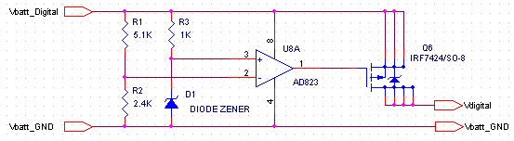
Figure 4.4.2 – Digital Battery Voltage Detector Circuit

Section 5: Motors
5.1 Why Change to Brushless?
In previous years RoboCup has used brushed DC motors to drive our robots. DC motors work well because they are easy to control and are relatively small. This year The team is using brushless DC motors to drive the robots. Brushless DC motors combine these same advantages but are more efficient and even smaller. The trade-off, however, is in the simplicity of control. Therefore, if brushless motors can be controlled without sacrificing too much electrical board space than they are preferred to brushed because of their weight, size and mechanical efficiency.

5.2 Brushless DC Motor Control Theory
A brushless DC motor works by varying the internal magnetic field through the varying of three inputs in a certain order. As the magnetic field rotates the permanent magnet rotor spins. The desired magnetic field is determined by the current position of the rotor. This is produced through the use of Hall sensors. Three sensors determine the current location and when this information changes then you need to change the inputs to the motor in order to keep the motor spinning. By using this feedback the motor takes care of its own timing issues for the magnetic field. A magnetic field is created by passing current from one motor input to another. Applying battery voltage to one lead and ground to the other creates this magnetic field. The extraneous input is given high impedance so no current flows. The motor will spin if the inputs match the values found in Table 4.1.

Table 5.1: Necessary Motor Inputs as a Function of Hall Sensor Feedback
Hall 1 | Hall 2 | Hall 3 | Motor A | Motor B | Motor C
1 | 0 | 1 | V_{batt} | Ground | High Z
1 | 0 | 0 | V_{batt} | High Z | Ground
1 | 1 | 0 | High Z | V_{batt} | Ground
0 | 1 | 0 | Ground | V_{batt} | High Z
0 | 1 | 1 | Ground | High Z | V_{batt}
0 | 0 | 1 | High Z | Ground | V_{batt}

In order to apply these values to the motor inputs the convention is to use half H-bridges to control each of the three inputs. A half H-bridge is simply two transistors. One transistor controls current flow from the battery and one controls current flow to ground. Therefore, when the top transistor is on the motor input sees battery voltage, when the other is on the input sees ground, and when both are off it sees high impedance. This will allow gate signals to control the motor inputs indirectly. Using this theory, the information from Table 4.1 becomes the actual drive signals that are required to drive a brushless DC motor. These values along with the necessary values to drive the motor in the reverse direction can be found in Table 4.2 below.

Table 5.2: Drive Inputs as a Function of Hall Sensor Feedback†
 | Hall Sensors |  |  | H1 | L1 | H2 | L2 | H3 | L3
Forward | 1 | 0 | 1 | 1 | 0 | 0 | 1 | 0 | 0
Forward | 1 | 0 | 0 | 1 | 0 | 0 | 0 | 0 | 1
Forward | 1 | 1 | 0 | 0 | 0 | 1 | 0 | 0 | 1
Forward | 0 | 1 | 0 | 0 | 1 | 1 | 0 | 0 | 0
Forward | 0 | 1 | 1 | 0 | 1 | 0 | 0 | 1 | 0
Forward | 0 | 0 | 1 | 0 | 0 | 0 | 1 | 1 | 0
Reverse | 0 | 0 | 1 | 0 | 1 | 1 | 0 | 0 | 0
Reverse | 0 | 1 | 1 | 0 | 0 | 1 | 0 | 0 | 1
Reverse | 0 | 1 | 0 | 1 | 0 | 0 | 0 | 0 | 1
Reverse | 1 | 1 | 0 | 1 | 0 | 0 | 1 | 0 | 0
Reverse | 1 | 0 | 0 | 0 | 0 | 0 | 1 | 1 | 0
Reverse | 1 | 0 | 1 | 0 | 1 | 0 | 0 | 1 | 0

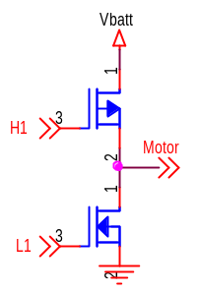

Half H-Bridge

The speed of a brushless DC motor can be controlled in the same manner as a brushed motor. Speed depends on the applied voltage from the battery to ground. If however, instead of applying simple logic to the driver gates, a PWM signal with a known duty cycle is applied then the motor will see the battery voltage for only a percentage of the on-time. Because the electronics can operate much faster than the mechanical parts of the motor, the motor simply sees that percentage of the total battery voltage. Therefore, by varying the duty cycle the effective voltage to the motor varies and therefore the speed.

Finally, by adding an encoder on the motor and a feedback controller the speed and direction of the brushless DC motor can be fully controlled. The encoder returns two pulse signals that can be used to determine the current speed and direction of the motor. As feedback to a controller the encoders will stabilize the speed of the motor, usually with a simple PI controller.

5.3 First Design Attempts
There are many miracle cures to the problem of controlling a brushless DC motor. All of them claim simple, reliable results for any application. As discovered this semester, these off-the-shelf controllers are difficult to configure and rarely work in accordance to the printed specifications. The controllers that were tried include the LS7560 controller by LSI Computer Systems, the TDA5142T controller by Phillips, and the IR2133 Bridge Driver by International Rectifier.

The LS7560 looked very promising. This chip had many built-in features including: overcurrent and undervoltage sensing fault detection, speed feedback, a brake input, and a built-in 5-volt regulator. These features would be valuable for our design so this circuit was preferred. Because all parts of the circuit relied on the chip, even for 5-volt power, the chip required the entire circuit before any testing could be done. This made things very difficult to debug. Of course, when the circuit was completed, nothing worked. After many hours of debugging it was determined that the chip never came out of its protective fault-detection mode. Even when all the inputs were forced to valid inputs the chip remained in this mode, which means that it never outputs motor signals. Therefore this chip was abandoned a new design alternative was pursued.

The next chip that was the TDA5142T controller chip. This chip was similar to the LS7560 chip but with fewer features. This chip, however, required an analog control input to control the speed. This isn’t feasible for our robots because D2A chips are very large and each of the motors would require an entire chip. Therefore, this design was abandoned as well.

The next alternative mirrored the design of the Autonomous Flying Vehicle Team because it used brushless DC motors to drive its propellers. After reviewing their documentation, schematics and speaking with Sean who designed their controller boards their design was determined to be feasible. After populating one of their boards, it was determined that their hardware worked. There were problems, however, with the microcontroller that they were using because it did not include the necessary software to load their code. Regardless, a better alternative, on a smaller scale, was found so this alternative was abandoned as well.

The next alternative used a PIC microcontroller instead and the transistors from last year, IRF7822. It also included the IR2133 Bridge Driver that the AFV used. This basically allows all NMOS transistors instead of NMOS for the bottom half and PMOS for the top half. This setup is beneficial because PMOS has a slower switching time which leads to timing problems and it also requires more than 5 volts to turn on a PMOS gate so you need more than just logic††. When this design was completed the motor spun but not at the rated speed and it did not start up on its own. After analyzing the bridge driver chip in more detail it was discovered that the chip was only driving the top transistors with a pulse instead of an on-characteristic. This means that as long as the motor was spinning fast enough it would work but it needed a kick-start to get going. This design would work once the PWM control signal was employed but if there are any other options that don’t require as much board space as this chip then those alternatives would be preferred.

5.4 Final Working Prototype
The final design that works completely is the most basic. There were no off-the-shelf control chips or gate drivers. It is simply the design from last year’s brushed motor control, modified it so that it will work for brushless. This means that the circuit will rely on the FPGA or a microcontroller to perform the commutation for our final robots. The design is simply three half H-bridges with the PMOS transistor gates controlled by secondary NMOS gates that control a voltage divider from the battery to ground, Figure 4.1. A PMOS transistor turns off when the gate voltage is high, battery voltage, and on when the voltage is more than 4.5 volts below battery voltage. Therefore, when the secondary NMOS gate sees 5-volt logic it turns on, allowing current to flow through the voltage divider and bringing the PMOS gate voltage down to turn it on. The bottom, NMOS transistors in the half H-bridge can turn on by basic 5-volt logic as well so now a PIC microcontroller can control our brushless motor by reading the hall sensors and driving the 6 NMOS gates according to the look-up table (Table 4.2).

Figure 5.1: Brushless DC Motor Prototype

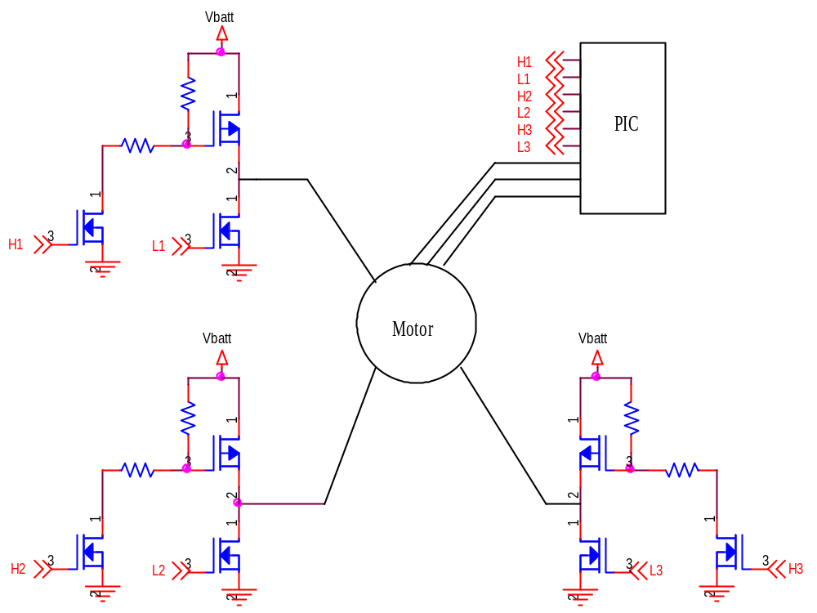
With this design there is an inherent timing issue that must be resolved. When these gates change rapidly there is a risk that the top and bottom transistors of an H-bridge may both be on at once. If this happens then there is a short from the battery to ground. This will endanger the transistors and drain our batteries so it is important that this doesn’t happen. The PMOS transistors that are being used, IRF7424, have a turn-on time of 23 ns and a turn-off time of 76 ns. When compared to the 7822’s turn-on of 5.5 ns and turn-off of 12 ns it is evident that this would cause problems if an NMOS turns on and a PMOS turns off at the same time for a particular half H-bridge. This is especially significant because not only does the commutation turn gates on and off continuously but PWM will turn things on and off rapidly as well. For the design, the solution to this problem is simple. First, the commutation has been designed to solve this issue. No two consecutive states will ever switch both the top and bottom gates of a single half H-bridge. The only time this might happen is while switching directions. Therefore, a simply delay for 100 ns whenever the direction changes, while the motors coast, will fix this problem. This won’t affect the performance enough to even notice. Finally, to solve the PWM issue the software can use the solution from last year. The FPGA can simply PWM only the bottom half of each H-bridge. This will not affect the speed control but avoids all timing problems.

As shown in the schematic there isn’t much more hardware involved in this design compared to last year’s design. While it used 6 transistors last year there will be 9 this year. This design has only 3 more chips for each motor so RoboCup should definitely go with brushless motors this year. The benefits of the smaller weight and size far outweigh the complexity of the control. The FPGA will be necessary to control the motors anyway. The robots will simply need a larger FPGA this year.

5.5 Final Design
The final motor design for 2004 contains only minor improvements on the working prototype. Obviously the final design runs off of signals from the FPGA. To protect these signals, a pull-down 10k resistor to each gate signal was added. Also, to simplify the design the bottom resistor in each voltage divider has been removed because it isn’t necessary. Basically, instead place of a voltage divider, a pull-up 10k resistor on the PMOS gates is used. Now when a high signal is driven, the secondary NMOS turns on and the PMOS sees battery voltage instead of some smaller voltage. Diodes were also added across each power MOSFET to protect from any back emf current created by the motors. Back emf current of as much as 2 to 3 amps is expected this year so diodes are important. Finally, a large decoupling capacitor was added from battery voltage to ground to protect from high frequency noise in the system. The final circuit can be found in the final schematics, which are included with this report.

5.6 PWM Frequency
The PWM duty cycle controls the apparent voltage seen by the motors and therefore the speed of the motors. Therefore, the frequency of the PWM is independent from the motor control. Though a wide range of frequencies may be used for the PWM control of the motors there are guidelines for the best choice of frequency. The radian frequency lower bound is set by the RL characteristics of the motors that are being used. If the frequency is less than this frequency than the motor essentially see the PWM and will dissipate a lot of heat. This creates a large amount of lost energy and a risk of burning motors. According to the motor datasheet the L and R characteristics of our motor are 0.41 mH and 1.2 Ohm. The on-resistance of the PMOS and NMOS transistors that are in series with the motor must be included. These values are 22 mOhm and 5 mOhm respectively. The frequency lower bound can be found by the following formula.

2f = R/L so f = (1.2+0.005+0.022)/(20.00041)) = 476.3 Hz

The frequency upper bound is set by the switching characteristics of the MOSFETs. Since only the bottom sides of the motor circuits are PWMed due to possible timing issues only the switching times for the NMOS need to be considered. When the MOSFET is switching it dissipates more heat and uses more energy. If this happens too much then there is a risk of overheating the chips and damaging the circuit. The guideline claims that the switching time for the MOSFETs should not exceed 1% of the total time for each cycle. For the IRF7822 the switching times are a 5.5 ns turn-on and a 12 ns turn-off. Therefore the fastest the PWM should change is 100 times the turn-off time or 833 kHz. This turns out to be a wide range but the guideline also states that a faster PWM will be more efficient electrically. The PWM is currently running at 1.2 kHz and may be increased to more than 20 kHz before the competition. Another reason to switch to a higher frequency is the audible noise caused by switching in the audible range at 1.2 kHz. The sound is beneficial during testing but will be annoying to everyone at the competition.

The implementation of PWM control is simple. A variable PWM signal is directly ANDed with each NMOS control signal from the FPGA before it is sent to the motor. The duty cycle is set by the PC104. The implementation is described in more detail in these sections of the report.

5.7 Dribbler Motor
The dribbler motor is the same this year. Though brushless has advantages for the drive system it is not worth it to try and change the dribbler motor mainly because of its shape in comparison with the chassis. Another reason to not spend too much time improving this circuit is the new restrictions placed on dribbling in the rules this year. Therefore, the dribbler motor is still a brushed motor and has a different control process entirely.
Controlling a brushed DC motor requires a single H-bridge. To go in one direction the FPGA simply turns on two of the MOSFETs and to reverse direction the FPGA switches to the other two (Figure 4.2). For our purposes, this circuit is identical to two-thirds of a brushless motor circuit. This simplifies the overall design by reducing the number of different components on the boards. Though the circuits are the same it is important to remember that the two are controlled differently.

Figure 5.2: Dribbler Motor Circuit

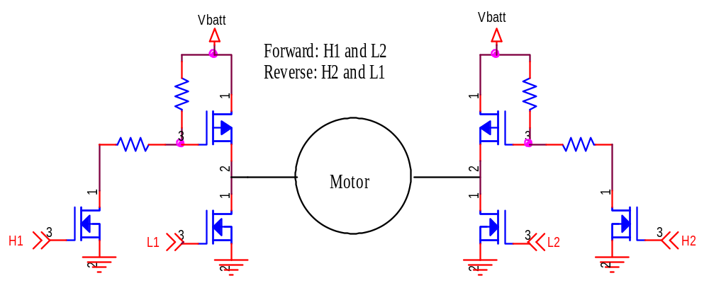

Again, to finalize the design of the dribbler motor pull down resistors were added to each of the MOSFET gates to protect the FPGA and the voltage divider of each high signal was simplified by eliminating the low-half resister. Diodes across each MOSFET were included similar to the brushless motors. We will be using PWM control on the dribbler motor also and will again be only PWMing the low side of the H-Bridge.

5.8 Dribbler Motor Encoder
The only major improvement to the dribbler circuit this year is the addition of an encoder. Speed feedback will allow more precise control of the speed of the dribbler. The dribbler encoder in the design is an optical encoder and comes already attached to the back of the motor. The encoder needs 5 volts and ground and returns three signals. There are two encoder-count signals and an index bit. The index bit is not used in the design so it is a no-connect. The two encoder-count signals go directly to the FPGA and the signal descriptions can be found in the FPGA section. It is important to note that the dribbler encoder ground is on the digital ground net while the H-bridge control circuit is grounded to the analog ground net.

Section 6 FPGA

6.1 Overview:

This year’s electrical design for control is quite a bit different than in previous years. The majority of computation is done by a PC104 processor instead of a pair of microcontrollers. This new implementation vastly changes how the control of the robot is achieved. The functions carried out by the old microcontrollers have been divided up between the PC104 and the field programmable gate array (FPGA).

The FPGA does all of the logic manipulation and generates the control signals for motor control, dribbling, kicking, and motion sensing. In addition, the FPGA communicates with the PC104 via the PC104 bus interface. A register file in the FPGA enables the PC104 to read and write data for various functions. Below is a block diagram of the FPGA and how it interfaces with the rest of the robot design.

PC104 bus interface

Flex 10K FPGA
EPF10K100E

Motor Control, Dribbling, Kicking, Motion Sensing

Figure 6.1: Block Diagram of the FPGA Design

6.2 FPGA Selection
In this year’s electrical design, the FPGA plays a much larger role than in previous years. Last year a chip from the Altera Max 7000 family was used. For the desired application the chip was a good fit, however due to the added complexity in this year’s design, the Max 7000 family is no longer a viable option.

In selecting a new line of chips several things were considered. The team wanted to continue using Altera brand chips, because they have been a generous sponsor of our team in the past, donating components, software, and development boards. Additionally, the Altera development board and software is a familiar environment because it is used in the digital design lab here at Cornell.

Other important consideration included, number of available I/O pins, number of logic elements (capacity), dimensions of the chip, and type of packages available. Searching through the numerous lines of Altera FPGAs revealed two viable families of FPGA chips, the FLEX 10K and the APEX 20K. The biggest limitation proved to be package types. Many of the new, larger, faster FPGAs only are available in ball grid array packages (BGA). It is impossible for us to populate a BGA package chip with our current capabilities. The team would have to pay to have the boards populated and have no way to verify that all pins were connected correctly. Therefore, a quad flat pack package is the best way for us to go at this time.

For our purposes, the FLEX 10K and APEX 20K are not very different. They both come in quad flat pack packages about 30mm on a side, have devices with over 100 I/O pins, and an ample number of logic elements. The decision to go with the FLEX 10K was based upon the fact that the RoboCup lab already had the development tools for the FLEX 10K chips. The Altera University Program development board is equipped with a Flex 10K chip, along with LEDs, dip switches, and header outputs. Using this environment for development will make development easier.

When picking the FPGA for this year’s design, the smallest chip with a sufficient number of I/O pins and logic elements was selected. The field was first narrowed down to two possible options, the EPF10K200S chip and the EPF10K100E chip. The EPF10K200S chip, has 35 extra I/O pins, but is 248.5 square millimeters larger. The EPF10K100E was selected because real estate on DA Board is extremely limited and 147 I/O pins meets our needs. A chart comparing the two FPGA options and the FPGA from the 2002 robot prototype is in figure 6.1.

 | 2002 Robot Proto | Option 1 | Option 2
Line | Flex 10k | Flex 10k | Flex 10k
Part # | EPF10k20 | EPF10K200S | EPF10K100E
Pins | 144 | 240 | 208
IO pins | 102 | 182 | 147
Logic Elements | 1152 | 9984 | 4992
Dimensions(mm) | 22x22 | 34.6x34.6 | 30.8x30.8
Pitch(mm) | 0.5 | 0.5 | 0.5
Package | TQFP | RQFP | PQFP
Figure 6.2: FPGA Comparison Chart

6.3 FPGA Programming
The FPGA is capable of on board programming using JTAG. The FPGA is a volatile device, so it loses all data and programming data when power is lost. An Altera EPC2TC32 configuration device is placed on the board to store all FPGA programming data.

In order to program the FPGA, a .pof file is loaded into the configuration device through the JTAG header. The next time the FPGA powers up, it will load the new data and be reprogrammed. There is no way to reprogram the FPGA without power cycling the chip. For this purpose, a switch was built in to momentarily kill power to the FPGA so it can load newly programmed data.

6.4 FPGA Functionality:

6.4.1 Pulse Width Modulation (PWM) Generator:

A PWM generator is used in several places on the FPGA. The generator requires three generic signals, three inputs, and has one output. The generic signals define the characteristics of the generator. Our generator is defined to have eight bit resolution and 256 resulting PWM levels. The PWM_CLK_RATIO defines the resulting PWM frequency and is defined by the following equation:

PWM_CLK_RATIO = Input Frequency / (PWM Frequency * # of PWM levels) (Eq X.1)

The module inputs a reset signal, the global clock, and an eight bit number to define the PWM value. A PWM value of all ones would yield a 100% duty cycle (always 1) signal, a PWM value of “11000000” would yield a signal with a duty cycle of 75% and a PWM value of all zeros would yield a signal with 0% duty cycle (always 0).

6.4.2 Brushless Drive Motor Control:

Control of the brushless motors is accomplished in two steps. First, data from the internal hall sensors is read by the FPGA and the state of the motor established. There are a total of three hall sensors that define six valid states. Knowing the current state of the motor and the desired direction of the motor, a six bit motor command is driven to the motor control H-bridges.

In order to control the motor velocity, a PWM signal at 1.2 kHz is generated and is logically anded with the three motor command bits for the high side of the H-bridges. There is a direct, non-linear relationship between PWM duty cycle and motor velocity. Because of different rise and fall times between the nMOS and pMOS in the H-bridges, it is important that the PWM be applied to the high signals. If the low signals are anded with the PWM signal, then a short circuit will briefly occur during each state transition. This is obviously not a desirable outcome.

The selection of 1.2 kHz as the PWM frequency has yet to be tested to see if it is optimal. Although this frequency falls within the range of valid PWM frequencies for the motors, performance will vary for different values. It is important that an optimal frequency be found so that our motors operate with the highest efficiency.

6.4.3 Encoders:

Another responsibility of the FPGA is to implement a quadrature decoding scheme for each of the encoders on the motors. This year there are separate encoders running on each drive wheel, plus an encoder for the dribbler motor which allowed us to perform feedback control on every motor.

The previous years’ FPGA implementation of the quadrature decoding scheme was not very robust. It relied heavily on the timing of the chip, which is not guaranteed to be consistent from FPGA to FPGA. It was to the point where the Control Loop needed to filter encoder reads in order to be stable.

This year’s implementation was much more stable. Counts were tested at the motors maximum speed, and the accumulator for each motor was set to be as large as 16 bits per control loop cycle (more than 65000 counts per 3.3 ms). These features allowed us to enhance our control code while keeping it very straight forward.

The encoder functions by taking two quadrature encoded signals that are 90 degrees out of phase. By determining the order in which their states transition, the FPGA determines whether to count up or down. In VHDL, this means the past state of the signal must be “remembered.” This is accomplished by use of a pair of dual flip flops (one for each quadrature input). Then, one can compare the outputs of the flip flop with the output of the current quadrature signal. The quadrature signal is “valid” when three of the signals are the same and only one is different (a quadrature encoder will only change one signal at a time). The states are listed in the table below:

A | PreviousA | B | PreviousB | CountDir
1 | 0 | 0 | 0 | UP
1 | 1 | 1 | 0 | UP
0 | 1 | 1 | 1 | UP
0 | 0 | 0 | 1 | UP
1 | 0 | 1 | 1 | DOWN
1 | 1 | 0 | 1 | DOWN
0 | 1 | 0 | 0 | DOWN
0 | 0 | 1 | 0 | DOWN
Figure 6.3: Encoder State Table

Looking at the state table, there are two decisions that the FPGA needs to make based on the signals from the encoder. One is whether or not to count, and the other is which way to count (up or down). Both of these operations are simplified by using an XOR gate. If all the states are applied to an XOR gate, the XOR gate will only output high when the signal is valid (since only one signal is high at a time). Conveniently, another XOR comparing A and Previous B can determine which signal leads the other, telling us whether to count up or down.

In general, this solution will only work when the A and B signals are switching at the same time as the clock. This is because only a transition between A and B can be seen in that case. The best way around this is to use a “cascading” register, which allows us to avoid the problems of the encoder not being synchronous with our clock. To accomplish this, the signal is fed through another two sets of DFF, which act similarly to a buffer This way, the transition will always be latched into the last two sets of DFF and a transition will never be missed.

6.4.4 Dribbler:

The dribbler control is only slightly modified from last year’s design. The component requires one bit for direction, one bit for STOP_NOW, and an eight bit value to define the PWM duty cycle. The STOP_NOW bit is active high and automatically halts the motor when it is asserted and takes priority over the rest of the input signals. A zero on the direction bit will dribble in the reverse direction and a one will generate normal dribbling.

A 1.2 kHz PWM signal is generated to control the dribbler motor velocity. The PWM value is used to zero the motor output. When the signal is low, the output will be all zeros, which allows the motor to coast. When the signal is high, the output will be what appears in the table below.

Inputs |  | Outputs to motor circuit
Stop | Direction | Output 1 (H2) | Output 2 (L2) | Output 3 (H1) | Output 4 (L1)
0 | 0 | 1 | 0 | 0 | 1
0 | 1 | 0 | 1 | 1 | 0
1 | 0 | 0 | 1 | 0 | 1
1 | 1 | 0 | 1 | 0 | 1
Figure 6.4: Dribbler Control Input and Output Table

6.4.5 Analog-to-Digital Conversion Control:
There are four analog-to-digital converters (ADCs) on board to gather data from the rate gyro, accelerometers, and the analog battery voltage sensor. The chip selected for this application was the Analog Devices ADCS7477 10-bit converter in a 6-lead SOT-23 package. The FPGA generates the appropriate control signals for these ADCs so that it can obtain valid digital data from them.

Each ADC has three signals that interface with the FPGA: chip select (AD_CS), clock (AD_CLK), and serial output data. A 20MHz clock is used for AD_CLK for simplicity because it is the same as the global clock for the FPGA. This also happens to be the upper bound of acceptable clock values for the ADC.

A conversion in the ADC takes a total of sixteen clock cycles to complete. The FPGA starts a conversion by asserting and holding AD_CS low. For the first four clock cycles and final two clock cycles, the ADC will output zeros on the data line. The FPGA disregards these because they are not part of the valid data. After the first four cycles have passed, the FPGA begins to latch in the data output from the ADC. The data comes out MSB first but is stored in the FPGA in the zero bit first. Therefore, it is necessary to flip the data to maintain the little-endian convention applied to the rest of the FPGA data. This is an area of the code that could be optimized if time permits.

6.4.6 IR Beam Interface:

Most of the functionality of the IR beam is handled by discrete components elsewhere on DA Board. The FPGA however, is responsible for providing a 5 kHz signal to each of the two IR transmitters.

The signals are generated using a simple clock divider component. A modulus of 4000 was selected for this application to divide the 20 MHz system clock down to 5 kHz. The component will count clock cycles and change its output every time 2000 clock cycles have passed. This results in a very clean and accurate output clock signal.

There is also a one bit input to the FPGA for each of the two IR beams. When a beam is broken, the corresponding signal will be high. If it is intact, the signal will be low. These IR inputs play an important role in the kicker control.

6.4.7 Kicker Control:

The control code for the kicker circuit is a state machine with three states. The process begins by polling the KickFlag signal. When a high logic value is read, the kicking sequence is initiated. In the second state, the state of the IR beams is examined. If either of the two IR beams is broken, the process proceeds to the third state where the kicker is fired. If the neither of the beams are broken, the process will wait here until the condition is met.

The third state is a timing state that holds the kick signal high for the specified period of time. An eight bit value called KickForce is inputted to the component to set the desired kick duration. The range of possible kick durations varies from 25.6 μs to 6.4 ms. The relationship between KickForce the duration of the kick is direct and linear. The longer the duration of the kick pulse, the stronger the resulting kick. After the time for asserting the kick signal elapsed, the process returns to the first state and once again polls the KickFlag.

One important thing learned when developing this part of the FPGA was that there is a limit on how long you can assert the kick signal high. If the kick signal is asserted for more than a few hundred milliseconds, the kicker circuitry begins to heat up and damage can be done to various components in the circuit. As with all new designs, it is important to first simulate and then scope the actual output of the component before attaching the hardware to it.

6.4.8 Servo Motor Control:

The servo motor is a new addition this year to control the angle at which the robot kicks. For our application, there will be two positions on the servo motor, one for a ground kick and one for a chip kick. The position of the servo motor is determined by the width of the pulse sent to it.

To implement this functionality another instance of the PWM generator is used. For the servo motor application the appropriate PWM frequency is 50 Hz from the servo motor specification. A five bit input is used to specify the desired pulse width for the servo control output. Using this method, the resulting resolution of the generated PWM signal is 78 μs per bit of input data.

Tests with a kicker setup indicated that an input value of “11111” yielded a 2.3 ms pulse and a ground kick. An input value of “11000” yielded a 1.56 ms pulse and a chip kick. These values are not exact and will need to be calibrated for the final robot chassis.

6.4.9 User Interface and Debug I/O:

The FPGA has several I/O pins dedicated to debugging and interfacing with the user. A seven segment display with decimal point, three LEDs, a four pin DIP switch, and ten spare pins are designed into DA Board.

The seven segment display is very useful to report various things from the current state of a motor to the register that the PC104 bus is accessing. To make debugging easier, a decoder component was written. The component takes a four bit input and returns the correct seven bit value to illuminate the correct value in hex on the display.

The LEDs are active high and provide additional data to the developer or user. The DIP switches which will ultimately be used for robot IDs are useful during development to generate inputs and conduct simple tests.

The spare pins enable the developer to see what is going on inside the FPGA by routing one of the internal signals out to a test point. This is extremely useful for debugging and testing. The spare pins can also be used to add additional functionality if the need arises after the board has been fabricated.

6.4.10 PC104 Interface:

The PC104 interface is a critical part of the FPGA design. All data and commands for the FPGA are received through the PC104 bus. This data is then to instruct the FPGA on how to control all of the above mentioned devices. For information on the implementation of the PC104 bus on the FPGA see the PC104 section.

The FPGA contains seven read and seven write registers that enable it to share data with the PC104. Each sixteen bit wide register must be given an even number because of the PC104 bus standard. Below is the 2004 FPGA register map which shows what signals map to which register. It also gives a brief description of what behavior some of the signals will generate for given inputs.

2004 FPGA Register Map
 | Register | Bits | Signal | Comments
Registers Written by PC104 | 0 | 7-0 | Motor 0 PWM
Registers Written by PC104 |  | 8 | Stop Drib | 1 = Drib off, 0 = enable Drib
Registers Written by PC104 |  | 15-9 | Available
Registers Written by PC104 | 2 | 7-0 | Motor 1 PWM
Registers Written by PC104 |  | 15-8 | Available
Registers Written by PC104 | 4 | 7-0 | Motor 2 PWM
Registers Written by PC104 |  | 15-8 | Available
Registers Written by PC104 | 6 | 7-0 | Motor 3 PWM
Registers Written by PC104 |  | 15-8 | Available
Registers Written by PC104 | 8 | 7-0 | Motor 4 PWM
Registers Written by PC104 |  | 15-8 | Available
Registers Written by PC104 | 10 | 0 | Motor 0 Dir | 1 = Normal Drib, 0 = Reverse Drib
Registers Written by PC104 |  | 1 | Motor 1 Dir | 1 = Normal Drib, 0 = Reverse Drib
Registers Written by PC104 |  | 2 | Motor 2 Dir | 1 = Normal Drib, 0 = Reverse Drib
Registers Written by PC104 |  | 3 | Motor 3 Dir | 1 = Normal Drib, 0 = Reverse Drib
Registers Written by PC104 |  | 4 | Motor 4 Dir | 1 = Normal Drib, 0 = Reverse Drib
Registers Written by PC104 |  | 15-5 | Available
Registers Written by PC104 | 12 | 7-0 | Kick Force | 8 bit number to select kick pulse duration, "00000000" = 25.6 us ,"11111111" = 6.4ms
Registers Written by PC104 |  | 8 | Kick Flag | 1 = Request Kick, 0 = Don't Kick
Registers Written by PC104 |  | 13-9 | Servo Data | 5 bit number that defines the angle of the kicker, "11111" = Ground Kick, "11000" = Chip Kick
Registers Written by PC104 |  | 15-14 | Available
Registers Written by PC104 | 14 | 0 | Do_Enc_Read 0 | 1 = enable counter, 0 = counter frozen
Registers Written by PC104 |  | 1 | Do_Enc_Read 1 | 1 = enable counter, 0 = counter frozen
Registers Written by PC104 |  | 2 | Do_Enc_Read 2 | 1 = enable counter, 0 = counter frozen
Registers Written by PC104 |  | 3 | Do_Enc_Read 3 | 1 = enable counter, 0 = counter frozen
Registers Written by PC104 |  | 4 | Do_Enc_Read 4 | 1 = enable counter, 0 = counter frozen
Registers Written by PC104 |  | 15-5 | Available
Registers Read by PC104 | 0 | 15-0 | Encoder 0 counter data
Registers Read by PC104 | 2 | 15-0 | Encoder 1 counter data
Registers Read by PC104 | 4 | 15-0 | Encoder 2 counter data
Registers Read by PC104 | 6 | 15-0 | Encoder 3 counter data
Registers Read by PC104 | 8 | 15-0 | Encoder 4 counter data
Registers Read by PC104 | 10 | 3-0 | DIP switches
Registers Read by PC104 |  | 15-4 | Available
Registers Read by PC104 | 12 | 7-0 | Batt ADC data | 8 MSB of the 10 bit output of the Battery Sensor ADC
Registers Read by PC104 |  | 15-8 | Gyro ADC data | 8 MSB of the 10 bit output of the Gyro ADC
Registers Read by PC104 | 14 | 7-0 | Accel 0 ADC data | 8 MSB of the 10 bit output of the x-axis Accelerometer ADC
Registers Read by PC104 |  | 15-8 | Accel 1 ADC data | 8 MSB of the 10 bit output of the y-axis Accelerometer ADC
Figure 6.5 FPGA Register Map

6.5 FPGA Development

6.5.1 Prototype:

In order to reduce risk in the new design a prototype for the new FPGA was created. The goal of the prototype is to use the FPGA to control the kicker, dribblers, and drive motors of a 2003 robot. In order to accomplish this, the digital board from the 2003 robot has to be removed and replaced with the FPGA and PC104. The FPGA prototype consists of, a PC104 bus interface, a EPF10K70 (Flex 10K family) FGPA on an Altera University Program development board, and an interface to plug into the IDE connector on the 2003 analog board. It is designed in this way so that a working PC104 prototype and FPGA prototype could be connected to form a larger working prototype of the system.

PC104 bus interface

Flex 10K FPGA

Analog board interface

Kicker, dribblers, & drive motors

Figure 6.6: Block Diagram of the FPGA Prototype.

Development of the FPGA prototype was divided into three parts, researching and defining the FPGA interfaces, implementing robot control on the FPGA, implementing the PC104 bus interface on the FPGA.

Before starting any design, several things needed to be determined. First, experiments were conducted to determine what signals were needed to control the kicker, dribblers, and drive motors. It was determined that each motor (drive and horizontal dribbler) required a four bit signal to be driven. The kicker and side dribblers were significantly simpler to control, requiring only a one bit signal. It is also important to note that only these signals and ground need to be connected between the FPGA and robot. Several experiments failed due to extra signals being connected (Vcc, Vbatt, etc).

Research also needed to be done in order to be able to communicate over the PC104 interface. The PC104 interface consists of a 16 bit data bus, 10 bit address bus, an address enable (AEN) line, an I/O read (IOR) line, an I/O write (IOW) line, a five bit interrupt request bus (IRQ), and a one bit line called IOCS16. In order to communicate over the bus, the appropriate I/O line, AEN, and IOCS16 must be driven low. This allows the address on the bus to be read, and if valid, the data on the bus to be stored appropriately. The IRQ is used by the FPGA to request the attention of the PC104. For our design, this line should be driven with a 300Hz signal.

With the interfaces defined, design of the FPGA could begin. Several resources existed to help in the design. FPGA code from 2003 existed to control the drive motors, horizontal dribblers, and motor feedback. FPGA code from an R&D prototype of a PC104 solution from 2003 was also available. The FPGA design for the 2004 prototype consists of a blend of code from these two previous designs and additional new code.

Testing of the prototype was not an easy task. Initial tests were carried out by using wires to run from the header outputs on the Altera development board to the ribbon connector attached to the analog board of the robot. To aid in simplicity, only one part of the design was tested at a time to prevent a abundance of wires causing problems. However, after the PC104 bus was added to the design, it was necessary to test all parts of the system at the same time. This meant that there would have to be about seventy signals running from the FPGA development board. In order to keep things manageable, two home-made connectors were soldered together to interface with the FPGA. One connector was two headers with wires running to a breadboard that was connected to an interface for the PC104 bus. The other had wires soldered on one end to a modified IDE cable and the other to headers. The headers plugged directly into the Altera development board and made wiring much easier. Although the time invested up front to build the connectors was substantial, it proved to be worthwhile in the end.

For testing of the complete prototype, PC104 commands were simulated by driving the bus signals with either five volts or ground. The seven segment display on the development board displayed a number denoting what part of the bus transaction was taking place. This made it easy to tell when a response on the robot should be observed. After some debugging, the prototype responded as desired. Given that the correct data was written to the registers in the FPGA by the simulated PC104 bus commands, the robot performed the expected task.

6.5.2 Hardware:

Once the prototype was completed and the design was proven, hardware development began. Schematics were generated for the required circuitry to operate the FPGA. These circuits include the JTAG configuration, LED, DIP switch, seven segment display, and all traces for data I/O. These circuits were first built on a breadboard to ensure their correctness. Details such as pull up and pull down resistor values were finalized at this point of development.

One risky part of the design was the use of a zener diode circuit to step down the 3.3 volt line to 2.5 volts. The FPGA requires both 3.3 and 2.5 volts to operate properly. One problem saw later on was that the 2.5 volt line would drop to 1.8 volts. This was due to additional load placed onto the net by the addition of a voltage regulator. Although the team adjusted the in line resistor value to compensate for this problem, it would be advisable to find a better solution if 2.5 volts is needed in next year’s design.

6.5.3 Beta Load:

After hardware was completed, boards were fabricated with the desired circuits. This enabled for much easier testing of the full scale system. At this juncture the development of a full version of the FPGA code began. Prior to this point, all of the components existed mostly as individual pieces of code to be tested one at a time.

The beta load as it is known was built up from the working PC104 bus interface code. Individual components were added one at a time and tested. After working though countless problems with code integration, the load was finally complete with only a few known minor issues. At the time of the American Open, the FPGA was providing 95% of its intended functionality.

As the team moved towards total system integration, more features were requested by both the CS and MechE groups. The beauty of the FPGA is that it is easy to make modifications to the design without making any changes to the hardware board itself. At the time of this documentation functionality is still being added and modified to better meet the needs of the system. Any major changes to the FPGA design will be documented in an amendment to this document.

6.6 FPGA Challenges

6.6.1 Voltage Requirements and Outputs:

As mentioned earlier, the FPGA required 2.5 and 3.3 volts to operate correctly. This was not noticed initially because the FPGA specification says that the chip is compatible with 5 volt logic systems. It was not noticed until some time after that what the specification meant was that the chip outputs a 3.3 volt logic high which should be interpreted as high in 5 volt logic. This caused a minor panic until team members could test all of our circuitry to verify that it could indeed run with a 3.3 volt high.

The 2.5 and 3.3 volt nets were an added hindrance because they were initially only used for the FPGA. In the end it had some benefits and some set backs. Notably, keeping the FPGA on a different voltage net allowed us to easily kill power for reprogramming and the device used less power. The addition of 3.3 and 2.5 volt circuitry used up some valuable real estate on DA Board however. It would be useful to further investigate this area next year and make a determination if using a 3.3/2.5 volt FPGA is indeed worth it.

6.6.2 I/O Pins High at Startup:

When testing out the kicking circuitry it was observed that the kicker would always fire when the power was cycled on the FPGA. After looking through the FPGA specification the team found that the EPF10K100E asserts all I/O pins high during configuration. This is a potential problem because some devices cannot handle all signals going high. For example, driving all six motor signals high creates a power ground short through the FETS of the H-bridge. It seems that this is not a problem however because configuration is complete within a few milliseconds. It would still be worthwhile to build some safeguard against this potential problem in future years. This could mean finding a chip that does not configure in such a way or just modifying hardware.

6.6.3 Startup:

Several blown components were observed in the motor circuits when powering up the board. It was speculated that this was due to the sudden rush of analog current though the circuit and the drive of the motors from the FPGA. In order to safeguard our hardware, a five second startup delay was added to the FPGA. That is the FPGA will sit idle for five seconds after it exists configuration mode. This change helped to reduce the number of blown FETS during system power up.

6.6.4 Noise on Servo Motor Signal:

Noise has been observed along the signal going to the servo motor. Attempts to kill the noise with capacitors between the signal and ground have helped to alleviate the problem, but have not eliminated it. At the time of this documentation, a solution to the problem has not been found. A proposed solution is to drive the servo into mechanical stoppers built into the chassis to help eliminate some of the jitter caused by the noise on the signal. This is an issue that must be resolved because it affects our ability to chip kick.

Section 7.1 PC-104 OVERVIEW

The structure of our system has changed dramatically this year. Previously, we relied on an array of microcontrollers to process commands from our artificial intelligence which ran separately on a remote desktop computer. The microcontrollers functioned as the robot’s “brain”, interpreted the commands from the AI, and sent them to all the robot’s various subsystems. However, with this approach the robot lacked the ability to make decisions on its own. For the most part, the robot would simply get instructions and follow them. Despite the fact that every year we have been implementing more and more powerful microcontrollers with more sophisticated control algorithms, the long term goal of full autonomy could never be achieved with such restricted raw processing power.

As a solution to this fundamental limitation, we decided to implement a full scale Pentium class processor on the 2004 robot using the latest in PC104 technology. With this new system, we had the ability to implement our entire artificial intelligence directly onto the robot. However, the sophistication of this design brought new challenges to the table, each of which needed addressed in order to develop a reliable and robust system. Remote debugging became a priority, and a wireless return path became a must. Integration of the Windows CE.net environment brought us an entirely new and untested tool set which had to be modified for our specific needs.

The fundamental difference between the 2004 and 2003 system is the way that data flows from Vision to AI to Local Control on the robots. As seen in the diagram below, the 2003 system relied on an off-board Global Vision and off-board AI computer, which would send robot velocities and commands over the wireless system. This year, the Global Vision computer sends positions over our wireless network. For this first time, the AI decision making is done onboard.
2003 System 2004 System
VISION
PC
AI
PC
Robot 1
Robot2
Robot 3
Robot 4
Robot 5

VISION
PC
AI on Robot 1
AI on
Robot2
AI on
Robot 3
AI on
Robot 4
AI on
Robot 5

ARBITER

Section 7.2 PC-104 INTRODUCTION
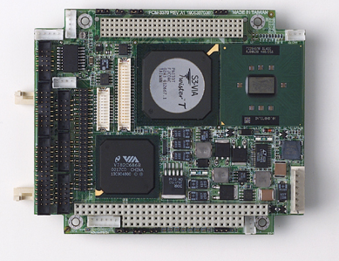
PC104 is a brand new technology designed specifically for embedded systems. The architecture of these modules is very similar to that of a standard desktop computer, but the entire package fits in a single 4 x 4” PCB. The modules make use of standard PC laptop components which are both inexpensive and readily available. Additionally, they feature x86 processors, so software integration is a lot less painful than migrating to a completely foreign system.

The primary feature of the PC104 system is the system interface bus, from which the module gets its name (104 is the number of pins on the bus). The newest modules have two separate busses, PC104 and PC104+. These are electrically the same as the ISA and PCI bus respectively. We chose to use the ISA bus in our design to communicate with our own proprietary Data Acquisition board. This bus offered us plenty of bandwidth and was relatively straight forward to implement. The PCI bus didn’t offer us any distinct advantage, used many more pins, and required a much more complex implementation.
In addition to these two busses, the PC104 modules also offer many other standard PC features, such as dual RS232 ports, USB capability, onboard Ethernet, video, and keyboard. These features allowed us to simplify our design substantially and interface many components directly to the PC104 module. For example, our wireless system directly plugs into the CPU without any need for an interface chip (with the exception of a level converter). The boards we selected also feature built in Compact Flash support, which allows us to use solid state disks as hard drives in the computer.

Section 7.3 ADVANTAGES OF THE PC104 IMPLEMENTATION

Microcontrollers have been an adequate solution for our system for many years. However, the use of PC104 modules offers us many advantages over a microcontroller based system. Perhaps the most obvious advantage is raw processing power. With the added complexity of onboard AI and sophisticated control and trajectory generation, we would have required more microcontrollers than we have room for on our circuit board to achieve the same level of performance as one single PC104 module. As a naïve comparison, one microcontroller has the ability to operate at 24Mhz (Motorola HCS12), while our PC104 module’s main CPU operates at 400Mhz. The simplest way by far to gain the advantages of onboard AI is through the use of PC104 technology.

Besides the long term goal of full autonomy, an onboard AI will significantly enhance our system’s apparent latency. There is almost no time from when the AI loop calls a command to when the command is actually executed. This makes sophisticated moves such as passing and one-timers possible. And with the added processing power, we have the capability to execute much more sophisticated control algorithms at much higher frequency. Although the system is running currently at only 300Hz, the load on the total processor from this loop is just under six percent. Speeds of up to 900Hz should be able to be achieved with little change to the underlying code. An overall faster control loop will give us more precision in movement and in ball handling.

The PC104 implementation requires an underlying operating system in order to execute control and AI code. In our case, we elected to use the toolset provided by Microsoft, under the name WindowsCE.net (version 4.2) . This package offers the familiarity of a Windows based system with the added advantages of real time interrupts and enhanced reliability. We are able to pick and choose the components of the operating system that we will use, and then recompile the entire OS for our own use. This package is discussed in more detail later in this document, with programming guides found in Appendix X. JOE ADD APPENDIX LOCATION!

In general, PC104 technology is very modular in that it has many plug-in modules that are available from various manufacturers. The form factor allows for these modules to be “stacked” on top of one another with up to 5 (or more) devices in one stack. Our final implementation did not require any other modules besides out DA board, however, the capability still exists for future expansion.

The main disadvantage of the PC104 implementation is that the PC104 CPU module itself lacks digital and analog IO ports. This means that we could not directly create any PWM signals or read any digital or analog values, both of which would be common features on almost any microcontroller. This forced us to create our own custom device through the use of an FPGA.

Section 7.4 THE TASKS OF THE PC104 MODULE
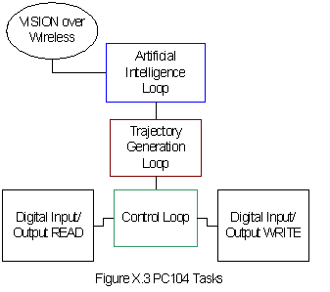
The PC104’s first task is to run the Artificial Intelligence Loop which generates new desired positions based on feedback from Global Vision as well as commands whether to kick or dribble. These values are updated at 60Hz.

After the AI runs, these positions are transformed into velocities by the trajectory generation loop. This loop runs synchronously with the AI, and occupies a majority of the processor on the PC104 as it tries to find the best path from A to B while avoiding any obstacles.

The next block is the Control Loop. The velocities from the trajectory generation loop are recalculated in the robot’s frame of reference, and then each wheel’s velocity is calculated based on information from the onboard sensors and commands from trajectory generation. This loop operates in “real time”, meaning a thread is fired at a precise 300Hz interval via an interrupt on the FPGA. This is necessary to ensure that our control algorithm remains stable.

When sensors need to be read or motors speeds need to be written, the PC104 must manage all the digital IO signals it sends and receives from the FPGA. All these functions have been neatly compacted into a C++ class called DIO (see Appendix X) JOE ADD THIS TOO!. This way, the code addressing these sensors need not worry about their specific interface. For example, to grab the reading of the encoder on motor 2, one would call the function ReadEncoder(2), which would return a signed number of counts elapsed since the last call of that motor. This approach keeps control code readable and makes the source code easier to debug overall.

Section 7.5 THE DESIGN OF THE PC104 SYSTEM
5.5.1 Hardware

The structure of the 2004 system is largely based off the 2003 PC104 prototype. This older prototype ran on a stripped down version of the 2002 robot with rudimentary control and no AI. After running many simulated tests with CS, a version of AI was ported onto the PC104 prototype robot. However, that CPU module was reaching levels of over 80% peak CPU usage and did not have much room left for improvement. Additionally, it was built on much older architecture that lacked the features of the newer boards and consumed almost the same power. For example, the PCI bus (PC104+) would not run cards at 3.3V (the latest PCI cards run at this reduced voltage, older cards would run at 5v). It was determined for this and a number of other reasons that these modules were not an option for the new 2004 robot.

After making several contacts and talking with several product engineers, three basic PC104 modules appeared to be acceptable for our use. All were based on the Pentium III/Celeron architecture, but each had specific advantages and disadvantages illustrated in the chart below. We eventually chose the Advantech PCM3370 module due to its straightforward design and low cost.

PC104 Module | Speed | Dimensions | Other Notes | Price
Versalogic Jaguar | 350Mhz Celeron-  850Mhz PIII | 3.95” x 3.8” | 2 boards high | $1100 (Celeron)
Ampro CoreModule 600 | 400Mhz Celeron | 3.6”x3.8” | Not available till January | $~500
Advantech PCM3370 | 400Mhz Celeron-  650Mhz PIII | 4.1”x4.3” (approx) | Requires+12V | $375 (Celeron)

Once the selection of the CPU was established, the supporting hardware needed to be designed. As noted in the table above, the 3370 Module requires a +12V supply. However, our digital power circuit had only +5V to supply. To solve this problem, a micro-sized DC/DC converter was implemented. The chip’s original design was for a small power supply in Compact Flash media readers (Max1771), but it provided just enough current for our unit to operate reliably. Additionally, we required two RS232 ports on the 3370 Module. However, these ports were native 12V/-12V volts, much like the ports found on regular desktop computer. A MAX232 chip was used to convert the logic to TTL level for the RX/TX modules, while a MAX3232 chip was used to convert the logic down to 3.3VTTL for the Bluetooth module. Other than these two issues, the implementation of the PC104 module from a hardware perspective was relatively straightforward.

Section 7.5.2 FPGA Interface

As mentioned before, the PC104 lacks the ability to interface directly with our digital and analog circuitry. Therefore, we needed to implement an interface on our FPGA to allow us to communicate between the PC104 and rest of our circuitry. Many of the functions that were previously the responsibility of the microcontroller could be emulated by use the FPGA. For example, the PWM frequency value would be set by the PC104 module, but the actual PWM signal would be generated by the FPGA. The best way for us to establish a link between the FPGA and PC104 was over the PC104 bus, which is electrically the same as the ISA bus (IEEE spec P996) described below.

The ISA bus was originally designed by IBM for use in full size computers and was popular around the same time as the early Pentium I. However, the specification was never fully implemented by the IEEE, so timings and signal definitions vary slightly from manufacturer to manufacturer. This made for a nightmare for implementing certain advanced features such as DMA and bus mastering (our board doesn’t use either of these features).

In general, the ISA bus consists of two main registers, address and data, and is governed by the signals AddressEnable, IOWrite, IORead, and IO16Bit . The address register is 10 bits wide, while the data register is 16 bits wide. In general, the PC104 CPU controls the bus, and the FPGA can only responds to the PC104’s commands. In this respect, please note that in this section, read and write is relative to the PC104, not the FPGA.

The first thing to happen on the PC104 bus is that AddressEnable will go low. This indicates to the FPGA that the PC104 will be reading or writing soon. As soon as the AddressEnable signal goes low, the FPGA must read the values of the Address Register and simultaneously pull IO16Bit low to indicate that it is capable of 16 Bit I/O operations. The upper six bits of the address register determine the “address space”. If the address space that the FPGA gets is the same as what the FPGA is set to (in our case 0x300), the FPGA will get ready for either a read or a write operation. The lower 3 bits of the address register determine the internal register, which are defined within the rest of the FPGA code. Each internal register determines a different function within the FPGA.

The two signals IOWRite and IORead determine whether this is read or write operation (both are active low). If it is a Write operation, the PC104 will pull the IOWrite signal low. On the falling edge of this signal, the FPGA will latch the value on the data bus and then send that value to its main loop. If this is a read operation, the PC104 pulls the IORead signal low, and while this signal is low, the FPGA will output the desired value onto the bus, which is then read by the PC104. This process is diagramed in the timing chart below:

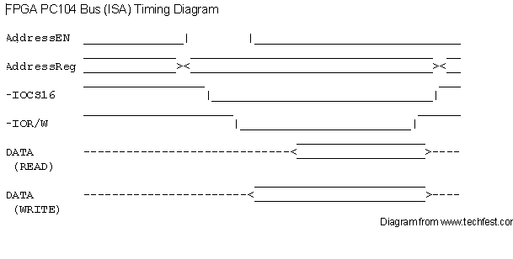
Additionally, the IRQ Pin is used to generate the real time interrupt to run the control loop. Although this has no affect on the data I/O just mentioned, we rely on this signal from the FPGA so there is a 300Hz clock between control loop signals.

Section 7.5.2 The DIO Class

The design of the DIO class is set up to encapsulate the read and writes to the PC104 bus into one common class. This way, other functions that need to access sensor information through the bus do not have to worry about addressing the correct sensor. Instead every sensor is simply addressed by name.

It is important to note that this class is only accessed by Local Control. For instance, if another thread attempted to read an encoder value for one of the motors, it would inadvertently clear the value after reading it (a feature designed into the DIO class), and then invalidate the value for the control loop. This can have catastrophic effects on control, and must be avoided.

A listing of functions is as follows:
void PWM(int motorNum, int value);
void DIR(int motorNum, bool forward);
void KickType (bool chip);
void Kick(int duration);
void StopHDrib();
void SevenSeg(int value);
int ReadCounter(int motorNum);
int ReadDIP();
int ReadIR();
int ReadBatt();
int ReadGyro();
int ReadAccelX();
int ReadAccelY();

These functions are mostly self explanatory. PWM sets the PWM (0 to 255) to any motor, DIR set the direction of any motor, where TRUE is forward. Motor 0 is the dribbler, and Motors 1 through 4 are the brushless drive motors. Kicktype should generally be set before calling the kick function. The kick function automatically sets the kick flag high and at the strength specified (0 to 255). StopHDrib is used to BRAKE the dribbler motor. SevenSeg outputs the specified value to the seven segment display.

The read functions work similarly. It is important to note that the ReadCounter function will automatically clear the count register on the FPGA. This means that once the value is read, the value in the FPGA is reset to 0. ReadDIP returns the value of the DIP switch in decimal (0 to 15), and the other function (ReadBatt, ReadGyro, ReadAccelX, ReadAccelY) return values from 0 to 255 based on the sensors input.

Section 7.6: THE SOFTWARE ENVIROMENT
The 2004 PC104 System runs on Microsoft Windows CE.net 4.2. Before going into the details of this operating system, a few basic concepts should be understood. **It is recommended that Appendix X is reviewed before continuing as it is serves as a step-by-step guide of how to program and develop on the PC104 platform. The following is a description, not a guide.**

The “Operating System” is the entire software package running on the robot, including the AI. WindowsCE.net has many two main programs within its toolset designed to develop this operating system. The first is Platform Builder, which the lower levels of the operating system are written in. The second is Embedded Visual C++, which is what all the control, AI and trajectory generation are written in.

There are also three levels of code which run on the robot. The base level is called the Board Support Package (BSP). This is a collection of hardware and software support definitions that are created in Platform Builder. This is where we specify which drivers our board (the Advantech PCM3370) needs, and what features of the operating system we plan to implement. The 2004 BSP is entitled RobocupPC104 and contains almost the identical package to the template BSP, CEPC, with a small modification to the serial port. It is important to note that the serial port is “hijacked” by WindowsCE when using the CEPC BSP, so when creating the new BSP, we freed the serial port so that it can be used for RX/TX or Bluetooth.

Once the BSP is established, the next layer we created is the Platform. As the name suggests, platforms are created within Platform Builder as well. Platforms take the BSP that was created and identify which components from the BSP to include in the final Operating System. For our purposes, we only have one Platform with our BSP, but in theory many platforms can be based off the same common BSP. Once the appropriate items were added to the Platform, we then added a project to the Platform.

This project acts much like a bootloader on a typical microcontroller. When the operating system is started, the project starts automatically (with a slight modification to the registry), and waits for a request over Bluetooth to download a new version of the AI. This project is defined and compiled in Platform Builder. These components make up the lower level of the Operating System. Once all these components are established, the Operating System is compiled within Platform Builder. This process can take as long as 20 minutes (depending on features and the CPU).

After the compilation process, Platform Builder creates an “image” of the Operating System. This is a single file entitled NK.BIN, which can be found in the X86Rel or X86Deb directories (depending on which type of image is built). The image is then downloaded onto a Compact Flash disk, which can be put in PC104 CPU for execution. The robot will load the Operating System and wait for a request to download the AI.

When the image creation process is complete, the next step is to create an SDK for Embedded Visual C++. This allows the EVC++ environment to recognize the Platform for which we are developing. The AI, control loop, and trajectory generation are developed in Embedded Visual C++. When compiled, we will get an executable that is designed to run on our operating system. Please note that although the output file is an EXE, it will not run in Windows NT/2000/XP. When developing the AI, control loop, and trajectory generation, it is not necrssary to recompile the entire operating system. Therfore debugging and debugging these components is much easier.

7.7 Conclusion
The use of the PC104 module has opened new doors to what the electrical system can accomplish. With such substantial raw processing power, more advanced tasks such as local vision and intelligent control are not so far fetched. Although our CPU module may not be the fastest of its kind, it is one of the best balances of performance, power consumption, and cost. Future teams should be able to make use of these modules as there appears to be much room for expansion.

This year has been marked by a complete overhaul of the electrical system, so there is still much work to be done in making the system more robust and reliable. The code on the PC104 and FPGA still has room for further optimization, and features for protection from accidental power failure and AI failure need to be added. By adding these failsafes, we can ensure the design of a system that is easy to maintain and friendly to use.

Section 8: Wireless Communication
8.1 Overview
In past years, the wireless communications system provided the sole function of relaying commands from the single off-board AI system to each robot. The information flow started with an overhead camera capturing live video of the field and transferring it to the Vision system. The images were then processed into digital representations of field positions for the ball, Cornell robots, and opponent robots. The resulting field positions and orientations were fed to the AI computer, which used the information to decide what each robot should do. To send commands to each robot, a one-way wireless communication system was used. This was a half-duplex system in which the AI computer was always in send mode and the robots were always in receive mode. Each robot had a unique identifier and was essentially a drone that performed commands specifically addressed to it. The resulting movements were captured by the overhead camera and fed back through the system to complete this information loop.

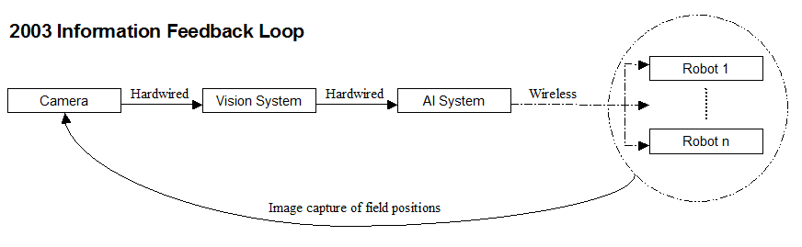

For the 2004 implementation, AI is moved onboard each robot. This creates the need for 2 separate wireless communication sub-systems:

- Vision-to-Robot Communication
- Inter-Robot Communication

The Vision-to-Robot link performs the same fundamental task as in the previous years’ Vision-to-AI link. Because Vision information is not robot-specific, the data sent over the wireless link for 2004 is a broadcast that is meant for all robots at all times.

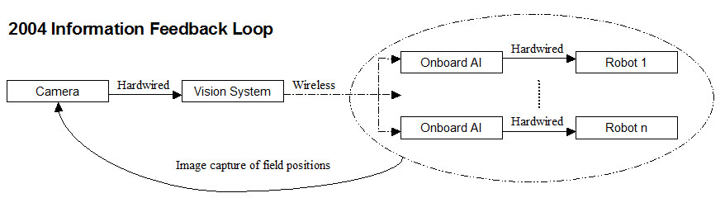

The Inter-Robot Communications subsystem is new for this year. In the past, there was only one AI system and hence, no critical need for full-duplex communication. Now that each robot has its own AI system, they function more like a real soccer team in which each player thinks autonomously and needs to communicate with the other players to coordinate movements and strategy.

8.2 Vision-to-Robot Communication
8.2.1 Performance Requirements

The requirements for the 2004 Vision-to-Robot communication link were mainly the same as those of the AI-to-Robot link in the past years. Quoting the documentation from 2003:

- High Speed
  - Speed is like the diameter of our water pipe. The wider the pipe, the higher the bandwidth. The ideal bandwidth we were looking for was 115200 bps or greater. The higher the speed, the less delay time between AI and the robots and the more flexibility in wireless packets.
    - Low Setup Time
  - The wireless receiver module needs time to “warm up” before it can produce useable data. The lower this time, the faster the system can recover if a data line were to go bad.
- Simple Serial Interface
  - Advantageous over RPC parallel interface. Serial uses much fewer pins and offers a much easier implementation with microcontroller code.
  - A 5+ V serial line would be ideal, as that is the interface on the Microcontroller side.
- Multiple Frequencies
  - As per Robocup rules, each team must have at least two operating frequencies to compete. If another team uses a frequency we are using, we must be able to change our frequency to avoid interference.

With basically identical requirements, this year’s design process started with analyzing the modules used in 2003 to determine how well they met the project needs. They are all manufactured by Radiometrix and are summarized in the following list. Each main bullet indicates a model number with sub-bullets indicating the specific variations used.

Cornell RoboCup 2003 Wireless Modules
- TX2/RX2 Transmitter/Receiver Modules
  - 433 MHz band, 160 kbps max throughput
  - 418 MHz band, 160 kbps max throughput
- TX3/RX3 Transmitter/Receiver Modules
  - 869 MHz band, 64 kbps max throughput
  - 914 MHz band, 64 kbps max throughput
- BiM2 Transceiver Modules
  - 433 MHz band, 160 kbps max throughput
- BiM3 Transceiver Modules
  - 869 MHz band, 64 kbps max throughput
  - 914 MHz band, 64 kbps max throughput

After experimenting with some spare parts from 2003 and consulting with team members from that year, it was decided that the TX/RX series would not be considered for this year’s implementation. Although they seem to possess specifications identical to the BiM modules on paper, laboratory and field testing revealed that there is a significant gap in performance. The TX/RX series are considerably less reliable and more difficult to establish a communication link with when compared to the BiM modules.

This year’s implementation uses the BiM modules listed above. There is a difference in maximum theoretical throughput between the BiM2 and BiM3 series, but they both offer more speed than required for the application and are run at 57,600 bps. The main reasoning behind this communication scheme was the goal of implementing a universal and modular system so that any frequency module could be swapped in without the need to change programming code. Although one of the requirements was high speed, it was determined that the most important performance objective for the Vision-to-Robot communication link would be low latency. It is essential that Vision data gets streamed to the onboard AI as close to real-time as possible, and this is where the BiM modules clearly outperform higher-throughput wireless technologies such as Bluetooth or 802.11a/b/g.

8.2.2. Preliminary Testing

Testing the wireless was of paramount importance. It gave us a chance to compare the modules that we had investigated into and also put a quantitative base to the decision that we had made.
The modules were tested for two things – latency and rawdata throughput . The testing was therefore done in two phases:
- Test for latency – this was done by transmitting a square wave at 35Khz and then observing the displacement in time between the sent and the received waves
- Test for Data Rate – A square wave was transmitted between the sender and the receiver and the freq. gradually increased - the freq. at which the received wave died down was noted
The results of the testing are shown below:
 | Specs | Data Rate | Latency | Conclusions
BiM-2 | 433Mhz, 50m and <20mA | 160 Kbps (on paper)  158 Kbps (Raw) | .015 ms (test sq. wave: 35Khz) | The performance is excellent with a test sq. wave – a test circuit using data transfer using a PIC was also constructed – the performance was satisfactory
BiM-3 | 914Mhz,  50m and <20mA | 64 Kbps (on paper)  58 Kbps (Raw) | .015 ms  (test sq. wave: 35Khz)
MS-9xStream | 900 Mhz  100m | 10 Kbps (on paper) (40Kbps for xCite)  9.6 Kbps(achieved) | 93 ms (10ms for xCite) | Excellent performance – rejected because of freq.

The performance of both the modules was good, as mentioned later Maxstream modules were not used because of the multiple freq. concern and also the low data rates and high latency.
At this point of time a preliminary version of a BiM circuit driven by a PIC microcontroller was developed – the performance of the circuit was satisfactory with some packet loss. The packet loss was attributed to an un-optimized RF design and code.

The other issue was electrical noise on ground, which was a major cause of packet loss in the 2003 design. The team decided to isolate the analog power and the digital power ground planes in the main DA board design to tackle the problem.

Some testing was also done by running the robot with all the motors on close to the receiver circuit and noting packet loss. There was heavy packet loss observed when the robot was run close to the receiver antenna. This test was inconclusive, again because of an un-optimal circuit.
The second series of testing was done on the BBA519 and the BBA332 amplifiers. Although there was no apparent difference in the performance, the electrical team decided to use the BBA519 because of a higher noise figure and proven capability as it was used last year.

8.2.3 Design Considerations

The BiM module’s receiver circuitry features an adaptive data slicer with a 2ms averaging time constant. It continuously examines the number of signal level transitions on the data coming in from the antenna and determines the appropriate baud rate for its digital output. To keep this data slicing rate as accurate and consistent as possible, two considerations must be taken into account. First, the data must contain a balanced number of 1’s and 0’s. The number of level transitions seen over any period of time will then be kept at a fairly consistent value. Second, there must never be an idle period where no data is being received. The data slicer would then adapt to its lowest baud rate and could take up to 2ms before rectifying itself to the appropriate baud rate once data is present again. There would be unnecessary loss of data after every idle period on the wireless channel.

It was determined that a PIC microcontroller (PIC16F876A) would be implemented on the transmitter and receiver ends to aid in packetizing and decoding data in addition to keeping the wireless channel alive by sending dummy bytes. The Vision computer generates a digital interpretation of field positions that is 41 bytes long. To maintain a balanced number of 1’s and 0’s in the data being transmitted, a Manchester-encoding algorithm is employed. This process involves a bit-wise operation that translates every ‘0’ into ‘01’ and every ‘1’ into ‘10’. An example is shown below:

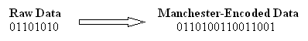

After encoding, the amount of data to be sent over the wireless link is effectively doubled. Some preamble bytes are appended to the beginning of the Manchester-encoded data packet before it leaves the Vision computer so that each stage in the data path can properly synchronize on the start of the packet. The total number of bytes per packet going from the Vision system to the wireless transmitter board becomes 90. The PIC on the transmitter board synchronizes on the first two bytes and sends out the remaining 88 bytes over the wireless link. The PICs onboard each robot synchronize on the first two bytes of non-dummy data that they receive and Manchester-decode the next 86 bytes into 43 bytes of raw data. This data is sent to the PC104 on the fly as each byte is decoded. The PC104 synchronizes on the first two bytes it receives and uses the subsequent 41 bytes of Vision data. The receiving PIC also performs error checking on the data. If any of the 86 bytes fail to Manchester-decode properly, then the byte 0x30 is appended to the end of the packet going to the PC104. If there are no errors, then the byte 0x31 is appended.

8.2.4 Usability Considerations

In order to monitor the Vision-to-Robot communication link, a system of status LEDs is employed on both the transmitter and receiver boards. The following tables summarize the color and meaning of each LED.

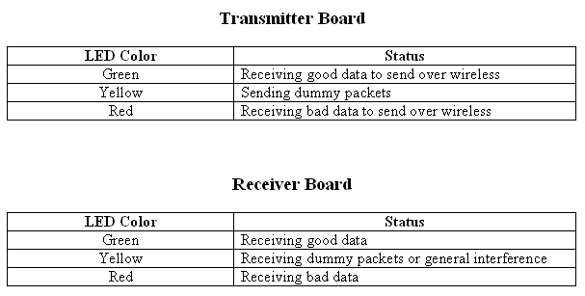

One of the usability goals for this year’s wireless system was to achieve good performance while using less transmitting equipment than last year’s implementation. The most prevalent characteristic of the 2003 wireless system was the use of a Yagi-style high-performance directional gain antenna for the 433 MHz frequency and a corner-style high-performance directional gain antenna for the 869 MHz and 914 MHz frequencies. While they did contribute to the overall performance, the team decided that a well-designed wireless system should be able to function with normal omni-directional ¼ wave whip antennas.

This year’s transmitter board implements high-power signal amplifiers (BBA-519) manufactured by Linx Technologies to boost the signal strength coming out of the BiM transmitter modules before being sent through the antennae. The same amplifier modules were used in the 2003 implementation. A series of tests were conducted that determined no difference in performance between the two transmitter boards if both of them were to use identical antennas. At any given distance from either transmitter, a receiver board obtained the same percentage of good packets in relation to the total number of packets sent. At a radius of approximately three field lengths, there was no packet loss associated with either board while using reduced-height helical antennas on the transmitter end.

One final test was conducted to determine the latency associated with this system. For the purposes of this project, latency is defined from the time the first bit of a packet leaves the Vision computer until the last bit of the decoded packet is received by the PC104. The latency was determined to always be less than 15ms, which is within the guidelines set for this system. The following conceptual diagram presents an overview of the Vision-to-Robot wireless communication system.

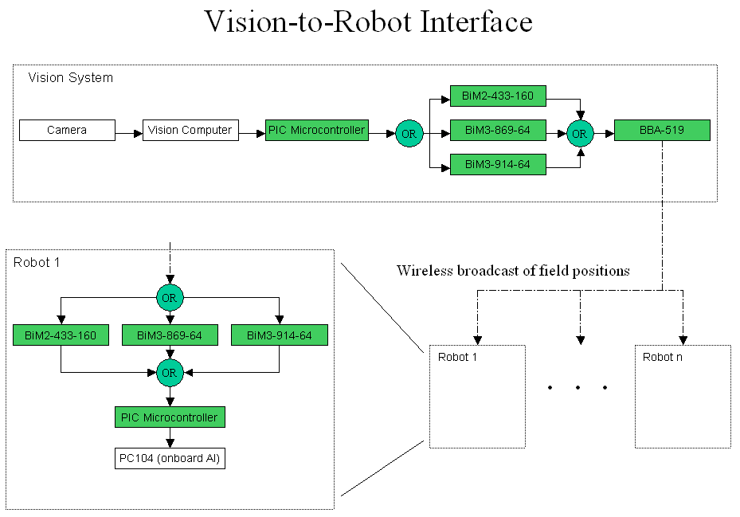

8.3 Inter-Robot Communication

8.3.1 Experimental Section

The requirements for the Inter-Robot Communications subsystem were as follows:

- Individually addressable robots
- Transmitting and receiving capability for all robots
- Reliable data transfer
- Multiple frequencies
- High resistance to interference

A number of solutions were researched thoroughly. Among these are Bluetooth, 802.11a, 802.11b, and 802.11g. A comparison chart of the basic performance measurements for each standard is shown below:

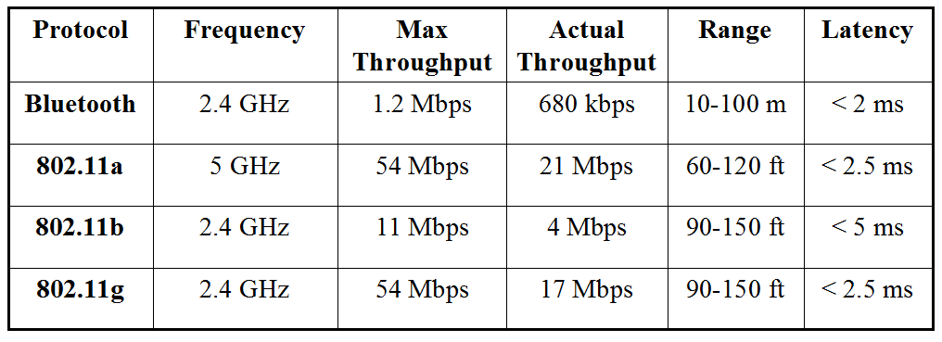

The actual modules that were researched in each category are:
- Bluetooth
  - BlueWAVE RS232 DCE
- 802.11b/g
  - Broadcom BCM 4306 chipset (www.broadcom.com)
- 802.11a/b/g
  - Atheros AR5002X chipset (www.atheros.com)

Each of the chipsets is considered among the best in their categories while also having an acceptable interface and a way to use them in a Windows CE.NET environment. The Bluetooth module uses an RS232 interface that would let it communicate with the PC104 board without taking up too much space. The Broadcom and Atheros chipsets are available in mini-PCI interfaces, which are the smallest packages available for wireless LAN modules. They also have drivers for operation in a Windows CE.NET environment.

The next concern was interference on the 2.4 GHz radio band. It is obviously the most widely used band, being employed by Bluetooth, 802.11b, and 802.11g. In addition, it is susceptible to interference from cordless phones operating on that frequency, wireless cameras, and microwave ovens. It became apparent that our implementation must use a card capable of 802.11a/b/g. This would allow the use of both 2.4 GHz and 5 GHz bands while satisfying all of the other requirements with the inherent benefits that come with setting up a local area TCP/IP network among the robots.

The specific card that was settled upon is the Netgate 5354 ARIES MP available at www.netgate.com. The key attractive features of this card are:

- Mini-PCI interface
- 802.11a, 802.11b, 802.11g capability
- Based on the second-generation Atheros 802.11a chipset (5002X)
- Existence of Windows CE.NET drivers

The 802.11a protocol is not as widely used as other WLAN protocols, so there are not as many options or support outside of the mainstream Windows 98,NT,XP environment. This is where the Atheros 5002X chipset shines. First of all, it is actually considered the best for 802.11a communications. A short quote from Tom’s Hardware:

One of the best kept secrets of the WLAN world, however, seems to be the significantly improved performance of Atheros' second-generation 802.11a designs. I recently stumbled across this discovery while testing NETGEAR's Atheros-based WAG511 dual-band, tri-mode CardBus card [reviewed here], and was so pleasantly surprised that I felt that it deserved an NTK of its own.
(http://www20.tomshardware.com/network/20030506/index.html)

Upon establishing that the card would be excellent for the project needs, the next step was to locate Windows CE.NET drivers for it. According to a press release on the Internet, the drivers do in fact exist:

Vytek, a Microsoft Windows Embedded Partner Gold-level member, today announced the availability of a Microsoft Windows CE .NET 802.11a/b/g driver for stations/clients. The Vytek Windows CE .NET driver is designed to work with Atheros Communications’ 802.11 chipsets including the latest generation that provides 802.11a, 802.11a turbo mode, 802.11b, 802.11g, 802.11h, and 802.11i capabilities.
(http://www.stellcom.com/about/press_releases/pr_rel_2003_04_22_windows.htm)

They were created by a company called Stellcom, now owned by Vytek Corporation (www.vytek.com) in California. Upon requesting additional information on the drivers, an initial contact person was established within Vytek. The drivers usually cost $25,000 to businesses for commercial applications, which necessitated going through many additional people and signing legal documents. After a few months, the drivers were obtained at no cost. A significant effort was attempted at incorporating the drivers into the CE.NET platform on the PC104. Although progress was made in this area, there were also many problems that continued to prevent successful integration. Eventually, work had to be stopped at the risk of spending too much time on it and ending up with nothing at the end of the year. A contingency plan involving Bluetooth was then pursued and successfully carried out.

The Netgate 802.11a/b/g cards would have interfaced with the PC104 board through the mini-PCI add-on module. Each robot would have a unique ID that the Linksys WAP54A 802.11a/b access point could use in assigning it with a static IP address. There would also be a packet analyzer computer called the “Arbiter” connected to the network. Any time a robot sent communications to another robot on the network, it would have also sent a copy to the Arbiter. The CS team could then have used this computer to track what the robots were doing. A conceptual overview of the planned system is presented in the following diagram.

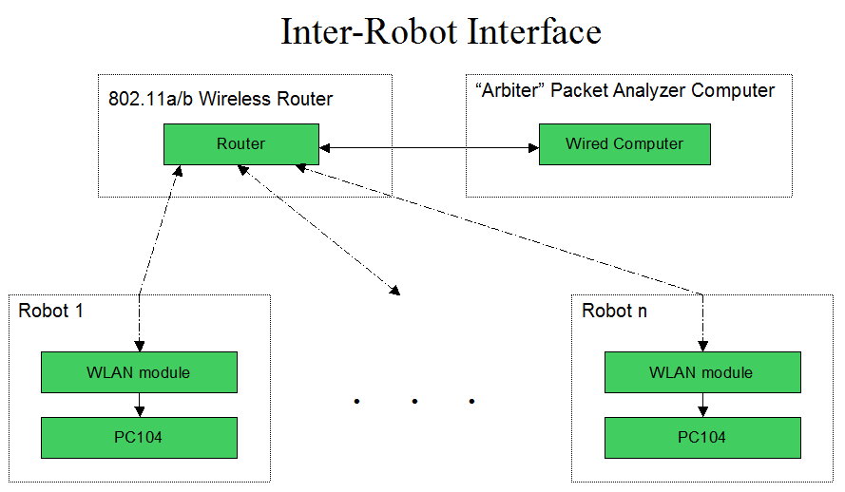

8.3.2 Bluetooth
The PC104 Platform developed in 2004 features various modifications to allow for programming and debugging over a wireless Bluetooth network. Using RS232 compliant Bluetooth modules, each robot can be connected to from a desktop computer running a USB Bluetooth dongle. Once connected, a robot can be reprogrammed with a new AI, or can be monitored for debugging purposes.

The Bluetooth modules work much like a serial cable replacement. On the robot, a COM port is dedicated to the Bluetooth module. On the desktop client side, each robot is assigned a predefined COM port, and when data is written to that specified COM port, it is routed to that robot. When not in debug mode, the robots use this scheme to communicate with one another. The arbiter computer relays messages from one robot to the next using a predefined messaging protocol.

Programming the robots over Bluetooth can be accomplished one of two ways. When running the HUB (part of the Arbiter), the AI can be stopped and then reprogrammed using the graphical interface provided by CS. The other method uses a simple DOS based program that does not require the entire HUB to be loaded. This should only be used for debugging purposes, and will eventually be made into a more friendly graphical program.

The managing of the serial ports on the Client computer is handled entirely by the driver of the Bluetooth dongle. It is possible that if a robot is terminated before it can be properly shut down that this driver will not recognize a connection is broken (or that a connection cannot be established). It is very important to check that the icon in the system tray actually turns green when attempting to connect over Bluetooth. If it remains white, the connection could not be established properly. Procedure is generally to reset the robot and then unplug and replug the USB dongle.

8.4 Alternative Modules – The Maxstream Xstream and the Xcite range of modules
There were several alternatives that were looked into – Alba, TI etc.
Perhaps the most interesting was the Maxstream range of addressable modules. These modules operate in the 900MHz and the 2.4GHz range and they have an incredible range of 200+m with high gain applications.
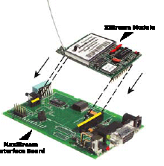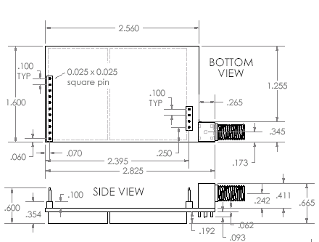

Perhaps the biggest benefit of Maxstream was the fact that the module was extremely simple to use and had a small footprint. The Electrical team acquired a development kit to carry out testing of the module at a discounted price.
The development kit came with interface board kits – these interface boards did the level conversion and also had an onboard microcontroller that could be programmed using an application downloadable from the Maxstream site called XCTU.
The XCTU could be used to set the data rates of the modules the directions and other parameters that governed the communication between two modules. (Configuration without the XCTU is possible using AT commands. A detailed list of all the AT commands is available in the application manual available on the www.maxstream.net).
An application circuit of the Maxstream is as shown:

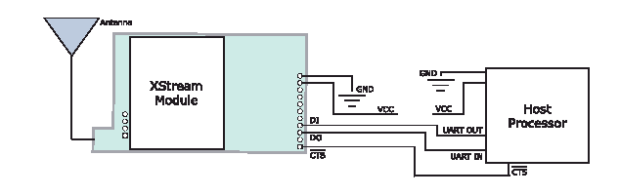

The Host processor as mentioned before was available on the interface board and was completely configurable. After the processor configured – data communication was seamless. The team was successful in transmitting files and data from one corner of the lab to the other with no apparent packet loss.

Further application testing needed to be done – the DI and the DO pins were scoped in the transmitter and the receiver and latency testing was done.
The results of the test were :
Latency with (19.2 Kbaud):  Full Multiplex  Broadcast with parameters tweaked | 117ms  90ms

The latency was obviously a cause of concern for the team. A telephonic conversation with an application engineer in the company revealed that the modules that we were using were slower and we could get the latency down to about 17ms if we switched to the X-cite range of modules in a broadcast mode.

The team however decided to discontinue the use of Maxstreams for a number of reasons:
- High Latency
- Low Data rates
- 2 frequencies as compared to the 3 frequencies of the BiMs
- BiMs worked well for the 2002-2003 team

Although the Maxstreams were not used they are very good and easy to use modules and are completely addressable. They could be used for some application requiring low latency of operation and low data rates. If any other team is reading this documentation we encourage the testing of these modules and seeing if they come in more frequencies.

8.5 The Daughter Board and the DA Board Wireless circuits
The daughter boards design of this year was completely driven by the design from 2002-2003. This was done to utilize the modules from 2003, giving the team a cost benefit. The circuit was however re-made, reducing the size of the RF trace, optimizing its performance. The boards have been designed keeping future compatibility in mind, a feature of the daughter boards this year is that the transmit select and the receive select lines are not tied to any of the planes, this gives a possibility of software driven configuration of the modules and full duplex communication in the future if the team designers desire. The schematic for the daughter board module is:
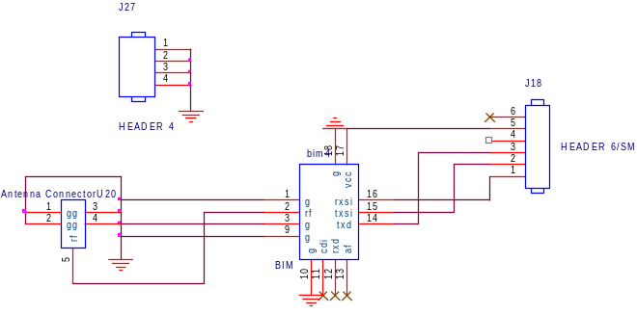

The same board is used for all the BiM modules, the daughter boards have to be physically replaced in all the robots if the user wishes to change the frequency if operation.
The schematic of the circuit on the DA-Board is shown below.
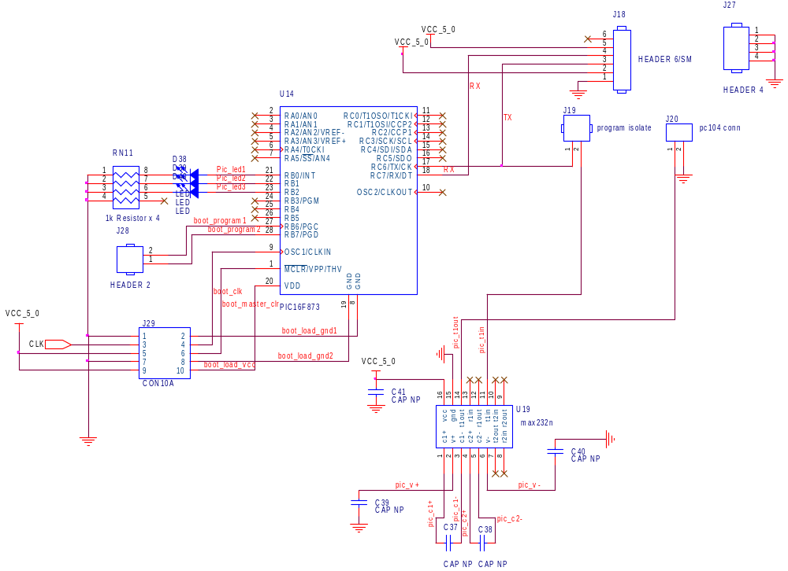

The parts of the circuit with the respective applications are described below:
- PIC 16f876a microcontroller – relays the data after de-manchestering to the PC104
- MAX232 – converts the levels for PC104, needs 5 1uF capacitors
- R-pack and LEDs – serve to indicate the status of the packets
- Jumper J-19 – programming jumper (to stay on for normal operation, to be removed for programming)
- Connector J-20 - communicates data to the PC104
- Header 6 and Header 4 – Female inline, for the wireless module
- Header 2 and 5 pin dual header – boot-loader deployment (please refer to the boot-loader section, all headers to stay on for normal operation and to be removed while boot-loader deployment)

The circuit is designed to be extremely flexible – with inline programming and boot-loader deployment facilities.

Application Notes:
- Please make sure that all the jumpers are in place before the robot is switched on. To deploy boot-loader and program the chip in line please refer to the respective sections and documentation.
- The MAX232 is rated for 1uF capacitors. The capacitors used on the board, however are .1uF, this makes no functional difference, but doesn’t meet the data sheet specs – any person designing the MAX232 is advised to design in 1uF capacitors.
- The daughter board needs a ground plane for optimal performance. The best way to design a daughter board is to design it with two layers – one for routing and the other one serving as a ground plane, this keeps the design optimal and the cost low. The 2004 team made the mistake of designing a 4 layer daughter board which was later corrected.

8.6 Transmitter Board

The TX board is just a slightly elaborate application of the BiM circuitry. The TX board is a four layer design. The TX board is designed to hook up to the serial port of the computer broadcasting data. The TX board receives data packets from the computer corresponding to the wireless packet structure (see the respective section for more details) and broadcasts it to all the robots. The board has inline programming facilities and also status Leds for better usability. The TX board will maintain sync by transmitting dummy packets if there is no data available at the serial buffer. The schematic of the TX board is shown in the figure below.

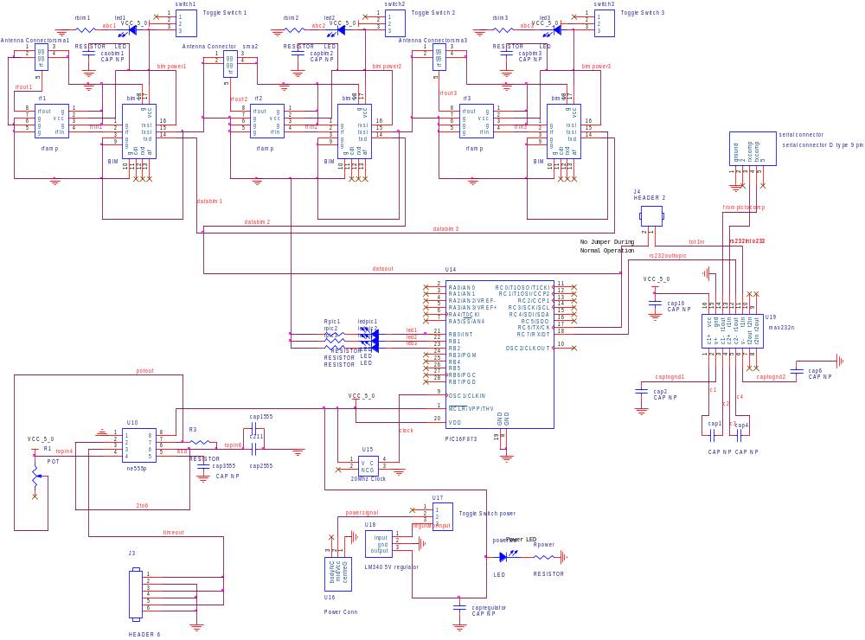
The components of the TX board with the operations are given below:
- PIC 16f876a microcontroller – relays the data packets to the BiM – if there is no data available sends out a dummy packet to maintain sync
- Standard 4 pin 20 MHz clock
- MAX232 – converts the levels for PC104, needs 5 1uF capacitors
- A serial port that interfaces to a computer
- Programming Header (header 2) - gives inline programming facilities – to replaced while normal operation, used only when programming
- LEDs and Resistors – 3 connected to PIC for diagnostics, one for power and one for each of the three BiMs
- 3 BiMs – 433/869/914 MHz for RF transmission
- 3 BBA 519s – for RF amplification
- LM340 5V regulator – for regulated voltage
- Switches to power the board and the BiMs
- Random Capacitors – to maintain a ripple free 5V level for optimal performance
- Vision Circuitry – please refer to the vision documentation

The Correct way to use the TX-Board:
- The board is powered by a wall mounted adaptor and can take any voltage from 7-15 V make sure of the polarity of the power connector – reversed could kill the 5V regulator
- Power all the BiMs off and then power the board on – make sure that there is no vision data being streamed at the time of power up – make sure that the jumper is dislodged from its position
- Power on the BiM once the PIC is powered up – DO NOT POWER UP MORE THAN ONE BIM AT A TIME – it could damage the LM340
- Turn on vision data to communicate – watch the yellow blinking LED to make sure that the data is being streamed
- Kill the Power to PIC before you turn off the board

There were several issues of user interfaces that came to the fore front. The designer of the board must remember that the board will probably be used by a non EE. When originally designed the board used Jumpers to switch data lines. This was unacceptable since BiMs were still powered on. The board design was changed with the power lines switched. Another issue is a wireless monitor on board – although there is no wireless monitor right now any designer should plan to include one where a daughter board or module can be plugged in and status seen on hyperterm or other software. Its critical that there are LEDs to indicate everything. This was another thing missing from the preliminary design, its very important for the user to get feedback from the design and it’s the designers responsibility to design in as many features as possible.

Application Notes:
OrCAD layout outputs a very bad design if auto-routed. Most of the ground traces are in the open defeating the purpose of investing in a four layer board. The designer must go through the traces and eliminate the unwanted traces, making sure that through holes are connected to the ground planes.

The BBA amplifier even though simple to use comes in a SMD package with the pads for soldering underneath the chip. The chip is also mechanically fragile and sensitive to overheating. All these factors make the chip hard to solder. To solder the chip touch both the PCB pad and the module castellation, running down the side of the chip with a fine soldering tip. Tack one module corner first, then work around the remaining attachment points, using care not to touch the soldering iron for too long. The best way to solder is to touch the iron on the castellation of the chip with a lot of flux and letting the flux wick the solder underneath the chip.

8.7 Wireless Monitoring
Because we had no arrangements on the wireless tx boards we had no make an independent wireless monitor.
The schematic of the wireless monitor is as shown:
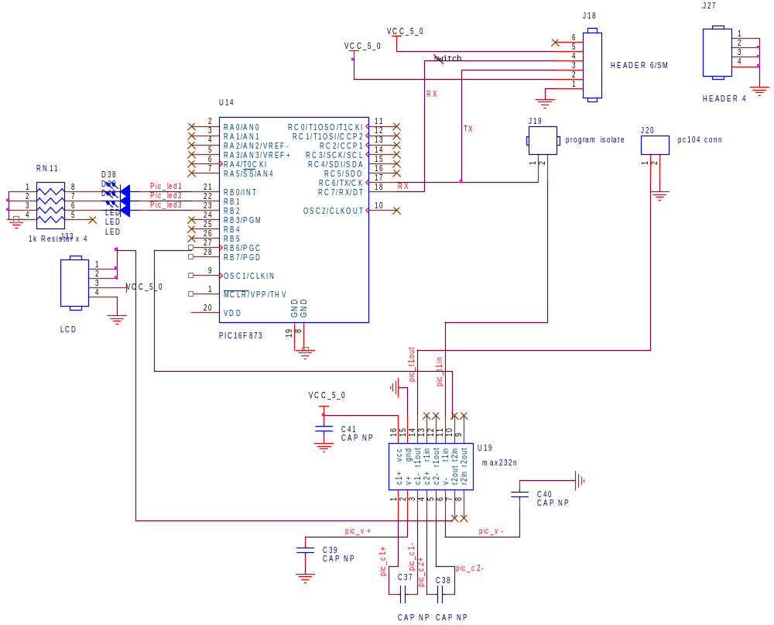

The components of the circuit are as shown:
- PIC 16f876a microcontroller – relays the data after de-manchestering to the PC104
- MAX232 – converts the levels for PC104, needs 5 1uF capacitors
- R-pack and LEDs – serve to indicate the status of the packets
- Jumper J-19 – programming jumper (to stay on for normal operation, to be removed for programming)
- Serial port for communication to the computer
- Header 6 and Header 4 – Female inline, for the wireless module
- LCD display for remote monitoring

The LCD used here is the matrix orbital mini:

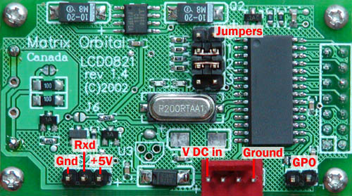
The only connections we will be using are the RS232 in Vcc and ground. Make sure that the jumper settings are as shown in the picture above for a baud rate of 19.2Kbps. To use the LCD we configured multiple serial ports on the PIC – the PIC then outputted using the latest declaration of the serial port. The LCD takes in RS232 data directly and reflects the input data on the screen. Its very straight forward and easy to use. To get information on clearing the screen and changing the baud rates please go to www.matrixorbital.com.
The code for the monitor is a modified version of the rx code where instead of outputting the data we keep track of all the good packets and bad packets and we just calculate the percentage of good and bad packets and display it on the screen.
The correct way to use the monitor:
- Make sure that the communication switch is off before powering up the monitor
- Put the Wireless daughter board in the circuit using the headers available for it
- Power on the monitor and wait for it to say “No wireless found, Please chek”
- On seeing this message turn on the communication line and wait for “Wireless found” message
- Wait for about 3-5 seconds and the test results will be displayed on the screen
- Turn off the communication switch
- Turn off the power switch
- Replace the Daughter Board
To save cost, the entire board was soldered on a perforated board and no PCB was fabricated.

Application Note:
The LCD can be configured to take in 5V signals. Designers are discouraged to do this since the MAX232 has two TTL input pins and the MAX can be used to convert the voltage level to 12V. Don’t make permanent changes to the LCD if you can work around it. Another important point is to configure the jumpers and note the baud rate. If any other baud rate is used the LCD will display junk. Designers are also advised to have inline programming facilities and a detailed monitoring mode that can be observed through hyperterm.

Overview
Section 9: Batteries
9.1 Overview
The idea behind the search for the batteries to be used in the 2004 robots was primarily driven by the decision to use brushless motors, which can draw approximately 20A in bursts over the robot’s run time. Since the robots will be accelerating quickly and frequently, the battery must be quite robust and should be able to simultaneously maintain fairly regular voltage supply as well as provide ample current for this kind of mobility. Other components on board the robots, such as the digital circuitry or the type of processor to be used, dribbling ability, vertical belt for the goalie, local vision, etc., are also of importance.

Other concerns included the sizes and the weights of the batteries, as used in packs containing enough cells to power each robot, and the amount of money that will have to be spent on each robot for batteries alone.

9.2 Introduction
The basic idea is to be able to supply a practically constant source of power for the robots while at the same voltage that the robot requires. Since current is proportional to the power, for constant voltage, higher power calls for higher current and capacity.

Each robot should be able to last at least 10 minutes (half-time). However, it is much safer and a more professional approach to design around a minimum runtime of a full game of 20 minutes. This creates the ideal condition where a battery can last for 20 minutes at a constant current drain capacity of 20 A! This would mean finding a battery, or combinations of cells thereof, that effectively exhibit 60000mAh. Obviously, the solution would consist of a pack of batteries connected together in series, for increased voltage, and in parallel, for increased current.

The concept of higher capacity also introduces the concept of a proportional weight. If last years batteries were to be used again, being assembled in even higher quantities per robot, the resulting weight would be too great for the robot to take full advantage of its available power. Thus, the batteries should be light and still provide enough current.

There has also been a concern regarding the amount of available space on each robot, due to an increased number of mechanical and electrical components. Hence, the number of batteries should be reasonable as well.

9.3 Finding the Right Battery
The batteries used on the 2003 robots were of the NiMH chemistry. They weigh about 700-800 grams per pack. Each robot from last year uses two packs of six cells each, giving it a total of 12 cells.

The first reason that these batteries were chosen last year was internal resistance. The documentation shows that the idea of LiIon cells was almost immediately eliminated considering the high internal resistance of the cells. This left the primary chemistry choices to be NiMH and NiCd. Second, last year’s choice was based around the sizes and voltage characteristics of the 2002 batteries. The drain curve for the final 2003 choice is as follows:
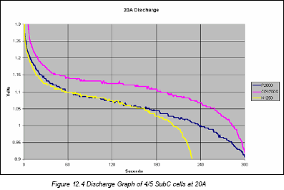

This year, after doing some research on various types of batteries, the choices, along with some initial considerations are as follows:
Type | Voltage/cell | Capacity (available) | Cyles | Weight/cell | ~Cost/cell | Weight/robot | ~Cost/robot
Zinc Carbon | 1.5 V |  |  | 9g-99g
Lithium Polymer | 3.7 V | 300-8000 mAh | 500 | 25 g | $15 | 300g | $150-500
Nickel Metal-Hydride | 1.2 V | 550-7000 mAh | 500 | 8g-160g | $4 | 800g | $50-250
Nickel Cadmium | 1.2 V | 500-1100 mAh | 1000 | 23 g | $4 | 2200g | $50-100
Lithium Ion | 2-4 V | 180-5000 mAh | 400 | 6-45 g | $20 | 500g | $200-$500

The zinc carbon chemistry was immediately eliminated, since it was mainly produced in button cell form and could not possibly support a robot, unless there were an unreasonably large number of interconnected cells. Some more research showed that led to the elimination of Ni-Cd—basically the total weight of the battery was not well justified by the amount of current that the cells would be able to provide at a large scale.

Thus, the remaining choices were LiPoly, LiIon, and NiMH. The NiMH batteries, already being used in the 2003 robots would become too heavy if they were to provide the amount of power needed. Lithium Ion batteries were the second choice due to their price, weight, and sensitivity to overcharging. Therefore the first choice to explore was the Lithium Polymer type.

Following is a Lithium Polymer manufacturer’s provided drain curve:

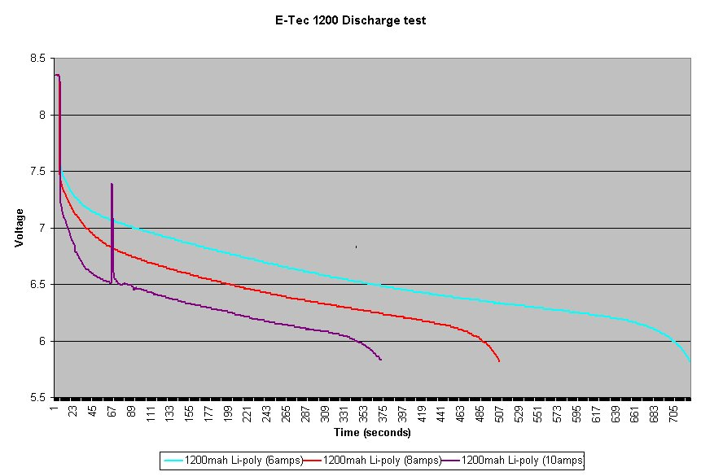

The manufacturer promised up to 7.5A continuous and more than 9A in short bursts per cell. The graph shows that at a 10 A current draw, a battery last for about 6 minutes.

These batteries seemed promising due to their relative sizes, weights and capacities. As an example, the dimensions of one cell are attached below:

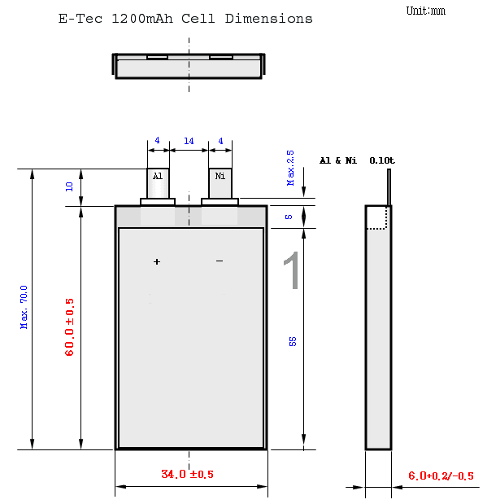

As an initial step, about 14 1200mAh lithium polymer cells were purchased for testing. The first round of testing was done with 8 batteries connected to a robot (4s2p). The robot was turned on and was made to dribble and kick constantly. The process seemed to last for about 20 minutes without any problems.

The second test was done for an individual cell. The cell was connected to an array of about 8 power resistors, creating a load resistance of about ½ Ω. The resulting drain curve is as follows:
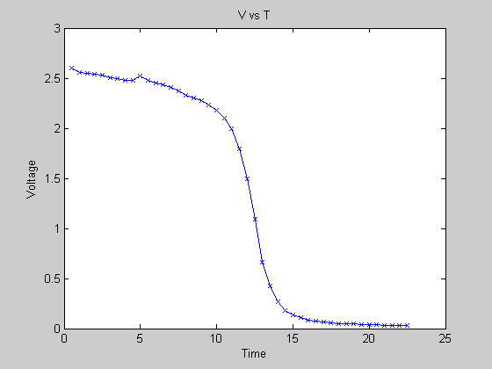

To do this effectively, since each robot was connected using long wires that would constitute their own internal resistance, the wires’ internal resistance was determined and then accounted for in the final result. The internal resistance of the cell was also determined. On average, this resulted in a 0.15Ω internal resistance per battery! This was much better in comparison to last year’s NiMH, whose internal resistance was at least 0.2-0.3Ω (per cell).

Accordingly, the battery lasted about 10 minutes while enough voltage was still being provided. It seemed, if enough cells were connected together, that these batteries would prove to be sufficient for the 2004 design. Thus, more tests had to be done.

A third round of tests was done with 2 cells connected together. First, tests were repeated with a sample load resistance of 1Ω, producing the following curve:
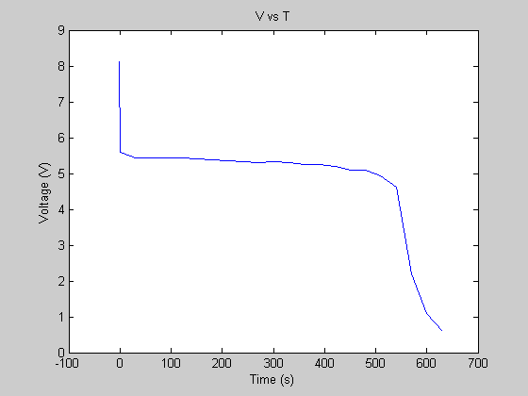
This was then done again with 1.5Ω, producing the following curve:
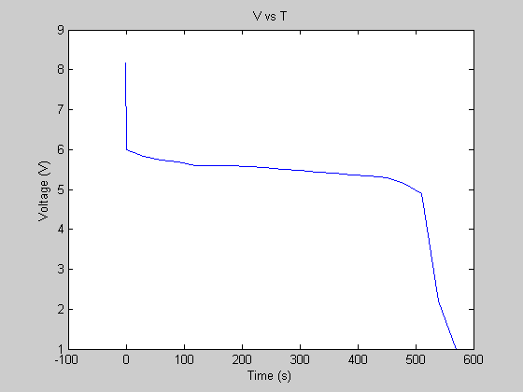

Another test, perhaps the most decisive, was done with 12 batteries (4s3p) where each pack of batteries was made of 4 cells in series. With the help of the AI team, the robot (Spartacus) was run for more than an hour while it was controlled by an algorithm to constantly accelerate, dribble, and kick. At the end of the test, the voltage had only dropped down by about 1.5V!!!

Time (min) | Voltage | Comments
-1 | 16.65 | pack 1
-1 | 17.14 | pack 2
-1 | 16.6 | pack3
0 | 16.67 | Spartacus playing with himself. Constant movement, shooting, dribling
5 | 16.36
10 | 16.2
13 |  | Shut off dribbler/kicker
20 | 16.09
30 | 15.92
31 |  | Turned back on dribble/kicker
40 | 15.47
50 | 14.97

After this test, we have decided to use, or continue testing, the Lithium Polymer batteries for the 2004 robots as the first choice.

There was another test performed with 8 cells (4s2p) on one of the robots. It turned out that 8 cells were not enough for the required minimum performance as the robot seemed to significantly loose its ability to move, kick, and dribble after only half an hour. The test may be redone for confirmation.

9.4 Digital Circuit Power
In addition to the motor/dribbler/kicker power, the same LiPoly chemistry was chosen to provide power for the digital circuit. With the possibilities that the voltage requirements may be anywhere from 5V-12V, the characteristics considered while choosing the LiPoly batteries also are a good match for the digital board.

As of right now, the team uses a 2s battery pack for the digital circuit. A fully charged 2s pack has a voltage of about 8.3V. The regulator we use is specified to work from 8V to 24V but has been proven to work down to 7.5V by drawing more current. While the team is considering changing to 3s packs in order to have better efficiency, the 2s packs from initial tests last about 45 minutes and this more than covers our requirements.
9.5 Purchasing
The battery model chosen for purchasing is the ETec 1200mAh. These batteries cost about $10.95 each. Since we need 12 batteries for the mechanical portion of the robot and 4 for the digital circuitry, a total of 16 batteries per robot will cost approximately $175.20 per robot. As decided, about 16 of these sets are to be bought. Thus results in a total battery budget of about $2803.20.

We have been able to successfully contact Bishop Power Products, Inc. for support with the batteries. The company provides 1200mAh cells as well as 1500mAh cells in pre-assembled packs, for virtually no extra packing cost. A representative is willing to provide us with a few samples of 1200mAh and 1500mAh cells for testing purposes. In addition, the company is willing to offer about a 30% discount on our purchase. This amounts to a total battery budget of approximately $1962.24 (exclusive of shipping). In return, the company simply asks that we list its name on our sponsors list.

9.6 Charging
Unfortunately, the team was not fully aware of the charging rules before the batteries were used. First off, and it cannot be emphasized enough, do not ever charge the lithium polymer batteries on the NiMh setting. The team was aware of this rule, but it was accidentally done anyway, and batteries puffed up to twice their size. Another rule about charging batteries is that if packs are charged together, they can have a voltage difference greater than 0.01V or else the batteries begin to fill with hydrogen and become unusable.

Section 10: Layout

10.1 Overview
With the addition of the PC104 to this years EE system, the main microcontroller was removed from the design. This provided the extra room needed to compress the entire layout to fit upon a single circuit board (DA Board). Because this board would house both the digital and analog components and the power supplies were separated to reduce noise. This requires that the power and ground planes be divided into analog and digital regions. In an attempt to simplify board population and debugging, a minimum / standard feature size of 805 (8x5 mm) was enforced for all surface mount resistors and capacitors. Finally, due to the density of the design, components are to be soldered on both sides of the board.

10.2 Splitting the Plane Layers
Since isolated power supplies was an important noise goal for this year, the analog and digital power and ground planes each had to be separated. Since the motor circuits are the dominant component of analog power consumption and they must be near the outside of the board to minimize connector length to the actual motors, it became clear that the analog planes would be needed on the outer arc of the board. This left the center of the board for all of the digital components. After a quick spin through the Cadence layout tool, this design seemed quite feasible. All that remained was figuring out how to divide the plane layers. After consulting the help files for the tool, it was learned that by creating non-overlapping obstacles on the plane layers where the planes were desired to be and changing the type to copper pour, separated plane layers could be created. All that remained was to change associated the obstacles with the proper net.

10.3 Minimum Feature Size
In the first revision of DA Board, no minimum feature sizes were set. Because of this, many resistors and capacitors were laid out in sizes 402 (4x2 mm) and 603 (6x3mm). This made soldering these components more difficult than they needed to be. The space savings due to the fact that they were below 805 were relatively small compared to the frustration cause by soldering 402 components, which are essentially flecks of material.

10.4 General Comments/Suggestions
By allowing for components to be laid out on both sides, the board was capable of holding more components without making either layer too dense. However, the amount of traces needed made routing fairly challenging. After manually routing the bus from the FPGA to the PC104 headers, auto-route would come close to close to routing the entire board, but leave 20+ traces unrouted. By reducing the via size to a 10 mil hole surrounded by a 10 mil ring (minimum size allowed by 4PCB), auto-route was able to get down to around 10 unrouted traces that could be down manually.

Even though power and ground planes were available and often used, the auto-routing program seems to have not force all connections to ground where ever possible. While debugging, several traces were blown out due to the fact that power or ground was being supplied by a tiny trace run from an adjacent circuit rather than from the through hole component in the current circuit. Deleting all unnecessary power and ground traces could easily have solved this, but it was assumed that they were simply in parallel with the planes.
Though all of the components and connectors fit and work on the final version of DA Board, having a second board which connects to the motors and handles all analog battery usage might be worth the extra cost of fabricating boards by easing debugging and reducing the amount of time needed for layout.

The traces for the raw analog power and ground need to be made wider to ensure that traces do not blow out as easily. Though no traces were blown out on the first revision of the board, even when attempting to draw more than the maximum expected current, when the motors were shorted or blown, substantially greater amounts of current were drawn, which blew out several traces.

Finally, Molex connectors, though incredibly stable, are probably not the best choice for our robots for the following reasons. The combined male and female connectors are quite long and take up substantially more space on the board than connectors used in the previous years. Disconnecting and reconnecting a boards worth of Molex connectors can be a pain and cause soreness in finger tips. Making the connectors takes a lot of time.

Appendix: Schematics

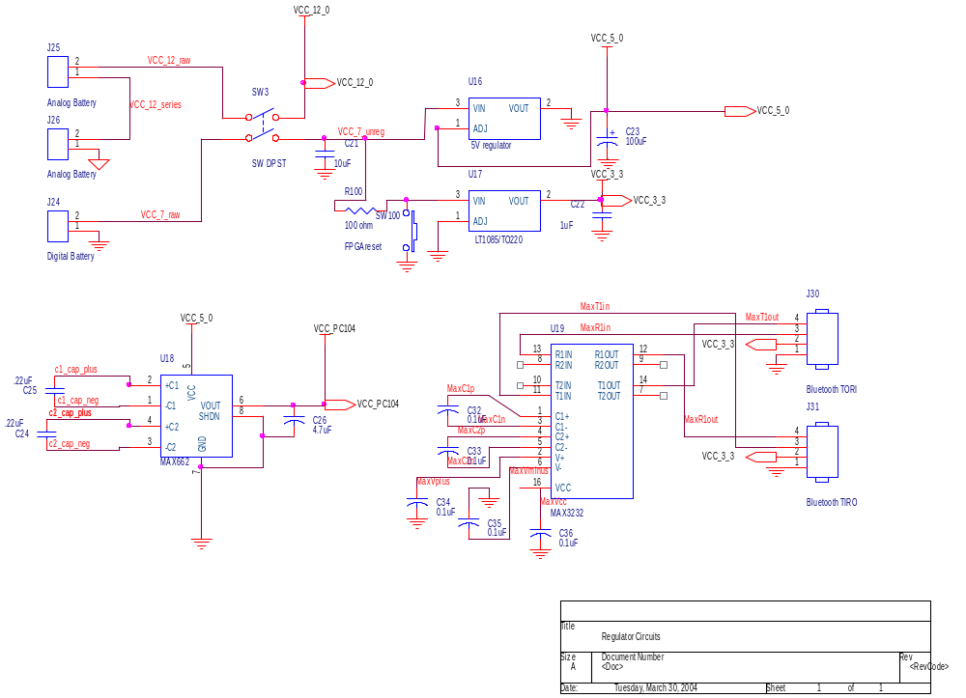
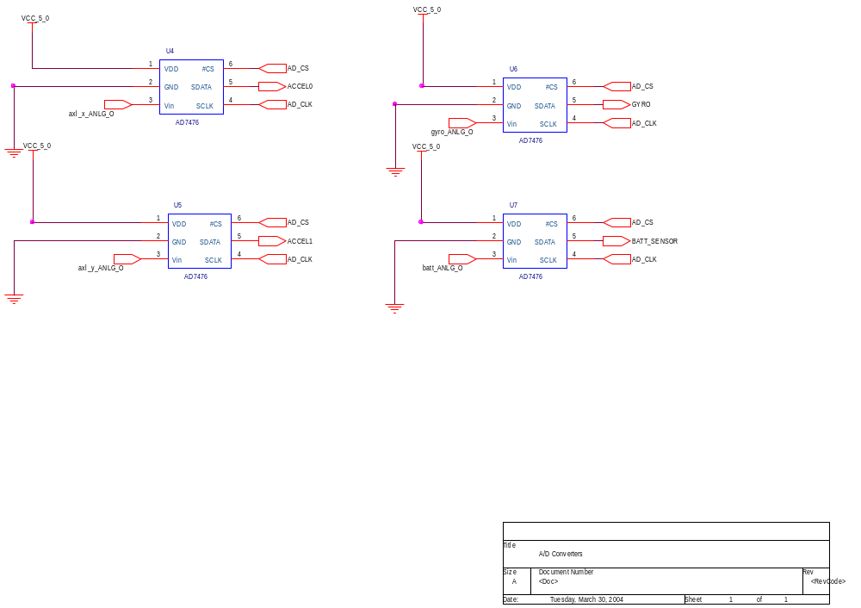

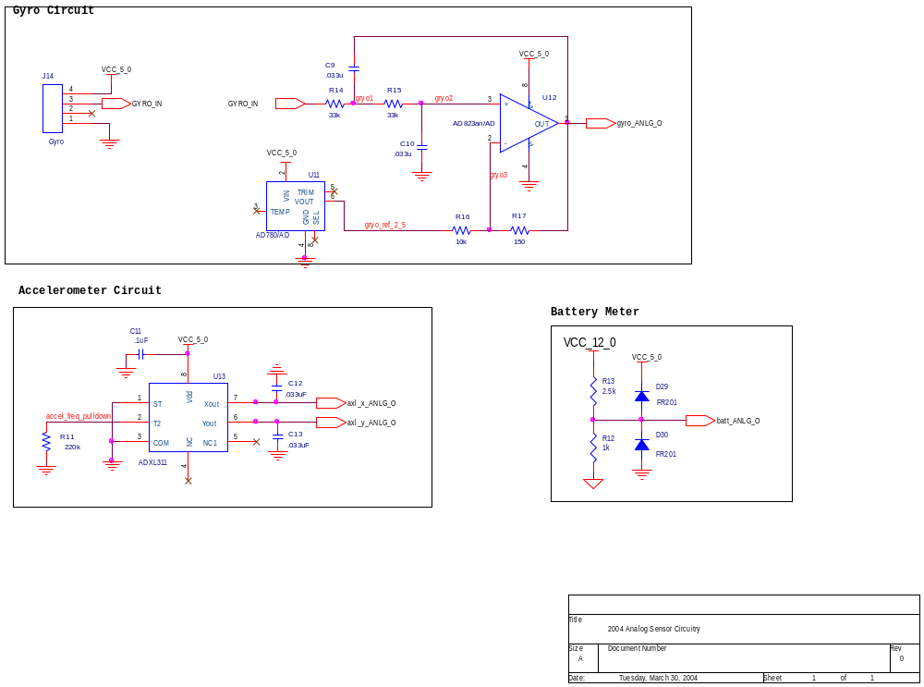
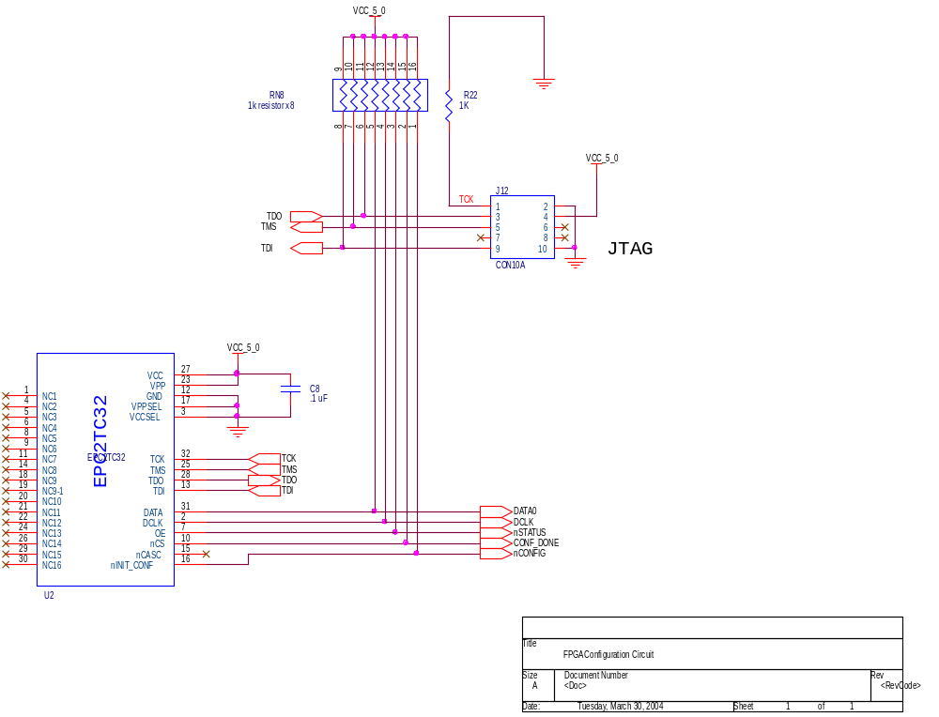
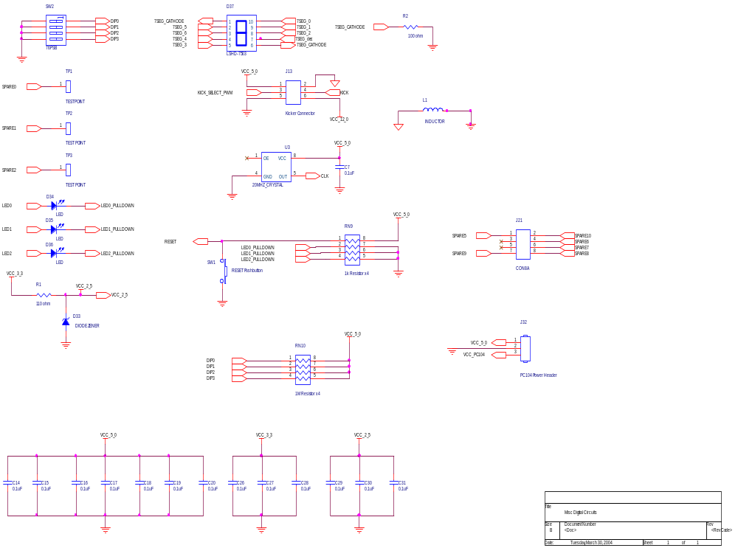
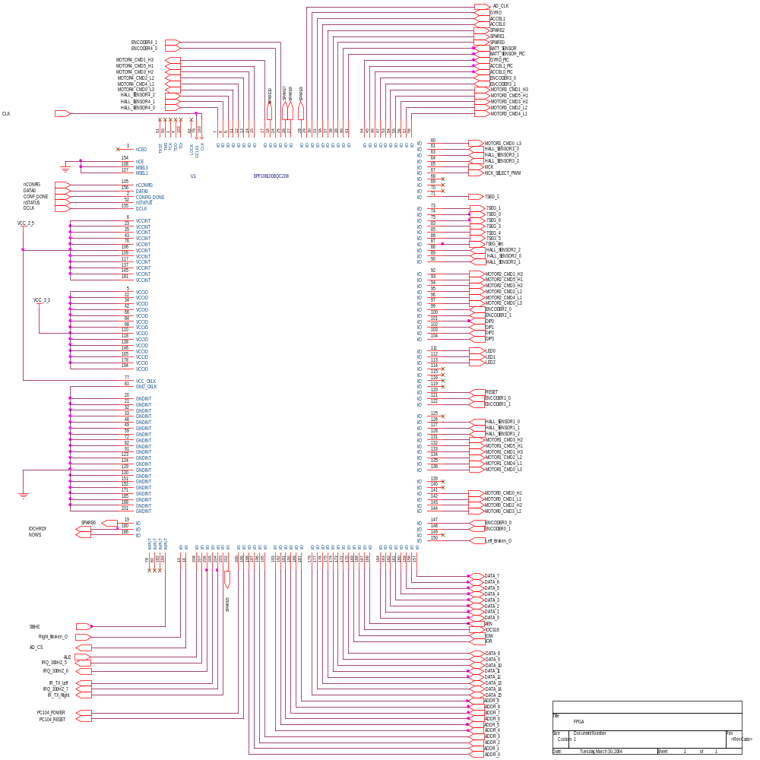
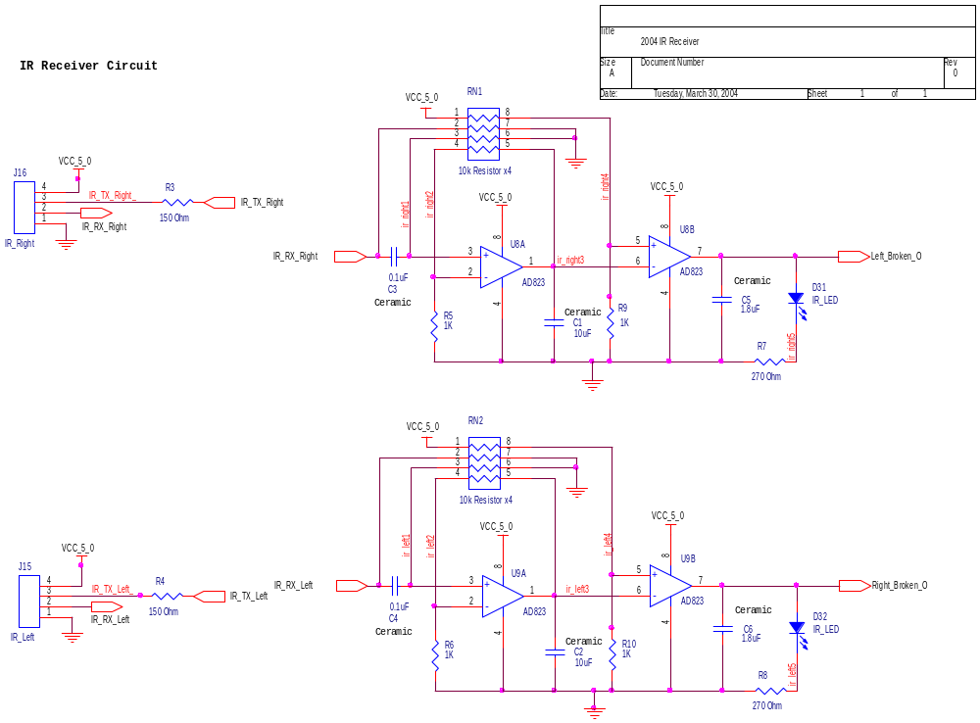
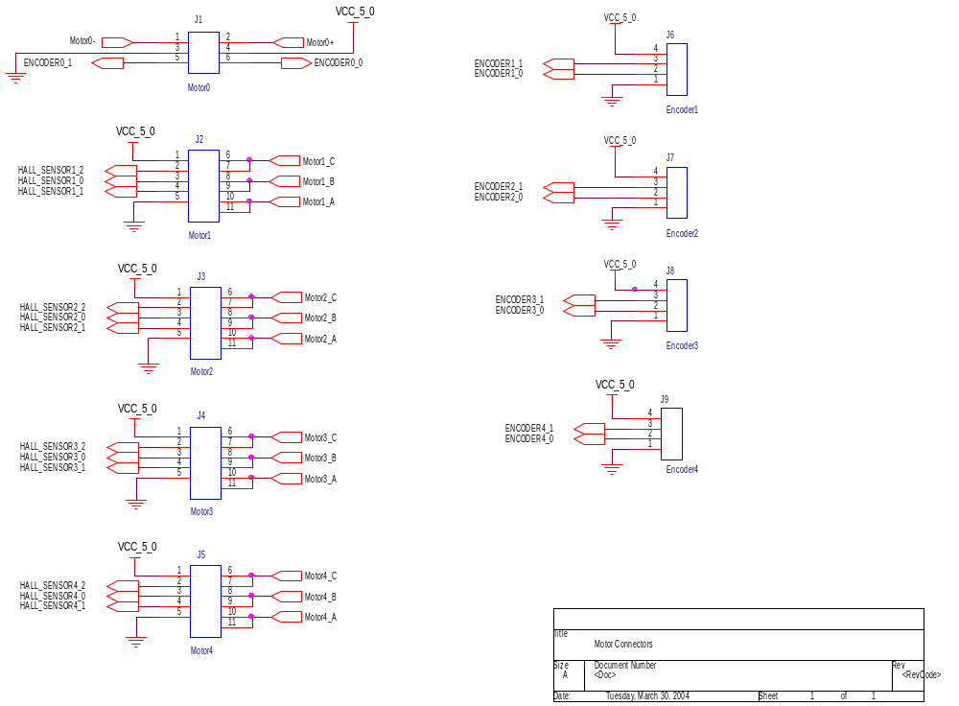
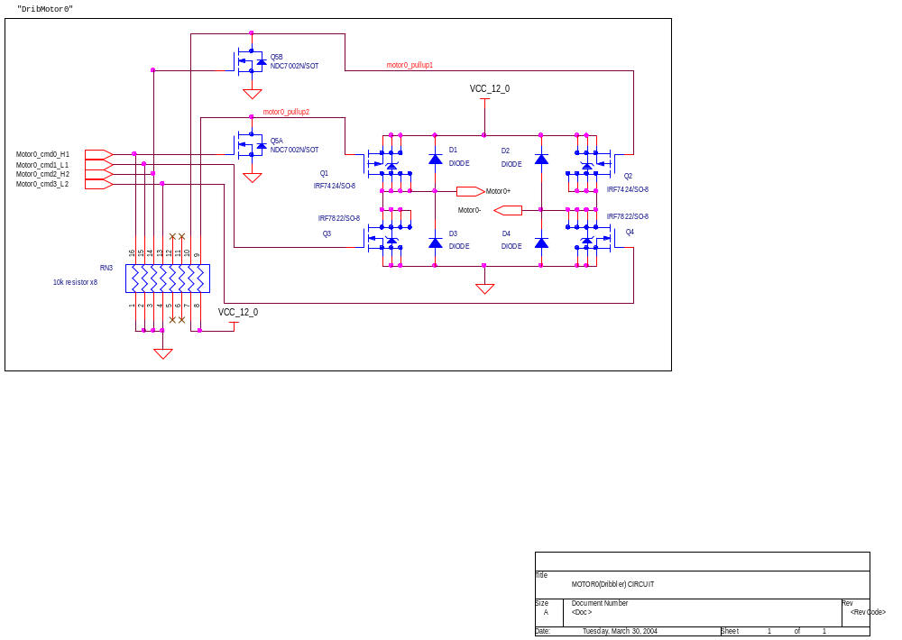
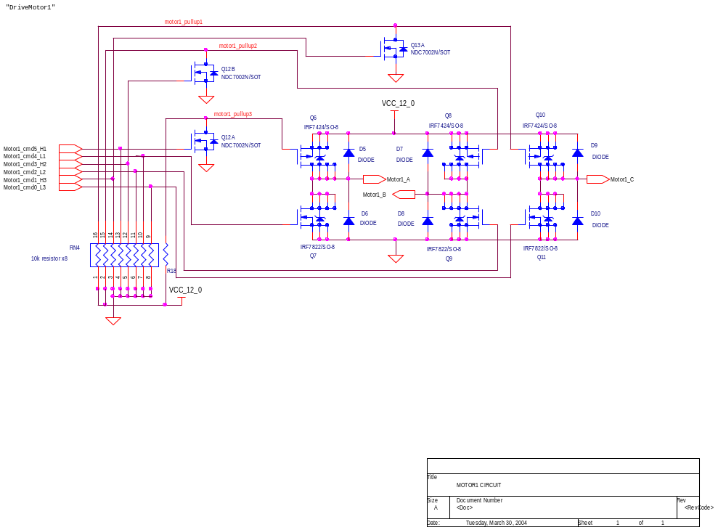
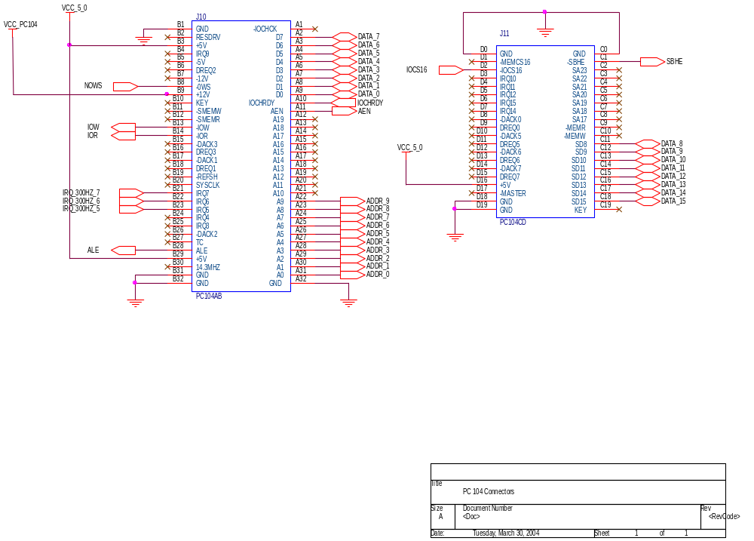
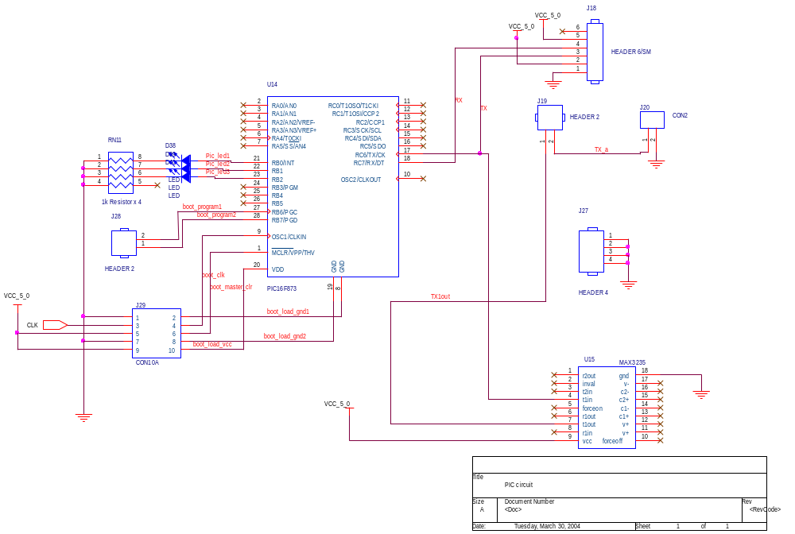

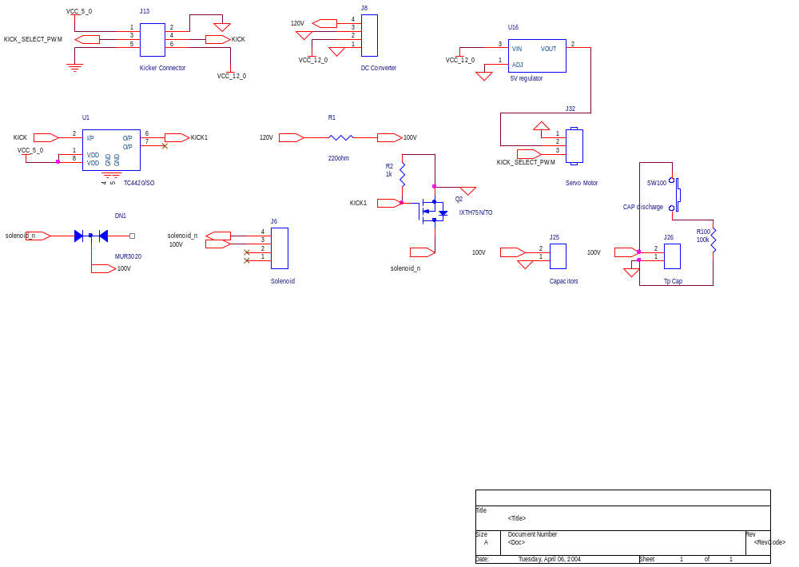

Appendix: Wireless Code
The TX – RX Code
The TX RX code before the American Open was un-optimal. It was buffering 21 bytes of data and waiting for a redundant packet terminate byte to transmit the packet to the PC104. The transmit side was just the same – with delays in place to maintain sync.
When the packet size was changed to 42 bytes, another array was used to buffer data and then transmit it over to the computer.
A whole new approach was needed and the problem was solved using interrupts.
When receiving data and change in status from I/O Ports, we have two methods available to us. We can Poll the port, which involves reading the status of the port at fixed intervals to determine whether any data has been received or a change of status has occurred. If so, then we can branch to a routine to service the ports requests.
Polling the port consumes quite some time. A better alternative would be to use Interrupts. Once the processor receives an Interrupt Request, it finishes its current instruction, places a few things on the stack, and executes the appropriate Interrupt Service Routine (ISR) which can remove the byte from the port and place it in a buffer. Once the ISR has finished, the processor returns to where it left off.
Using this method, the processor doesn't have to waste time, looking to see if your I/O Device is in need of attention, but rather the device will interrupt the processor when it needs attention.
Using ISRs made the code not only more efficient but also operational and optimal.
The state diagram for the codes is as shown:
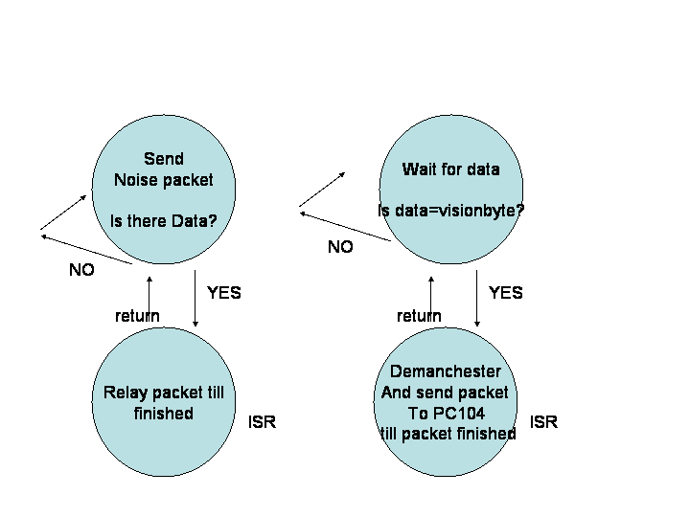
Another important change and characteristic of the system is that the vision does the Manchester encoding of data and the transmitter simply relays the data using the ISR. The receiver apart from sending data demanchesters it on the fly. Manchester encoding makes the number of zeros and ones equal and is necessary because of the noise level of the BiMs as explained before.
In one of the versions developed for the RX the RX polls and then relays It works just as well because our microcontroller on the robot does nothing but data transfer.

PIC Wireless Transmitter Code

PIC Wireless Transmitter Code
// TX Code
// RoboCup 2004

#include <16F876A.h>
#org 0x1F00, 0x1FFF void loader16F877(void) {}
// Allocate Space for Bootloader

#use delay(clock=20000000)

//-------------- Begin Variables Definitions ----------------------

#define BAUD_RATE_MODULE 57600 // Outgoing Data rate to RX MICRO
#define BAUD_RATE_PC 57600 // Outgoing Data rate to COMPUTER MONITOR

#define INIT_PACKET 0b01010101 // Avoid Noise Filter ( 0x55 )
#define FIRST_VISION 0b10101100 // Sync 1 of VISION FRAME ( 0xAC )
#define SECOND_VISION 0b01010011 // Sync 2 of VISION FRAME ( 0x53 )
#define FIRST_DETECT 0b00110101 // Sync 1 of TX FRAME ( 0x35 )
#define SECOND_DETECT 0b01010010 // Sync 2 of TX FRAME ( 0x52 )
#define END_DETECT 0b11101010 // Final Byte of FRAME ( 0xEA )
#define PACKETSIZE 88 // SIZE OF RAW DATA PACKET

unsigned char k=0; // declare global variables
unsigned char count=0;
unsigned char t=0;
unsigned char status=0;

//-------------------------MAIN-----------------------------------

void main()
{
#use rs232(baud=BAUD_RATE_PC, xmit=PIN_C6, rcv=PIN_C7, PARITY=N, BITS=8)

count = 0; // initialize counter
status = 0; // initialize status flags

enable_interrupts(INT_RDA); // enable RS-232 interrupts
enable_interrupts(GLOBAL); // enable global interrupts

while(1)
{
delay_us(130); // approximate time to send one byte
putc(INIT_PACKET); // transmit noise filter avoidance packet

if(count==50) // status update stage 1
output_low(PIN_B1);

if(count==255) // status update stage 2
{
count = 0; // reset counter
output_high(PIN_B1);

output_bit(PIN_B0,bit_test(status,0));
output_bit(PIN_B2,bit_test(status,2));

status = 0; // reset status flags
}

count++; // increment counter
}
}

#int_rda
void sisr(){
disable_interrupts(GLOBAL); // disable further interrupts

if(getc()==SECOND_VISION) // if real data is present
{
for(k=0; k<PACKETSIZE; k++) // transmit data
putc(getc());

bit_set(status,2); // set status flags
bit_clear(status,0);
}
else // real data is not present
{
bit_set(status,0); // set status flag
}

enable_interrupts(GLOBAL); // re-enable interrupts
}

PIC Wireless Receiver Code
// RX Code
// RoboCup 2004

#include <16F876A.h>
#org 0x1F00, 0x1FFF void loader16F877(void) {}
// Allocate Space for Bootloader

#use delay(clock=20000000)

//-------------- Begin Variables Definitions ----------------------

#define BAUD_RATE_MODULE 57600 // Outgoing Data rate to RX MICRO
#define BAUD_RATE_PC 57600 // Outgoing Data rate to COMPUTER MONITOR

#define FIRST_DETECT 0b00110101 // Sync 1 of TX FRAME ( 0x35 )
#define SECOND_DETECT 0b01010010 // Sync 2 of TX FRAME ( 0x52 )
#define PACKETSIZE 86 // SIZE OF RAW DATA PACKET
#define GOOD_PACKET 0x31 // FLAG for GOOD PACKET
#define BAD_PACKET 0x30 // FLAG for BAD PACKET

unsigned char k; // declare global variables
unsigned char hi0;
unsigned char lo0;
unsigned char outputvar;
unsigned char flagger;
unsigned char count;
unsigned char status;

//-------------------------MAIN----------------------------------

void main()
{
#use rs232(baud=BAUD_RATE_MODULE, xmit=PIN_C6, rcv=PIN_C7, PARITY=N)

flagger = 0; // initialize global variables
count = 0;
status = 0;

enable_interrupts(GLOBAL); // enable global interrupts
enable_interrupts(INT_RDA); // enable RS-232 interrupts

while(1)
{
delay_us(130); // approximate time to send a byte

if(count==50) // status update stage 1
{
output_bit(PIN_B1,0);
}

if(count==255) // status update stage 2
{
count = 0; // reset counter
output_bit(PIN_B0,bit_test(status,0));
output_bit(PIN_B1,bit_test(status,1));
output_bit(PIN_B2,bit_test(status,2));
status = 0; // reset status flags
}

count++; // increment counter
}
}

#int_rda
void sisr()
{
disable_interrupts(GLOBAL); // disable further interrupts

if (getc()==SECOND_DETECT) // if real data is present
{
bit_set(flagger,0); // set status flag

for (k=0; k<PACKETSIZE; k++) // Manchester decode
{
if ((k%2)==0) {hi0=getc();}
if ((k%2)==1)
{
lo0=getc();

if (lo0==0x55) outputvar=0b00000000;
else if (lo0==0x56) outputvar=0b00000001;
else if (lo0==0x59) outputvar=0b00000010;
else if (lo0==0x5A) outputvar=0b00000011;
else if (lo0==0x65) outputvar=0b00000100;
else if (lo0==0x66) outputvar=0b00000101;
else if (lo0==0x69) outputvar=0b00000110;
else if (lo0==0x6A) outputvar=0b00000111;
else if (lo0==0x95) outputvar=0b00001000;
else if (lo0==0x96) outputvar=0b00001001;
else if (lo0==0x99) outputvar=0b00001010;
else if (lo0==0x9A) outputvar=0b00001011;
else if (lo0==0xA5) outputvar=0b00001100;
else if (lo0==0xA6) outputvar=0b00001101;
else if (lo0==0xA9) outputvar=0b00001110;
else if (lo0==0xAA) outputvar=0b00001111;
else bit_clear(flagger,0);

if (hi0==0x55) outputvar=outputvar|0b00000000;
else if (hi0==0x56) outputvar=outputvar|0b00010000;
else if (hi0==0x59) outputvar=outputvar|0b00100000;
else if (hi0==0x5A) outputvar=outputvar|0b00110000;
else if (hi0==0x65) outputvar=outputvar|0b01000000;
else if (hi0==0x66) outputvar=outputvar|0b01010000;
else if (hi0==0x69) outputvar=outputvar|0b01100000;
else if (hi0==0x6A) outputvar=outputvar|0b01110000;
else if (hi0==0x95) outputvar=outputvar|0b10000000;
else if (hi0==0x96) outputvar=outputvar|0b10010000;
else if (hi0==0x99) outputvar=outputvar|0b10100000;
else if (hi0==0x9A) outputvar=outputvar|0b10110000;
else if (hi0==0xA5) outputvar=outputvar|0b11000000;
else if (hi0==0xA6) outputvar=outputvar|0b11010000;
else if (hi0==0xA9) outputvar=outputvar|0b11100000;
else if (hi0==0xAA) outputvar=outputvar|0b11110000;
else bit_clear(flagger,0);

putc(outputvar);
}
}

if(bit_test(flagger,0)) // append flag for GOOD_PACKET
{
putc(GOOD_PACKET);
bit_set(status,2);
}
else // append flag for BAD_PACKET
{
putc(BAD_PACKET);
bit_set(status,0);
}
}
else // real data is not present
{
bit_set(status,1); // set status flag
}
enable_interrupts(GLOBAL); // re-enable interrupts
}

Wireless Data Packet Structure
Wireless 2004 Packet Structure
(Data Rate must be 57600 bps, 8-N-1)

Vision-to-TX Board Packet Structure

Total Bytes = 90
Preamble: Bytes 1-4
Manchester-Encoded Data: Bytes 5-90

Byte 1 = 0xAC (this shows up as character "1/4")
Byte 2 = 0x53 (this shows up as character "S")
Byte 3 = 0x35 (this shows up as character "5")
Byte 4 = 0x52 (this shows up as character "R")
Byte 5 = Bytes 5+6 will Manchester decode to the

Byte 6 = first packet for the PC104 to sync on
Byte 7 = Bytes 7+8 will Manchester decode to the
Byte 8 = second packet for the PC104 to sync on

Byte 9 = *** Start of Manchester-Encoded Vision Data ***
Byte 10 =
.
.
.
.
.
Byte 89 =
Byte 90 = *** End of Manchester-Encoded Vision Data ***

The PIC on the TX board watches for the byte 0x53, then enters a for loop to send the next 88 bytes that it receives. When there is no data being received, it transmits the dummy byte 0x55 (shows up as a 'U' character) over the wireless link to avoid disrupting the BiM's adaptive data slicer.

The two data bytes Manchester-encoded into bytes 5-8 are for the PC104 to synchronize on.

TX-to-RX (over wireless) Packet Structure

Total Bytes = 88
Preamble: Bytes 1-2
Manchester-Encoded Data: Bytes 3-88

Byte 1 = 0x35 (this shows up as character "5")
Byte 2 = 0x52 (this shows up as character "R")
Byte 3 = Bytes 3+4 will Manchester decode to the
Byte 4 = first packet for the PC104 to sync on
Byte 5 = Bytes 5+6 will Manchester decode to the
Byte 6 = second packet for the PC104 to sync on

Byte 7 = *** Start of Manchester-Encoded Vision Data ***
Byte 8 =
.
.
.
.
.
Byte 87 =
Byte 88 = *** End of Manchester-Encoded Vision Data ***

The receiver PIC onboard the robot watches for the byte 0x52, then enters a for loop to Manchester decode the next 86 bytes and output them to the PC104. If any data byte in the packet cannot Manchester decode properly, a flag is raised to indicate that the entire packet is bad. If the packet is bad, the byte 0x30 is appended to the end. If the packet is good, the byte 0x31 is appended instead.

RX-to-PC104 Packet Structure

Total Bytes = 44
Preamble: Bytes 1-2
Manchester-Decoded Data: Bytes 3-43
Integrity Indicator: Byte 44

Byte 1 = First byte for PC104 to synchronize on
Byte 2 = Second byte for PC104 to synchronize on

Byte 3 = *** Start of Decoded Vision Data ***
.
.
.
.
.
Byte 43 = *** End of Decoded Vision Data ***

Byte 44 = 0x31 for GOOD_PACKET, 0x30 for BAD_PACKET

The PC104 implements a cascading detection scheme to synchronize on the data coming from the PIC. It accepts the decoded Vision data if Byte 44 is 0x31, or it discards the data if byte 44 is 0x30.

Wireless Monitor Code

#include <16F876A.h>

#use delay(clock=20000000)

//--------------------------------------------- Begin Variables Definitions ------------------------

#define BAUD_RATE_MODULE 57600 // Outgoing Data rate to RX MICRO
#define BAUD_RATE_PC 57600 // Outgoing Data rate to COMPUTER MONITOR

#define PACKETSIZE 86 // SIZE OF RAW DATA PACKET
#define GOOD_PACKET 0x31 // FLAG for GOOD PACKET
#define BAD_PACKET 0x30 // FLAG for BAD PACKET
#define INIT_PACKET 0b10101011 // Avoid Noise Filter ( 0xAB )
#define FIRST_VISION 0b10101100 // Sync 1 of VISION FRAME ( 0xAC )
#define SECOND_VISION 0b01010011 // Sync 2 of VISION FRAME ( 0x53 )
#define THIRD_VISION 0b00110101 // Sync 1 of TX FRAME ( 0x35 )
#define FOURTH_VISION 0b01010010 // Sync 2 of TX FRAME ( 0x52 )

unsigned char k;
unsigned char hi0;
unsigned char lo0;
unsigned char outputvar;
float counter=0;
char clear=0x0C;
float badcount=0;
float goodcount=0;

int1 flagger;
int1 flasher;

//---------------------------------------------MAIN--------------------------------------------

void main()
{
//#use rs232(baud=19200, xmit=PIN_C6, rcv=PIN_C7, PARITY=N)
#use rs232(baud=19200, xmit=PIN_B6, rcv=PIN_B7, PARITY=N)
{
putc(clear);
printf("Wireless\nTester");
for(counter=0;counter<50000;counter=counter+1);
putc(clear);

}

counter=0;
#use rs232(baud=BAUD_RATE_MODULE, xmit=PIN_C6, rcv=PIN_C7, PARITY=N)
//delay_ms(1000);
output_bit(PIN_C3,1);
output_bit(PIN_C2,1);
//enable_interrupts(GLOBAL);
//enable_interrupts(INT_RDA);
#use rs232(baud=19200, xmit=PIN_B6, rcv=PIN_B7, PARITY=N)
printf("No Wi\nCheck .. ");
delay_ms(10);
#use rs232(baud=BAUD_RATE_MODULE, xmit=PIN_C6, rcv=PIN_C7, PARITY=N)
while(1)
{
if (kbhit()) break;

}
//#use rs232(baud=19200, xmit=PIN_C6, rcv=PIN_C7, PARITY=N)
#use rs232(baud=19200, xmit=PIN_B6, rcv=PIN_B7, PARITY=N)
putc(clear);
printf("Wi Found");
#use rs232(baud=BAUD_RATE_MODULE, xmit=PIN_C6, rcv=PIN_C7, PARITY=N)

while(1)
{

//disable_interrupts(GLOBAL);

printf("\n\r INSIDE WHILE LOOP NOW ....");
if (getc()==FOURTH_VISION)
{
flagger=1;
flasher = !flasher;
//runs 0 to 85
printf("Inside Loop Now ... \n\r");
for (k=0;k<PACKETSIZE;k++)
{
if ((k%2)==0) {hi0=getc();} //xecute statement whent the count is eveni
if ((k%2)==1) // execute statement when the count is odd
{
lo0=getc();
if (lo0==0x55) outputvar=0b00000000; //inline manchester coding to prevent looping
else if (lo0==0x56) outputvar=0b00000001;
else if (lo0==0x59) outputvar=0b00000010;
else if (lo0==0x5A) outputvar=0b00000011;
else if (lo0==0x65) outputvar=0b00000100;
else if (lo0==0x66) outputvar=0b00000101;
else if (lo0==0x69) outputvar=0b00000110;
else if (lo0==0x6A) outputvar=0b00000111;
else if (lo0==0x95) outputvar=0b00001000;
else if (lo0==0x96) outputvar=0b00001001;
else if (lo0==0x99) outputvar=0b00001010;
else if (lo0==0x9A) outputvar=0b00001011;
else if (lo0==0xA5) outputvar=0b00001100;
else if (lo0==0xA6) outputvar=0b00001101;
else if (lo0==0xA9) outputvar=0b00001110;
else if (lo0==0xAA) outputvar=0b00001111;
else if (lo0==INIT_PACKET) outputvar = outputvar;//do nothing;
else flagger=0;

if (hi0==0x55) outputvar=outputvar|0b00000000;
else if (hi0==0x56) outputvar=outputvar|0b00010000;
else if (hi0==0x59) outputvar=outputvar|0b00100000;
else if (hi0==0x5A) outputvar=outputvar|0b00110000;
else if (hi0==0x65) outputvar=outputvar|0b01000000;
else if (hi0==0x66) outputvar=outputvar|0b01010000;
else if (hi0==0x69) outputvar=outputvar|0b01100000;
else if (hi0==0x6A) outputvar=outputvar|0b01110000;
else if (hi0==0x95) outputvar=outputvar|0b10000000;
else if (hi0==0x96) outputvar=outputvar|0b10010000;
else if (hi0==0x99) outputvar=outputvar|0b10100000;
else if (hi0==0x9A) outputvar=outputvar|0b10110000;
else if (hi0==0xA5) outputvar=outputvar|0b11000000;
else if (hi0==0xA6) outputvar=outputvar|0b11010000;
else if (hi0==0xA9) outputvar=outputvar|0b11100000;
else if (hi0==0xAA) outputvar=outputvar|0b11110000;
else if (hi0==INIT_PACKET) outputvar = outputvar;
else flagger=0;

putc(outputvar);
}
}
if(flagger==1)
{
output_low(PIN_C3);
putc(GOOD_PACKET);
goodcount=goodcount+1;
}
else
{
putc(BAD_PACKET);
output_high(PIN_C3);
badcount=badcount+1;

}
output_bit(PIN_C2, flasher);
if ((badcount+goodcount)>=2000)
{
#use rs232(baud=19200, xmit=PIN_B6, rcv=PIN_B7, PARITY=N)
putc(clear);
printf("G : %f",goodcount/(5*57600)*100);
printf("B : %f",badcount/(5*57600)*100);
while(1)
{}
}

}

}
}

#int_rda
void aba()
{
}

Appendix: FPGA Code

Analog.vhd:

LIBRARY ieee;
USE ieee.std_logic_1164.all;
USE ieee.std_logic_arith.all;

ENTITY Analog IS
PORT(
reset : IN STD_LOGIC;
clk : IN STD_LOGIC;

Batt_Sensor : IN STD_LOGIC;
Gyro : IN STD_LOGIC;
Accel0 : IN STD_LOGIC;
Accel1 : IN STD_LOGIC;

Batt_Data : OUT STD_LOGIC_VECTOR(9 downto 0);
Gyro_Data : OUT STD_LOGIC_VECTOR(9 downto 0);
Accel0_Data : OUT STD_LOGIC_VECTOR(9 downto 0);
Accel1_Data : OUT STD_LOGIC_VECTOR(9 downto 0);
AD_CLK : OUT STD_LOGIC;
AD_CS : OUT STD_LOGIC;

IRclkoutL : OUT STD_LOGIC;
IRclkoutR : OUT STD_LOGIC
);
End Analog;

ARCHITECTURE behavior OF Analog IS

Component clkdvd
generic(Modulus: NATURAL);
PORT ( ClkIn : IN STD_LOGIC;
Reset : IN STD_LOGIC;
ClkOut : OUT STD_LOGIC
);
END Component;

signal Batt_Reverse : STD_LOGIC_VECTOR(9 downto 0);
signal Gyro_Reverse : STD_LOGIC_VECTOR(9 downto 0);
signal Accel0_Reverse : STD_LOGIC_VECTOR(9 downto 0);
signal Accel1_Reverse : STD_LOGIC_VECTOR(9 downto 0);
signal IRclkout : STD_LOGIC;
signal done : STD_LOGIC;

BEGIN

AD_CLK <= clk;
--send clock to both IR outputs
--IRclkoutR <= IRclkout;
--IRclkoutL <= IRclkout;

ClockCopy: Process(IRclkout)
Begin
IRclkoutR <= IRclkout;
IRclkoutL <= IRclkout;
end Process;

--Reverse values so msb is in 9 slot
Reverse:Process(done)
Begin
if(done = '1') then
--done <= '0';
Batt_Data(0) <= Batt_Reverse(9);
Batt_Data(1) <= Batt_Reverse(8);
Batt_Data(2) <= Batt_Reverse(7);
Batt_Data(3) <= Batt_Reverse(6);
Batt_Data(4) <= Batt_Reverse(5);
Batt_Data(5) <= Batt_Reverse(4);
Batt_Data(6) <= Batt_Reverse(3);
Batt_Data(7) <= Batt_Reverse(2);
Batt_Data(8) <= Batt_Reverse(1);
Batt_Data(9) <= Batt_Reverse(0);

Gyro_Data(0) <= Gyro_Reverse(9);
Gyro_Data(1) <= Gyro_Reverse(8);
Gyro_Data(2) <= Gyro_Reverse(7);
Gyro_Data(3) <= Gyro_Reverse(6);
Gyro_Data(4) <= Gyro_Reverse(5);
Gyro_Data(5) <= Gyro_Reverse(4);
Gyro_Data(6) <= Gyro_Reverse(3);
Gyro_Data(7) <= Gyro_Reverse(2);
Gyro_Data(8) <= Gyro_Reverse(1);
Gyro_Data(9) <= Gyro_Reverse(0);

Accel0_Data(0) <= Accel0_Reverse(9);
Accel0_Data(1) <= Accel0_Reverse(8);
Accel0_Data(2) <= Accel0_Reverse(7);
Accel0_Data(3) <= Accel0_Reverse(6);
Accel0_Data(4) <= Accel0_Reverse(5);
Accel0_Data(5) <= Accel0_Reverse(4);
Accel0_Data(6) <= Accel0_Reverse(3);
Accel0_Data(7) <= Accel0_Reverse(2);
Accel0_Data(8) <= Accel0_Reverse(1);
Accel0_Data(9) <= Accel0_Reverse(0);

Accel1_Data(0) <= Accel1_Reverse(9);
Accel1_Data(1) <= Accel1_Reverse(8);
Accel1_Data(2) <= Accel1_Reverse(7);
Accel1_Data(3) <= Accel1_Reverse(6);
Accel1_Data(4) <= Accel1_Reverse(5);
Accel1_Data(5) <= Accel1_Reverse(4);
Accel1_Data(6) <= Accel1_Reverse(3);
Accel1_Data(7) <= Accel1_Reverse(2);
Accel1_Data(8) <= Accel1_Reverse(1);
Accel1_Data(9) <= Accel1_Reverse(0);
end if;
end Process reverse;

Convert:
PROCESS(reset,clk)
variable count: INTEGER RANGE 0 to 17;
BEGIN
if(reset = '0') then
count := 0;
AD_CS <= '1';
elsif(clk'event and clk = '0') then -- look for negative edge
if (count /= 17) then --"10001") then
AD_CS <= '0';
count := count + 1;
else
AD_CS <= '1';
count := 0;
end if;
if (count >= 6 and count <= 15) then --in valid data range
--Read in 10 bit converted value serially
--msb is in zero slot
done <= '0';
Batt_Reverse(count - 6) <= Batt_Sensor;
Gyro_Reverse(count - 6) <= Gyro;
Accel0_Reverse(count - 6) <= Accel0;
Accel1_Reverse(count - 6) <= Accel1;
elsif (count = 16) then
done <= '1';
end if;
end if;
end PROCESS Convert;

--Generate IR clock output
Clockgen: clkdvd
generic map( Modulus => 4000)
PORT map ( clk,
reset,
IRclkout
);

end behavior;

Brushless Motor.vhd:

LIBRARY ieee;
USE ieee.std_logic_1164.all;
USE ieee.std_logic_arith.all;

ENTITY brushlessmotor IS
GENERIC ( PWM_RES : NATURAL := 8;
PWM_CLK_RATIO : NATURAL := 40;
PWM_LEVEL : NATURAL := 256
) ;
PORT ( RESET : IN STD_LOGIC;
DIRECTION : IN STD_LOGIC;
HALL_SENSOR : IN STD_LOGIC_VECTOR(2 downto 0); --left bit is LSB
CLK : IN STD_LOGIC;
DATA_IN : IN STD_LOGIC_VECTOR(PWM_RES-1 downto 0);
MOTOR_CMD : OUT STD_LOGIC_VECTOR(5 downto 0) --MSB is H1, LSB L3 (out to fets)
);

END brushlessmotor;

ARCHITECTURE behavior OF brushlessmotor IS

COMPONENT pwmmain
GENERIC ( PWM_RES : NATURAL;
PWM_CLK_RATIO : NATURAL;
PWM_LEVEL : NATURAL
);
PORT ( reset : IN STD_LOGIC;
clk : IN STD_LOGIC;
data_in : IN STD_LOGIC_VECTOR(PWM_RES-1 downto 0);
PWM_OUT : OUT STD_LOGIC
);

END COMPONENT;

signal PWM_OUT : STD_LOGIC;
signal BULLSHITPWM : STD_LOGIC;

BEGIN

PWMGEN: pwmmain
GENERIC MAP(PWM_RES => 8,
PWM_CLK_RATIO => 65,
PWM_LEVEL => 256
)
PORT MAP(
RESET,
CLK,
DATA_IN,
PWM_OUT
);

MAINMOTORLOGIC: PROCESS(DIRECTION, HALL_SENSOR, PWM_OUT)
BEGIN
if(HALL_SENSOR = "101") then
--bit numbering HLHLHL
if(DIRECTION = '1') then
MOTOR_CMD(0) <= '0' AND PWM_OUT;
MOTOR_CMD(1) <= '0';
MOTOR_CMD(2) <= '0' AND PWM_OUT;
MOTOR_CMD(3) <= '1';
MOTOR_CMD(4) <= '1' AND PWM_OUT;
MOTOR_CMD(5) <= '0';
else
MOTOR_CMD(0) <= '0' AND PWM_OUT;
MOTOR_CMD(1) <= '0';
MOTOR_CMD(2) <= '1' AND PWM_OUT;
MOTOR_CMD(3) <= '0';
MOTOR_CMD(4) <= '0' AND PWM_OUT;
MOTOR_CMD(5) <= '1';
end if;
elsif(HALL_SENSOR = "001") then

if(DIRECTION = '1') then
MOTOR_CMD(0) <= '0' AND PWM_OUT;
MOTOR_CMD(1) <= '1';
MOTOR_CMD(2) <= '0' AND PWM_OUT;
MOTOR_CMD(3) <= '0';
MOTOR_CMD(4) <= '1' AND PWM_OUT;
MOTOR_CMD(5) <= '0';
else
MOTOR_CMD(0) <= '1' AND PWM_OUT;
MOTOR_CMD(1) <= '0';
MOTOR_CMD(2) <= '0' AND PWM_OUT;
MOTOR_CMD(3) <= '0';
MOTOR_CMD(4) <= '0' AND PWM_OUT;
MOTOR_CMD(5) <= '1';
end if;
elsif(HALL_SENSOR = "011") then

if(Direction = '1') then
MOTOR_CMD(0) <= '0' AND PWM_OUT;
MOTOR_CMD(1) <= '1';
MOTOR_CMD(2) <= '1' AND PWM_OUT;
MOTOR_CMD(3) <= '0';
MOTOR_CMD(4) <= '0' AND PWM_OUT;
MOTOR_CMD(5) <= '0';
else
MOTOR_CMD(0) <= '1' AND PWM_OUT;
MOTOR_CMD(1) <= '0';
MOTOR_CMD(2) <= '0' AND PWM_OUT;
MOTOR_CMD(3) <= '1';
MOTOR_CMD(4) <= '0' AND PWM_OUT;
MOTOR_CMD(5) <= '0';
end if;
elsif(HALL_SENSOR = "010") then

if(DIRECTION = '1') then
MOTOR_CMD(0) <= '0' AND PWM_OUT;
MOTOR_CMD(1) <= '0';
MOTOR_CMD(2) <= '1' AND PWM_OUT;
MOTOR_CMD(3) <= '0';
MOTOR_CMD(4) <= '0' AND PWM_OUT;
MOTOR_CMD(5) <= '1';
else
MOTOR_CMD(0) <= '0' AND PWM_OUT;
MOTOR_CMD(1) <= '0';
MOTOR_CMD(2) <= '0' AND PWM_OUT;
MOTOR_CMD(3) <= '1';
MOTOR_CMD(4) <= '1' AND PWM_OUT;
MOTOR_CMD(5) <= '0';
end if;
elsif(HALL_SENSOR = "110") then

if(Direction= '1') then
MOTOR_CMD(0) <= '1' AND PWM_OUT;
MOTOR_CMD(1) <= '0';
MOTOR_CMD(2) <= '0' AND PWM_OUT;
MOTOR_CMD(3) <= '0';
MOTOR_CMD(4) <= '0' AND PWM_OUT;
MOTOR_CMD(5) <= '1';
else
MOTOR_CMD(0) <= '0' AND PWM_OUT;
MOTOR_CMD(1) <= '1';
MOTOR_CMD(2) <= '0' AND PWM_OUT;
MOTOR_CMD(3) <= '0';
MOTOR_CMD(4) <= '1' AND PWM_OUT;
MOTOR_CMD(5) <= '0';
end if;
elsif(HALL_SENSOR = "100") then

if(DIRECTION = '1') then
MOTOR_CMD(0) <= '1' AND PWM_OUT;
MOTOR_CMD(1) <= '0';
MOTOR_CMD(2) <= '0' AND PWM_OUT;
MOTOR_CMD(3) <= '1';
MOTOR_CMD(4) <= '0' AND PWM_OUT;
MOTOR_CMD(5) <= '0';
else
MOTOR_CMD(0) <= '0' AND PWM_OUT;
MOTOR_CMD(1) <= '1';
MOTOR_CMD(2) <= '1' AND PWM_OUT;
MOTOR_CMD(3) <= '0';
MOTOR_CMD(4) <= '0' AND PWM_OUT;
MOTOR_CMD(5) <= '0';
end if;
else --reset state
MOTOR_CMD(0) <= '0';
MOTOR_CMD(1) <= '0';
MOTOR_CMD(2) <= '0';
MOTOR_CMD(3) <= '0';
MOTOR_CMD(4) <= '0';
MOTOR_CMD(5) <= '0';
end if;
END PROCESS MAINMOTORLOGIC;

END behavior;

Clkdvd.vhd:

LIBRARY ieee;
USE ieee.std_logic_1164.all;
USE ieee.std_logic_arith.all;

entity ClkDvd is
generic(Modulus: NATURAL := 64);
port(ClkIn : IN STD_LOGIC;
Reset : IN STD_LOGIC;
ClkOut : OUT STD_LOGIC);
end ClkDvd;

architecture Behavior of ClkDvd is

constant duty_cycle: NATURAL := Modulus -1;

begin

U0: process (ClkIn, Reset)
variable Count: INTEGER RANGE 0 to Modulus-1;
BEGIN
if (Reset = '0') then
Count := 0;
ClkOut <= '0';
elsif (ClkIn = '1' and ClkIn'event) then
if (Count = duty_cycle) then
Count := 0;
else
Count := Count + 1;
end if;

if (Count >= Modulus/2) then
ClkOut <= '0';
else
ClkOut <= '1';
end if;
end if;
END PROCESS U0;

end Behavior;

Counter.vhd:

LIBRARY ieee;
USE ieee.std_logic_1164.all;
USE ieee.std_logic_arith.all;

--MODIFIED TO HAVE TRIPPLE LATCH
ENTITY counter IS
generic ( COUNTER_RES : NATURAL := 16 );
PORT( reset : IN STD_LOGIC; -- low enable
clk : IN STD_LOGIC;
do_enc_read : IN STD_LOGIC; -- low enable
encoder : IN STD_LOGIC_VECTOR(1 downto 0);
data_out : OUT STD_LOGIC_VECTOR(15 downto 0)
);
END counter;

--DFF built in
ARCHITECTURE behavior OF counter IS

COMPONENT DFF
PORT (d : IN STD_LOGIC;
clk : IN STD_LOGIC;
clrn: IN STD_LOGIC;
prn : IN STD_LOGIC;
q : OUT STD_LOGIC );
END COMPONENT;

type STATE_TYPE is (S0, S1);
signal resetcounter : STD_LOGIC;
signal next_state, current_state : STATE_TYPE;
signal readstate : STD_LOGIC_VECTOR (1 downto 0); --2 bit state machine for reads
signal countdir : STD_LOGIC;
signal docount : STD_LOGIC;
signal sig01,sig02, sig03, sig11, sig12, sig13 : STD_LOGIC; --intermediate latch signals
signal numcounts : UNSIGNED(15 downto 0); --INTEGER RANGE 0 TO 65535;
BEGIN
--the following are cascading registers to filter the encoder readings
latch01: DFF
PORT MAP ( encoder(0), clk, '1', '1', sig01);
latch02: DFF
PORT MAP ( sig01,clk,'1','1',sig02);
latch03: DFF
PORT MAP ( sig02,clk,'1','1',sig03);

latch11: DFF
PORT MAP ( encoder(1),clk,'1','1',sig11);
latch12: DFF
PORT MAP ( sig11,clk,'1','1',sig12);
latch13: DFF
PORT MAP ( sig12,clk,'1','1',sig13);

--constant signals:
countdir <= sig02 XOR sig13;
docount <= sig02 XOR sig03 XOR sig12 XOR sig13;

counterproc: PROCESS(clk,reset,do_enc_read)
BEGIN
data_out <= CONV_STD_LOGIC_VECTOR(numcounts,16); --output to bus
if(reset = '0') then
numcounts<= "0111111111111111"; --start at the half way point
elsif ( do_enc_read = '0') then
numcounts<= "0111111111111111"; --start at the half way point
else --this code will not operate unless we are "allowed to" by the bus.
if (rising_edge(clk) AND docount = '1') then
if (countdir = '1') then
numcounts <= numcounts + 1;
else
numcounts <= numcounts - 1;
end if;
end if;
end if;
END PROCESS counterproc;

END behavior;

Dribbler.vhd:

LIBRARY ieee;
USE ieee.std_logic_1164.all;
USE ieee.std_logic_arith.all;

ENTITY dribbler IS
GENERIC ( PWM_RES : NATURAL := 8;
PWM_CLK_RATIO : NATURAL := 65;
PWM_LEVEL : NATURAL := 256
) ;
PORT( reset : IN STD_LOGIC;
clk : IN STD_LOGIC;
PWM_in : IN STD_LOGIC_VECTOR(PWM_RES-1 downto 0);
direction : IN STD_LOGIC;
STOP_NOW : IN STD_LOGIC;
motor_cmd : OUT STD_logic_vector(3 downto 0)
);
END dribbler;

ARCHITECTURE behavior OF dribbler IS

COMPONENT pwmmain
GENERIC ( PWM_RES : NATURAL;
PWM_CLK_RATIO : NATURAL;
PWM_LEVEL : NATURAL
);
PORT ( reset : IN STD_LOGIC;
clk : IN STD_LOGIC;
data_in : IN STD_LOGIC_VECTOR(PWM_RES-1 downto 0);
PWM_OUT : OUT STD_LOGIC
);

END COMPONENT;

signal PWM_OUT: STD_LOGIC;

BEGIN

PWMGEN: pwmmain
GENERIC MAP(PWM_RES => 8,
PWM_CLK_RATIO => 65,
PWM_LEVEL => 256
)
PORT MAP(
RESET,
CLK,
PWM_IN,
PWM_OUT
);

PROCESS(PWM_out,direction,STOP_NOW)
BEGIN

if (STOP_NOW = '1') then
motor_cmd <="0101";
elsif (PWM_out = '1' and STOP_NOW = '0') then
--reverse dribbling
if direction = '0' then
motor_cmd <= "1001";
--normal dribbling
else motor_cmd <= "0110";
end if;

elsif (PWM_out = '0' and STOP_NOW = '0') then
motor_cmd <= "0000";
end if;
END PROCESS;
END behavior;

Kicker.vhd:

LIBRARY ieee;
USE ieee.std_logic_1164.all;
USE ieee.std_logic_arith.all;

ENTITY kicker IS
PORT(
reset :IN STD_LOGIC;
clk :IN STD_LOGIC;
KickFlag :IN STD_LOGIC; --PC104 requests kick
Left_Broken :IN STD_LOGIC; --high when ball in possession
Right_Broken :IN STD_LOGIC;
KickForce :IN STD_LOGIC_Vector(7 downto 0);
Kick :OUT STD_LOGIC --pulsed high to kick the ball
);
END kicker;

ARCHITECTURE a OF kicker IS

TYPE STATE_TYPE IS (s0, s1, s2);
SIGNAL state : STATE_TYPE;
SIGNAL Force_Compare : STD_LOGIC_VECTOR(16 downto 0);
SIGNAL Force_Adder : UNSIGNED(16 downto 0);
SIGNAL Force_Shifted : STD_LOGIC_VECTOR(16 downto 0);

BEGIN

--max kick: KickForce = "11111111" -> 6.4 ms pulse
--min kick: KickForce = "00000000" -> 25.6 us pulse
machine: PROCESS (clk, reset)
BEGIN
IF (reset = '0') THEN
state <= s0;
Force_Adder <= "00000000000000000";
Force_Compare <= "00000000000000000";
Force_Shifted <= "00000000000000000";
-- Kick <= '0';
ELSIF (clk'EVENT AND clk = '1') THEN
CASE state IS
WHEN s0=>
IF (KickFlag = '1') THEN
state <= s1;
ELSE
state <= s0;
END IF;
WHEN s1=>
IF (Left_Broken = '1' and Right_Broken = '1') THEN
Force_Shifted(8 downto 0) <= "000000000";
Force_Shifted(16 downto 9) <= KickForce;
Force_Adder <= "00000000000000000";
state <= s2;
ELSE
state <= s1;
END IF;
WHEN s2=>
Force_Compare <= CONV_STD_LOGIC_VECTOR(Force_Adder,17);
IF (Force_Compare = Force_Shifted) THEN
state <= s0;
ELSE
Force_Adder <= Force_Adder + 1;
state <= s2;
END IF;
END CASE;
END IF;
END PROCESS;

Kick_state: PROCESS (state)
BEGIN
IF (reset = '0') THEN
Kick <= '0';
Else
CASE state IS
WHEN s0 =>
Kick <= '0';
WHEN s1 =>
Kick <= '0';
WHEN s2 =>
Kick <= '1';
END CASE;
End if;
END PROCESS;

End a;

Mainrobot.vhd:

--Currently included:
-- drive motors
-- encoders
-- dribbler
-- A/D converter
-- IR TX generator
-- Seven Seq
-- DIP switch

-- LEDs
-- Kicker
-- servo control
-- pulse duration control
-- IR RX

LIBRARY ieee;
USE ieee.std_logic_1164.all;
USE ieee.std_logic_arith.all;

ENTITY mainrobot IS
GENERIC (
ABUS_WIDTH : NATURAL := 10; -- address bus width
DBUS_WIDTH : NATURAL := 16; -- data bus width
PWM_BIT_WIDTH : NATURAL := 8; -- PWM resolution
PWM_CLOCK_RATIO : NATURAL := 65; -- 20MHz / (256*1.2Khz) = 39
INT_REQ_RATIO : NATURAL := 66666; -- 20,000,000Hz / 300Hz=66666
START_DELAY_DIV : NATURAL:= 2000000;
START_DELAY_TIME : NATURAL :=50
);
PORT(
--Misc Entities
CLK : IN STD_LOGIC;
DISPLAY : OUT STD_LOGIC_VECTOR(7 DOWNTO 0); --7 Segment Display
DIP : IN STD_LOGIC_VECTOR(3 DOWNTO 0);
RESET_sw : IN STD_LOGIC;
LED0 : OUT STD_LOGIC;
LED1 : OUT STD_LOGIC;
LED2 : OUT STD_LOGIC;

--PC104 Bus Interface
AEN : IN STD_LOGIC; --active low address enable
IOW : IN STD_LOGIC; --low when reading from PC104
IOR : IN STD_LOGIC; --low when writing to PC104
DATA : INOUT STD_LOGIC_VECTOR(DBUS_WIDTH-1 DOWNTO 0);
ADDR : IN STD_LOGIC_VECTOR(ABUS_WIDTH-1 DOWNTO 0);
IRQ_300HZ_5 : OUT STD_LOGIC; --interupts the bus on the pc104
IRQ_300HZ_6 : OUT STD_LOGIC; --interupts the bus on the pc104
IRQ_300HZ_7 : OUT STD_LOGIC; --interupts the bus on the pc104
IOCS16 : OUT STD_LOGIC;

--Motor Signals
HALL_SENSOR1 : IN STD_LOGIC_VECTOR( 2 DOWNTO 0);
HALL_SENSOR2 : IN STD_LOGIC_VECTOR( 2 DOWNTO 0);
HALL_SENSOR3 : IN STD_LOGIC_VECTOR( 2 DOWNTO 0);
HALL_SENSOR4 : IN STD_LOGIC_VECTOR( 2 DOWNTO 0);
MOTOR0_CMD : OUT STD_LOGIC_VECTOR( 3 DOWNTO 0);
MOTOR1_CMD : OUT STD_LOGIC_VECTOR( 5 DOWNTO 0);
MOTOR2_CMD : OUT STD_LOGIC_VECTOR( 5 DOWNTO 0);
MOTOR3_CMD : OUT STD_LOGIC_VECTOR( 5 DOWNTO 0);
MOTOR4_CMD : OUT STD_LOGIC_VECTOR( 5 DOWNTO 0);
ENCODER0 : IN STD_LOGIC_VECTOR( 1 DOWNTO 0);
ENCODER1 : IN STD_LOGIC_VECTOR( 1 DOWNTO 0);
ENCODER2 : IN STD_LOGIC_VECTOR( 1 DOWNTO 0);
ENCODER3 : IN STD_LOGIC_VECTOR( 1 DOWNTO 0);
ENCODER4 : IN STD_LOGIC_VECTOR( 1 DOWNTO 0);

--Sensors
RIGHT_BROKEN_O : IN STD_LOGIC;
LEFT_BROKEN_O : IN STD_LOGIC;
IR_TX_LEFT : OUT STD_LOGIC;
IR_TX_RIGHT : OUT STD_LOGIC;

ACCEL0 : IN STD_LOGIC;
ACCEL1 : IN STD_LOGIC;
GYRO : IN STD_LOGIC;
BATT_SENSOR : IN STD_LOGIC;

--A/D Convertor
AD_CLK : OUT STD_LOGIC;
AD_CS : OUT STD_LOGIC;

--kicker
KICK : OUT STD_LOGIC;
KICK_SELECT_PWM : OUT STD_LOGIC;

--spares
SPARE0 : OUT STD_LOGIC;
SPARE1 : OUT STD_LOGIC;
SPARE2 : OUT STD_LOGIC;
SPARE4 : OUT STD_LOGIC;
SPARE5 : OUT STD_LOGIC;
SPARE6 : OUT STD_LOGIC;
SPARE7 : OUT STD_LOGIC;
SPARE8 : OUT STD_LOGIC;
SPARE9 : OUT STD_LOGIC;
SPARE10 : OUT STD_LOGIC

);
END mainrobot;

ARCHITECTURE mainarch OF mainrobot IS
----------------------COMPONENTS-----------------------------

--Brushelss Motor Component
COMPONENT brushlessmotor
GENERIC
(
PWM_RES : NATURAL;
PWM_CLK_RATIO : NATURAL;
PWM_LEVEL : NATURAL
);

PORT(
RESET : IN STD_LOGIC; --reset
DIRECTION : IN STD_LOGIC; --Reverse is 1 (in from PC104)
HALL_SENSOR : IN STD_LOGIC_VECTOR(2 downto 0); --left bit is LSB (in from hall)
CLK : IN STD_LOGIC; --system clock
DATA_IN : IN STD_LOGIC_VECTOR(7 downto 0); --PWM Duty Cycle
MOTOR_CMD : OUT STD_LOGIC_VECTOR(5 downto 0) --MSB is H1, LSB L3 (out to fets)
);
END COMPONENT;

--7 Segment Component
COMPONENT seven_seg
PORT(
value : IN STD_LOGIC_VECTOR(3 downto 0);
decimal : IN STD_LOGIC;
display : OUT STD_LOGIC_VECTOR(7 downto 0)
);
END COMPONENT;

COMPONENT clkdvd
generic(Modulus: NATURAL);
PORT(ClkIn: in STD_LOGIC;
Reset: in STD_LOGIC;
ClkOut: out STD_LOGIC
);
END COMPONENT;

COMPONENT counter
GENERIC ( COUNTER_RES : NATURAL);
PORT(
reset : IN STD_LOGIC;
clk : IN STD_LOGIC;
do_enc_read : IN STD_LOGIC;
encoder : IN STD_LOGIC_VECTOR(1 downto 0);

data_out : OUT STD_LOGIC_VECTOR(COUNTER_RES-1 downto 0)
);
END COMPONENT;

COMPONENT analog
PORT(
reset : IN STD_LOGIC;
clk : IN STD_LOGIC;

Batt_Sensor : IN STD_LOGIC;
Gyro : IN STD_LOGIC;
Accel0 : IN STD_LOGIC;
Accel1 : IN STD_LOGIC;

Batt_Data : OUT STD_LOGIC_VECTOR(9 downto 0);
Gyro_Data : OUT STD_LOGIC_VECTOR(9 downto 0);
Accel0_Data : OUT STD_LOGIC_VECTOR(9 downto 0);
Accel1_Data : OUT STD_LOGIC_VECTOR(9 downto 0);
AD_CLK : OUT STD_LOGIC;
AD_CS : OUT STD_LOGIC;

IRclkoutL : OUT STD_LOGIC;
IRclkoutR : OUT STD_LOGIC
);
End COMPONENT;

COMPONENT dribbler
GENERIC(PWM_RES : NATURAL;
PWM_CLK_RATIO : NATURAL;
PWM_LEVEL : NATURAL
);
PORT( reset : IN STD_LOGIC;
clk : IN STD_LOGIC;
PWM_in : IN STD_LOGIC_vector(7 downto 0);
direction : IN STD_LOGIC;
STOP_NOW : IN STD_LOGIC;
motor_cmd : OUT STD_logic_vector(3 downto 0)
);
End COMPONENT;

COMPONENT servo_control
PORT( reset : IN STD_LOGIC;
clk : IN STD_LOGIC;
data_in : IN STD_LOGIC_VECTOR(4 downto 0);
pwm_out : OUT STD_LOGIC
);
End COMPONENT;

COMPONENT kicker
PORT( reset :IN STD_LOGIC;
clk :IN STD_LOGIC;
KickFlag :IN STD_LOGIC; --PC104 requests kick
Left_Broken :IN STD_LOGIC; --high when ball in possession
Right_Broken:IN STD_LOGIC;
KickForce :IN STD_LOGIC_Vector(7 downto 0);
Kick :OUT STD_LOGIC --pulsed high to kick the ball
);
END COMPONENT;

COMPONENT startdelay
generic(START_DELAY_DIV : NATURAL;
START_DELAY_TIME : NATURAL
);
PORT( reset_sw : IN STD_LOGIC; -- low enable
clk : IN STD_LOGIC;
reset : OUT STD_LOGIC
);
End COMPONENT;
---------------------SIGNALS----------------------------

--motor signals
signal PWM_IN0 : STD_LOGIC_VECTOR(PWM_BIT_WIDTH-1 downto 0); --hdrib motor
signal PWM_IN1 : STD_LOGIC_VECTOR(PWM_BIT_WIDTH-1 downto 0); --drv motor 1
signal PWM_IN2 : STD_LOGIC_VECTOR(PWM_BIT_WIDTH-1 downto 0); --drv motor 2
signal PWM_IN3 : STD_LOGIC_VECTOR(PWM_BIT_WIDTH-1 downto 0); --drv motor 3
signal PWM_IN4 : STD_LOGIC_VECTOR(PWM_BIT_WIDTH-1 downto 0); --drv motor 4
signal motordir0 : STD_LOGIC; --outgoing
signal motordir1 : STD_LOGIC;
signal motordir2 : STD_LOGIC;
signal motordir3 : STD_LOGIC;
signal motordir4 : STD_LOGIC;
signal Stop_Drib : STD_LOGIC;

--encoder signals
signal do_enc_read0 : STD_LOGIC;
signal ENC_DATA0 : STD_LOGIC_VECTOR(15 downto 0);
signal do_enc_read1 : STD_LOGIC;
signal ENC_DATA1 : STD_LOGIC_VECTOR(15 downto 0);
signal do_enc_read2 : STD_LOGIC;
signal ENC_DATA2 : STD_LOGIC_VECTOR(15 downto 0);
signal do_enc_read3 : STD_LOGIC;
signal ENC_DATA3 : STD_LOGIC_VECTOR(15 downto 0);
signal do_enc_read4 : STD_LOGIC;
signal ENC_DATA4 : STD_LOGIC_VECTOR(15 downto 0);

--bus signals
signal BUSDATAIN : STD_LOGIC_VECTOR (15 downto 0); --BUS IN buffer
signal BUSDATAOUT : STD_LOGIC_VECTOR (15 downto 0); --BUS OUT buffer
signal BASEADDR : STD_LOGIC_VECTOR (5 downto 0) ; --base address of ISA card
signal INTREG : STD_LOGIC_VECTOR (3 downto 0); --internal bus register
signal ADDRLATCH : STD_LOGIC; --indicates the register is latched
signal READYWRITE : STD_LOGIC; --signal goes high when the bus is done writing
signal READYREAD : STD_LOGIC; --signals goes high when the bus wants data
signal IRQ_300Hz : STD_LOGIC;

--Analog signals
signal Batt_Data : STD_LOGIC_VECTOR (9 downto 0);
signal Gyro_Data : STD_LOGIC_VECTOR (9 downto 0);
signal Accel0_Data : STD_LOGIC_VECTOR (9 downto 0);
signal Accel1_Data : STD_LOGIC_VECTOR (9 downto 0);

--Kick signals
signal Kick_Flag : STD_LOGIC;
signal Kick_Force : STD_LOGIC_VECTOR(7 downto 0);
signal servo_data : STD_LOGIC_VECTOR(4 downto 0);

--misc
signal dispdata : STD_LOGIC_VECTOR(3 downto 0); --the 7 seg output (in binary, MSB is an active low enable)
signal decimal : STD_LOGIC;
signal reset : STD_LOGIC;
signal written : STD_LOGIC;
SIGNAL PWM_safety : STD_LOGIC_VECTOR(7 DOWNTO 0);

--------------------IMPLEMENTATION----------------------
BEGIN
--constant signals
IRQ_300HZ_5 <= 'Z';
IRQ_300HZ_6 <= 'Z';
IRQ_300HZ_7 <= IRQ_300Hz;
--Spare2 <= '1';
--Spare1 <= '1';
--Kick <= '0';
--LED0 <= written;--LEFT_BROKEN_O;
LED1 <= pwm_safety(0);--Right_BROKEN_O;

--SPARE2 <= '0';
--BASEADDR <="110000";
MOTORENC0: counter
generic MAP ( COUNTER_RES => DBUS_WIDTH)
PORT MAP ( reset,
clk,
do_enc_read0,
encoder0,
ENC_DATA0
);
MOTORENC1: counter
generic MAP ( COUNTER_RES => DBUS_WIDTH)
PORT MAP ( reset,
clk,
do_enc_read1,
encoder1,
ENC_DATA1);
MOTORENC2: counter
generic MAP ( COUNTER_RES => DBUS_WIDTH)
PORT MAP ( reset,
clk,
do_enc_read2,
encoder2,
ENC_DATA2);
MOTORENC3: counter
generic MAP ( COUNTER_RES => DBUS_WIDTH)
PORT MAP ( reset,
clk,
do_enc_read3,
encoder3,
ENC_DATA3);

MOTORENC4: counter
generic MAP ( COUNTER_RES => DBUS_WIDTH )
PORT MAP ( reset,
clk,
do_enc_read4,
encoder4,
ENC_DATA4);

IRQGEN: clkdvd
generic map (Modulus =>INT_REQ_RATIO)
port map (clk,
reset,
IRQ_300HZ
);

--Seven Segment Display Driver
SEVENSEG: seven_seg
PORT MAP ( dispdata,
--Accel0_data(9 downto 6),
-- Batt_data(9 downto 6),
decimal,
DISPLAY
);

--Brushelss Motors Control
MOTOR1: brushlessmotor
GENERIC MAP ( PWM_RES => PWM_BIT_WIDTH,
PWM_CLK_RATIO => PWM_CLOCK_RATIO,
PWM_LEVEL => 256
)
PORT MAP ( RESET,
motordir1,
HALL_SENSOR1,
CLK,
PWM_IN1,
MOTOR1_CMD

);
MOTOR2: brushlessmotor
GENERIC MAP ( PWM_RES => PWM_BIT_WIDTH,
PWM_CLK_RATIO => PWM_CLOCK_RATIO,
PWM_LEVEL => 256
)
PORT MAP ( RESET,
motordir2,
HALL_SENSOR2,
CLK,
PWM_IN2,
MOTOR2_CMD

);
MOTOR3: brushlessmotor
GENERIC MAP ( PWM_RES => PWM_BIT_WIDTH,
PWM_CLK_RATIO => PWM_CLOCK_RATIO,
PWM_LEVEL => 256
)
PORT MAP ( RESET,
motordir3,
HALL_SENSOR3,
CLK,
PWM_IN3,
MOTOR3_CMD

);
MOTOR4: brushlessmotor
GENERIC MAP ( PWM_RES => PWM_BIT_WIDTH,
PWM_CLK_RATIO => PWM_CLOCK_RATIO,
PWM_LEVEL => 256
)
PORT MAP ( RESET,
motordir4,
HALL_SENSOR4,
CLK,
PWM_IN4,
MOTOR4_CMD

);
ADetc: analog
PORT MAP ( reset,
clk,
Batt_Sensor,
Gyro,
Accel0,
Accel1,
Batt_Data,
Gyro_Data,
Accel0_Data,
Accel1_Data,
AD_CLK,
AD_CS,
IR_TX_Left,
IR_TX_Right
);
Drib: dribbler
GENERIC MAP ( PWM_RES => PWM_BIT_WIDTH,
PWM_CLK_RATIO => PWM_CLOCK_RATIO,
PWM_LEVEL => 256
)
PORT MAP ( reset,
clk,
PWM_IN0,
motordir0,
Stop_Drib,
MOTOR0_CMD
);

Servo: servo_control
PORT MAP ( reset,
clk,
servo_data,
KICK_SELECT_PWM
);

Kicks: kicker
PORT MAP ( reset,
clk,
Kick_Flag,
Left_Broken_o,
Right_Broken_o,
Kick_Force,
Kick
);

Delay: startdelay
GENERIC MAP ( START_DELAY_DIV,
START_DELAY_TIME
)
PORT MAP ( reset_sw,
clk,
reset
);

--scontrol: Process(DIP)
--Begin
--chip kick
-- if(DIP(0) = '0') then
-- servo_data <= "11000";
-- --ground kick
-- elsif(DIP(0) = '1') then
-- servo_data <= "11111";
-- else
-- servo_data <= "00000";
-- end if;
-- if (reset = '0') then
-- Stop_Drib <= '1';
-- elsif(DIP(3) = '0') then
-- Stop_Drib <= '1';
-- elsif(DIP(3) = '1') then
-- Stop_Drib <= '0';
-- end if;

--end process;

--------------------MAIN CODE------------------------
--see registermap.txt for registers contents
--this is the MAIN process, it will fire all events of the sub componentry
--NOTE: DO NOT USE ODD REGISTERS ON THE 16BIT BUS. THE DATA IS UNRELIABLE
--SINCE x86 ARCHITECTURE USES ODD REGISTERS FOR 8 BIT COMPATIBILITY!
mainproc: PROCESS (READYREAD, READYWRITE, reset,PWM_safety)
BEGIN
if (reset = '0') then
dispdata <= "1000";
decimal <= '1';
--Stop_Drib <= '1';
PWM_IN0<= "00000000";
PWM_IN1<= "00000000";
PWM_IN2<= "00000000";
PWM_IN3<= "00000000";
PWM_IN4<= "00000000";
motordir0 <= '1';
motordir1 <= '1';
motordir2 <= '1';
motordir3 <= '1';
motordir4 <= '1';
DO_ENC_READ0 <= '1'; -- unfreezes and encoder value
DO_ENC_READ1 <= '1';
DO_ENC_READ2 <= '1';
DO_ENC_READ3 <= '1';
DO_ENC_READ4 <= '1';
servo_data <= "11111";
Kick_Force <= "00000000";
Kick_Flag <= '0';
written <= '1';
elsif (READYWRITE = '1') then --PC104 is ready to write to FPGA
dispdata (3 downto 0) <= INTREG;
decimal <='0';
LED2<= '0';
if (INTREG = "0000") then --0
PWM_IN0 <= (BUSDATAOUT (7 downto 0) and PWM_safety);
Stop_Drib <= BUSDATAOUT(8);
elsif (INTREG = "0010") then --2
PWM_IN1 <= (BUSDATAOUT (7 downto 0) AND PWM_safety);
written <= '1';
elsif (INTREG = "0100") then --4
PWM_IN2 <= (BUSDATAOUT (7 downto 0) AND PWM_safety);
elsif (INTREG = "0110") then --6
PWM_IN3 <= (BUSDATAOUT (7 downto 0) AND PWM_safety);
elsif (INTREG = "1000") then --8
PWM_IN4 <= (BUSDATAOUT (7 downto 0) AND PWM_safety);
elsif (INTREG = "1010") then --10
--we may want to consider doubling this signal becuase
--if this messes up somehow, it could be ugly!
motordir0 <= BUSDATAOUT (0);
motordir1 <= BUSDATAOUT (1);
motordir2 <= BUSDATAOUT (2);
motordir3 <= BUSDATAOUT (3);
motordir4 <= BUSDATAOUT (4);
elsif (INTREG = "1100") then --12
Kick_Force <= BUSDATAOUT(7 downto 0);
Kick_Flag <= BUSDATAOUT (8);
Servo_Data <= BUSDATAOUT(13 downto 9);
elsif (INTREG = "1110") then --14
DO_ENC_READ0 <= BUSDATAOUT (0); -- unfreezes and encoder value
DO_ENC_READ1 <= BUSDATAOUT (1);
DO_ENC_READ2 <= BUSDATAOUT (2);
DO_ENC_READ3 <= BUSDATAOUT (3);
DO_ENC_READ4 <= BUSDATAOUT (4);
end if;

elsif (READYREAD = '1') then --PC104 is requesting data from FPGA
dispdata (3 downto 0) <= INTREG;
decimal <='0';
LED2 <= '0';
--encoder counter register
if (INTREG = "0000") then --0
BUSDATAIN <= ENC_DATA0;
elsif (INTREG = "0010") then --2
BUSDATAIN<= ENC_DATA1;
elsif (INTREG = "0100") then --4
BUSDATAIN<= ENC_DATA2;
elsif (INTREG = "0110") then --6
BUSDATAIN<= ENC_DATA3;
elsif (INTREG = "1000") then --8
BUSDATAIN<= ENC_DATA4;
elsif (INTREG = "1010") then --10
BUSDATAIN (3 downto 0) <= DIP;
BUSDATAIN (4) <= Left_Broken_o;
BUSDATAIN (5) <= Right_Broken_o;
BUSDATAIN (15 downto 6) <= "1111111111";
elsif (INTREG = "1100") then --12
--gyro, batt
BUSDATAIN(7 downto 0) <= Batt_data(9 downto 2);
BUSDATAIN(15 downto 8) <= Gyro_data(9 downto 2);
elsif (INTREG = "1110") then --14
--Accelerometers
BUSDATAIN(7 downto 0) <= Accel0_data(7 downto 0);
BUSDATAIN(15 downto 8) <= Accel1_data(7 downto 0);
end if;
elsif(READYWRITE = '0' and READYREAD = '0' ) then
Kick_Flag <= '0';
if(PWM_safety = "11111111") then
LED2 <= '0';
written <= '0';
else
LED2 <= '1'; --there is somehting with LED2 casuing encoders to reset properly--resolved? 5/5
PWM_IN0 <= (PWM_IN0 AND PWM_safety);
PWM_IN1 <= (PWM_IN1 AND PWM_safety);
PWM_IN2 <= (PWM_IN2 AND PWM_safety);
PWM_IN3 <= (PWM_IN3 AND PWM_safety);
PWM_IN4 <= (PWM_IN4 AND PWM_safety);
end if;
end if;
END PROCESS mainproc;

--bus specific processes:
--address decode process, looks for when the card is addressed by the pc104 bus
--this process is used for both reads AND writes
addrdecode: PROCESS (ADDR,AEN, reset)
BEGIN
DATA<="ZZZZZZZZZZZZZZZZ"; --set data ready for PC104 read/write
if (reset='0') then --if in reset state
ADDRLATCH <= '0'; --address is not latched
IOCS16<='1'; --IOCS16 is Active Low indicating this is NOT a 16 bit transaction now

else
if(ADDR(9 downto 4) = "110000" ) then --check out base address (0x300 in this case)
if (AEN = '0') then --check to make sure this is NOT a DMA transfer (we only care about IO)
INTREG <= ADDR(3 downto 0); --latch in the correct register
ADDRLATCH <= '1'; --the address bus is now latched (this should actually occur after the ifs below)
IOCS16<='0'; --Indicates to the PC104 that we are going to do a 16 bit data transfer
else
ADDRLATCH <= '0'; --the address was not latched (most likely a DMA event)
IOCS16<='1'; --not a 16 bit transfer
end if;
else --someone else is being addresed on the data bus
ADDRLATCH <= '0';
IOCS16<='1';
end if;
end if;
END PROCESS addrdecode;

--this process handles IO writes to the bus (PC104 sends data to FPGA)
IOWdata: PROCESS (IOW, reset)
BEGIN
--DATA<="ZZZZZZZZZZZZZZZZ"; --free the data bus (this is probably unnecessary)
if (reset='0') then --reset state

elsif (ADDRLATCH = '1') then --we have decoded a valid address already
if (falling_edge(IOW)) then -- "trigger" for the latch of the data bus (PC104 write)
--LATCH the data bus
BUSDATAOUT <= DATA;
READYWRITE <= '1';
end if;
if (IOW = '1') then
READYWRITE <= '0';
end if;
end if;
END PROCESS IOWdata;

--this process handles IO reads from the bus (PC104 requests data from FPGA)
IORdata: PROCESS (IOR, reset)
BEGIN
if (ADDRLATCH = '1') then --this means we have decoded a valid address already
if ((IOR='0')) then --this is the "trigger" for the data bus (PC104 read)
READYREAD <= '1'; --signal the bus is ready for data for a read
DATA<= BUSDATAIN; --latch the bus
else
READYREAD <= '0'; --the bus is not ready for data for a read
DATA<="ZZZZZZZZZZZZZZZZ"; --free the data bus
end if;
else
DATA<="ZZZZZZZZZZZZZZZZ"; --free the data bus
end if;
END PROCESS IORdata;

bussafety: PROCESS(reset,written,clk)
variable count: INTEGER RANGE 0 to 500001;
BEGIN
if(reset = '0') THEN
PWM_safety <= "11111111";
elsif(clk'event and clk = '1') then
if(count > 400001) then
PWM_safety <= "00000000";
Led0 <= '1';
else
count := count + 1;
LEd0 <= '0';
end if;
end if;
if (written = '1') then
count := 0;
PWM_safety <= "11111111";
end if;
END PROCESS bussafety;

END mainarch;

Pwm.vhd:

LIBRARY ieee;
USE ieee.std_logic_1164.all;
USE ieee.std_logic_arith.all;

ENTITY pwm IS
generic ( RESOLUTION : NATURAL := 8;
RES_RANGE : NATURAL := 256
);
PORT( reset : IN STD_LOGIC;
pwm_clk : IN STD_LOGIC;
data_in : IN STD_LOGIC_VECTOR(RESOLUTION-1 downto 0);
pwm_sig : OUT STD_LOGIC
);
END pwm;

ARCHITECTURE behavior OF pwm IS

constant MAX_VALUE: NATURAL := RES_RANGE-1;
signal count : INTEGER RANGE 0 TO RES_RANGE-1;
signal data_in_us : UNSIGNED(RESOLUTION-1 downto 0);
signal data_in_i : INTEGER RANGE 0 TO RES_RANGE-1;
signal pwm_duty : INTEGER RANGE 0 TO RES_RANGE-1;

BEGIN

U0: data_in_i <= CONV_INTEGER(data_in_us);

U1: PROCESS(data_in)
BEGIN
FOR I IN 0 TO RESOLUTION-1 loop
data_in_us(I) <= data_in(I);
END LOOP;
END PROCESS U1;

U2: PROCESS(reset,pwm_clk)
BEGIN
if(reset = '0') then
count <= 0;
pwm_duty <= 0;
elsif(pwm_clk'event and pwm_clk = '1') then
if(count = MAX_VALUE) then
count <= 0;
pwm_duty <= data_in_i;
else
count <= count + 1;
end if;
end if;
END PROCESS U2;

U3: PROCESS(reset,pwm_clk)
BEGIN
if(reset = '0') then
pwm_sig <= '0';
elsif(pwm_clk'event and pwm_clk = '1') then
-- if(count >= data_in_i) then
if(count >= pwm_duty) then
pwm_sig <= '0';
-- elsif(count <= data_in_i) then
elsif(count = 0) then
pwm_sig <= '1';
end if;
end if;
END PROCESS U3;

END behavior;

Pwmmain.vhd:

LIBRARY ieee;
USE ieee.std_logic_1164.all;
USE ieee.std_logic_arith.all;

-- 8bit main generator
ENTITY pwmmain IS
generic ( PWM_RES : NATURAL := 8;
-- CLK_CYCLE = PWM_CLK_RATIO * PWM_DUTY_CYCLE * PWM_LEVEL
-- multiplication and division must be power of 2 and nonnegative
PWM_CLK_RATIO: NATURAL := 64; --CLK_CYCLE/(PWM_DUTY_CYCLE*PWM_LEVEL); -- 1.2khz
PWM_LEVEL : NATURAL := 256
);
PORT( reset : IN STD_LOGIC;
clk : IN STD_LOGIC;
data_in : IN STD_LOGIC_VECTOR(PWM_RES-1 downto 0);
pwm_out : OUT STD_LOGIC
);
END pwmmain;

ARCHITECTURE behavior OF pwmmain IS

COMPONENT clkdvd
generic(Modulus: NATURAL);
PORT(ClkIn: in STD_LOGIC;
Reset: in STD_LOGIC;
ClkOut: out STD_LOGIC
);
END COMPONENT;

COMPONENT pwm
generic ( RESOLUTION : NATURAL;
RES_RANGE : NATURAL
);
PORT( reset : IN STD_LOGIC;
pwm_clk : IN STD_LOGIC;
data_in : IN STD_LOGIC_VECTOR(RESOLUTION-1 downto 0);
pwm_sig : OUT STD_LOGIC
);
END COMPONENT;

signal pwm_base_clk : STD_LOGIC;

BEGIN
U0: clkdvd
generic map (Modulus =>PWM_CLK_RATIO)
port map (clk,
reset,
pwm_base_clk);

U1: pwm
generic map( RESOLUTION => PWM_RES, -- 8 BIT
RES_RANGE => PWM_LEVEL) -- 256 LEVEL
PORT map ( reset,
pwm_base_clk,
data_in,
pwm_out );

END behavior;

Servo_control.vhd:

LIBRARY ieee;
USE ieee.std_logic_1164.all;
USE ieee.std_logic_arith.all;

-- 8bit main generator
ENTITY pwmmain IS
generic ( PWM_RES : NATURAL := 8;
-- CLK_CYCLE = PWM_CLK_RATIO * PWM_DUTY_CYCLE * PWM_LEVEL
-- multiplication and division must be power of 2 and nonnegative
PWM_CLK_RATIO: NATURAL := 64; --CLK_CYCLE/(PWM_DUTY_CYCLE*PWM_LEVEL); -- 1.2khz
PWM_LEVEL : NATURAL := 256
);
PORT( reset : IN STD_LOGIC;
clk : IN STD_LOGIC;
data_in : IN STD_LOGIC_VECTOR(PWM_RES-1 downto 0);
pwm_out : OUT STD_LOGIC
);
END pwmmain;

ARCHITECTURE behavior OF pwmmain IS

COMPONENT clkdvd
generic(Modulus: NATURAL);
PORT(ClkIn: in STD_LOGIC;
Reset: in STD_LOGIC;
ClkOut: out STD_LOGIC
);
END COMPONENT;

COMPONENT pwm
generic ( RESOLUTION : NATURAL;
RES_RANGE : NATURAL
);
PORT( reset : IN STD_LOGIC;
pwm_clk : IN STD_LOGIC;
data_in : IN STD_LOGIC_VECTOR(RESOLUTION-1 downto 0);
pwm_sig : OUT STD_LOGIC
);
END COMPONENT;

signal pwm_base_clk : STD_LOGIC;

BEGIN
U0: clkdvd
generic map (Modulus =>PWM_CLK_RATIO)
port map (clk,
reset,
pwm_base_clk);

U1: pwm
generic map( RESOLUTION => PWM_RES, -- 8 BIT
RES_RANGE => PWM_LEVEL) -- 256 LEVEL
PORT map ( reset,
pwm_base_clk,
data_in,
pwm_out );

END behavior;

Seven_seg.vhd:

LIBRARY ieee;
USE ieee.std_logic_1164.all;
USE ieee.std_logic_arith.all;

ENTITY Seven_Seg IS

PORT(
value : IN STD_LOGIC_VECTOR(3 downto 0);
decimal : IN STD_LOGIC;
display : OUT STD_LOGIC_VECTOR(7 downto 0)
);

end Seven_Seg;

architecture behavior of Seven_Seg is

begin

U0: PROCESS(Value,decimal)
Begin
if(decimal = '1') then
if (value = "0000") then
display <= "10111111";
elsif(value = "0001") then
display <= "10000110";
elsif(value = "0010") then
display <= "11011011";
elsif(value = "0011") then
display <= "11001111";
elsif(value = "0100") then
display <= "11100110";
elsif(value = "0101") then
display <= "11101101";
elsif(value = "0110") then
display <= "11111101";
elsif(value = "0111") then
display <= "10000111";
elsif(value = "1000") then
display <= "11111111";
elsif(value = "1001") then
display <= "11100111";
elsif(value = "1010") then
display <= "11110111";
elsif(value = "1011") then
display <= "11111100";
elsif(value = "1100") then
display <= "10111001";
elsif(value = "1101") then
display <= "11011110";
elsif(value = "1110") then
display <= "11111001";
elsif(value = "1111") then
display <= "11110001";
else
display <= "11000000";
end if;
else
if (value = "0000") then
display <= "00111111";
elsif(value = "0001") then
display <= "00000110";
elsif(value = "0010") then
display <= "01011011";
elsif(value = "0011") then
display <= "01001111";
elsif(value = "0100") then
display <= "01100110";
elsif(value = "0101") then
display <= "01101101";
elsif(value = "0110") then
display <= "01111101";
elsif(value = "0111") then
display <= "00000111";
elsif(value = "1000") then
display <= "01111111";
elsif(value = "1001") then
display <= "01100111";
elsif(value = "1010") then
display <= "01110111";
elsif(value = "1011") then
display <= "01111100";
elsif(value = "1100") then
display <= "00111001";
elsif(value = "1101") then
display <= "01011110";
elsif(value = "1110") then
display <= "01111001";
elsif(value = "1111") then
display <= "01110001";
else
display <= "01000000";
end if;
end if;
end process U0;

end behavior;

Startdelay.vhd:

LIBRARY ieee;
USE ieee.std_logic_1164.all;
USE ieee.std_logic_arith.all;

--MODIFIED TO HAVE TRIPPLE LATCH
ENTITY startdelay IS
generic ( START_DELAY_DIV : NATURAL := 2000000;
START_DELAY_TIME : NATURAL :=50);
PORT( reset_sw : IN STD_LOGIC; -- low enable
clk : IN STD_LOGIC;
reset : OUT STD_LOGIC
);
END startdelay;

ARCHITECTURE behavior OF startdelay IS

COMPONENT clkdvd
generic(Modulus: NATURAL);
PORT(ClkIn: in STD_LOGIC;
Reset: in STD_LOGIC;
ClkOut: out STD_LOGIC
);
END COMPONENT;

signal onetenthpulse : STD_LOGIC;
signal numcounts : NATURAL;
signal stopcounter : STD_LOGIC := '1';
signal STARTDELAYSIG : STD_LOGIC;
BEGIN

--this is the 1/10 second pulse generator
onetenthsec: clkdvd
generic map (Modulus =>START_DELAY_DIV)
port map (clk,
reset_sw,
onetenthpulse);

-- main process
timer1: PROCESS(onetenthpulse, reset_sw)
BEGIN
if (reset_sw='0') then
numcounts <= numcounts; --do nothing
elsif (numcounts > START_DELAY_TIME) then --we've reached the number of 1/10 seconds
STARTDELAYSIG <= '1'; --OK the pause is complete, lets get this going
numcounts <= numcounts; --chill here.

elsif (rising_edge(onetenthpulse)) then
STARTDELAYSIG <= '0'; --hold low! nothing is allowed to happen yet
numcounts <= numcounts + 1; --incremend the wait
end if;
END PROCESS timer1;

andproc: PROCESS(STARTDELAYSIG, reset_sw)
BEGIN
reset <= STARTDELAYSIG and reset_sw;
End PROCESS andproc;
END behavior;

† These values are specific to the motor that we are using. Different motors may have different Hall Sensor and/or Driver values. Look in the motor documentation for this information.
†† These issues are discussed in more detail in the prototype section of this report.

