Sep / 28 / 2020

HW1 Sagar’s solution and explanations
- Incremental code (record commits)
- main ()
  - Exceptions for invalid input : e.g. “-341343”
    - Use exception to make it easier for future changes
  - Switch statement for operators
    - e.g. switch(op) {
case ‘+’:
case ‘-’:
… …
Default:
}
- bignum class
  - Linking : #include “bignum.hpp”
  - Write public variables/functions ahead of private variables
  - Pass arguments/parameter using const
Bignum& operator+(const Bignum& other) const;
  - Default initialize
    - Default initialize a vector: a vector with 0 elements
e.g. zero bignum : for number 0
    - Assignment : Bignum(Bignum&&) = default;
    - Copy : Bignum& operator = (const Bignum&) = delete;
Deep Copy: copy.number = number
create a new variable with different address
    - Default move: Bignum& operator=(Bignum&&) = default;
- Different from clone, move will move object from one to another, the previous one no longer valid
  - Private constructor: Bignum(const uint32_t num_digits)
  - Accessing digit(override indexing operator):
uint8_t& operator[](uint32_t idx) -- reference to change
uint8_t operator[](uint32_t idx) const; --access index
  - Int vs. uint:
    - uint_8 element size in the vector
    - uint_32 to represent the number of digits
  - Transform : transform each ACIIchar -> int : char - ’0’
std::transform(strnum.begin(). strnum.end(), digits.rbegin(), [&strnum] (const char ch) ){
…… }
  - purge() :
    - Store the number in reverse order: since removing an element from the end ( pop_back() ) is easier than remove from the beginning
  - Exception : create a class exception.hpp link to Bignum
    - bignum::parse_error(strnum)
    - bignum::negative_number_error
  - Operators:
    - Principles: avoid creating extra variables during function
    - Operator compares:
< : comparing total digits number
(keep the invariant through code to ensure no extra digits in comparison)
lexicographical comparison operator
(from most significant digit to last digit)
    - Operator + :
While loop for merge two numbers
carry variable use bool to represent for precise
Inner function for carry + number[i] + other[i]
    - Operator - :
    - Operator * :
Grading method for multiplication 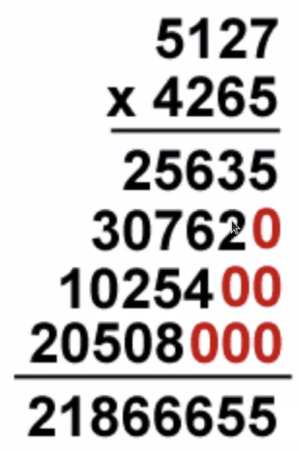
Iterate over small number of the two numbers multiplying
large*small
    - Operator / and % :
Dividend / divisor = quotient … remainder
Return quotient for / operator, return remainder for % operator
Above is Simplifier than get the remainder by (dividend-quotient*divisor)
  - gdb to debug
    - compile the executable
    - run the executable via gdb ./bignum + 3 2

