Near Optimal Card Counting Blackjack
Brett Hobbs

CS 473
Artificial Intelligence
Cornell University
Fall 2002
Explanation of the Game of Blackjack

This game of mixed chance and skill, whose object is to draw cards from a standard deck of fifty-two playing cards to a total value of twenty-one, begins with a deal of two cards to each player. Each of the cards dealt, save for the first card dealt to the dealer, lie face up in full view of all players. Play begins to the left of dealer. Initially, A player may choose from four choices of play. A player may:
1. Stand – The player may choose to stay with his current hand and take no more cards from the deck;
2. Hit – The player may choose to take a card from the deck to add to his hand in an effort to more bring the total face value of all cards closer to the ideal twenty-one;
3. Double Down - The player may choose, only when holding two cards, to double his bet, hit his hand with only one more card, and then immediately stand; or,
4. Split – The player may split a hand into two hands if the hand is a pair of cards with matching values. A player may split up to three times in a game, resulting in a total of four hands.
The value of a hand is the sum of the values of each card in the hand. All cards 2 through 10 are valued according to their normal value. All face cards J, Q, and K are have a value of 10. Aces are worth either 1 or 11 depending on which makes a better hand. A hand is known as soft if it contains an ace valued at 11 (e.g. Ace and an eight is a soft 19).
Each player plays against the dealer, and attempts to obtain a hand with a greater value than that of the dealer but less than or equal to 21. A player may hit as many times as they wish before standing or busting, going over 21. The dealer is governed by a strict set of rules and makes no decisions, usually as determined by the gaming house in which the game is taking place. Rules may vary from house to house but in this game the dealer must hit any hand with a value of less than 17 and stand on any hand with a value of 17 or greater. This rule set is the same used in most Las Vegas casinos, where a dealer must stand on a soft seventeen.
A Blackjack, the namesake of the game, is a hand comprised of a pair of cards with a value of 21. If a player is dealt blackjack he automatically wins his bet unless, the dealer is also dealt blackjack. If the dealer is showing a ten or an ace then any player holding a blackjack can take even money or wait to see what the dealer has, if the dealer has blackjack then the game is over and the dealer wins all bets and pushes, or ties, with any player with blackjack who did not settle for even money.
If a player is dealt a hand that consists of a pair of cards sharing the same value, the player may opt to split these cards. Splitting a hand in this way results in each of the original cards becoming the first card in a new hand, which is then dealt an additional card. The player is required to back the new hand up with an ante equal to the original ante. When aces are split the player must agree to only take only the additional card on each hand, unless that card is another ace in which case that hand may also be split. A player may split into as many as four hands.
Description of the Project
This project is a blackjack simulator involving a dealer and a player, with the player being controlled by the user of the simulator. The goal of the project is to create a feature that offers the player advice as he plays blackjack hands. The advice would include hand position decisions, when to stand, hit, double down, or split, and also betting advice, when to increase or decrease bets.
In preparing advice for the player the game attempts to make the best move based on the probability of future events and the value they will return. The ending value of any hand will be worth between +1.5 and –1.0. The former represents the 3 to 2 payout on a players blackjack and the latter represents a dealer victory, which will result in the loss of the bet.
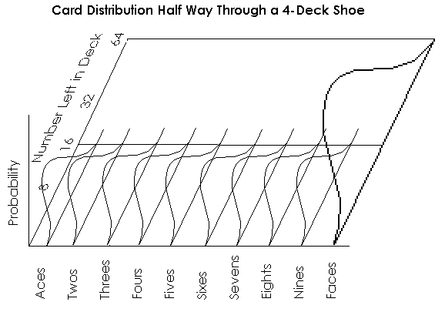
One thing that makes Blackjack unique over most games of chance, especially those involving dice, is that it allows for some limited memory. Since most houses use a multi-deck shoe, four in the case of this software and most casinos, each hand is not independent from the last. Although this makes the search space much larger for calculating the expected value of a move, it can also give a player who knows the count much greater advantages than most games afford.
Unlike in optimal zero-memory blackjack, decision tables that take into account the cards left in the deck are constantly changing. It may not make sense to split two face cards early in a deck, but if the deck is heavy with face cards and the shoe is getting low it may be optimal to split them into two hands. As a deck runs lower, knowledge of what it holds becomes very valuable when the variance is high. A deck of n cards should hold on average n / 13 of each card Ace through 9 and n * 4/13 face cards (including 10). Since 10, J, Q, and K all carry a value of 10 in blackjack they are fully equivalent in play and can be remembered in a single count. Since the dealer is bound by rules to hit anything 16 and lower the more positive the variance of face cards the better it is for the player.
The expected gain using a 4-deck shoe and an optimum zero memory strategy is -.0036. By using a card count to adjust decisions based on a given situation, we can improve this by about .0015. Finally, varying bets will allow an improvement to around +.020. Every deck has an expected value associated with it based on the anticipated gains from each and every hand that can be played from the deck. In theory, we would like to bet an infinite amount when we know the deck has a positive expected gain, and nothing when we know the deck has a negative expected gain. In reality, however, this is not possible given the social atmosphere of play and as a result this simulation allows for a minimum bet of 10 and a maximum bet of 100.
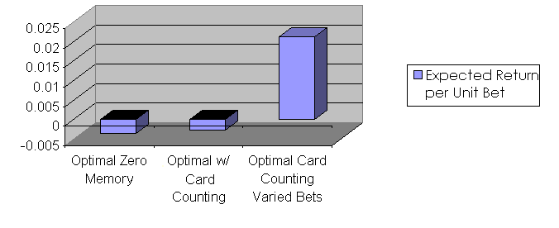
Situational Searches
All searches in blackjack involve the same process of projecting the gain of hands based on the probability. The differences lie in where the process of the shoe being played the search must begin. The simplest searches involve deciding whether or not the hit, stand, or double down after a non-matching pair of cards has been dealt to the player. The player must use what he knows is in the deck, what he currently holds in his hand and what the dealer is showing to calculate the best move. Since the player cannot know what the dealer is holding as the upside-down card, as far as he should be concerned the unknown card remains in the deck. The player may, however, know something about that card some of the time. Since a dealer blackjack immediately ends the round it can be inferred that if the dealer is showing a face card then the unknown card is not an ace, if he is showing an ace then the unknown card is not a face card. This will affect the probability of all other cards being the unknown card. The probability of a card being the unknown card should thus be assessed by the number of cards left in the deck divided by the total number of cards remaining less the number of aces or face cards remaining instead of the number of cards left in the deck divided by the total number of cards. For example, a hand of 7 and 10 is dealt to the player and the dealer is showing a 9. The player would like to move to the position with the greatest gain possible. The value of standing is equal to +1 * the chance of the dealer beating 17 –1* the chance of the dealer 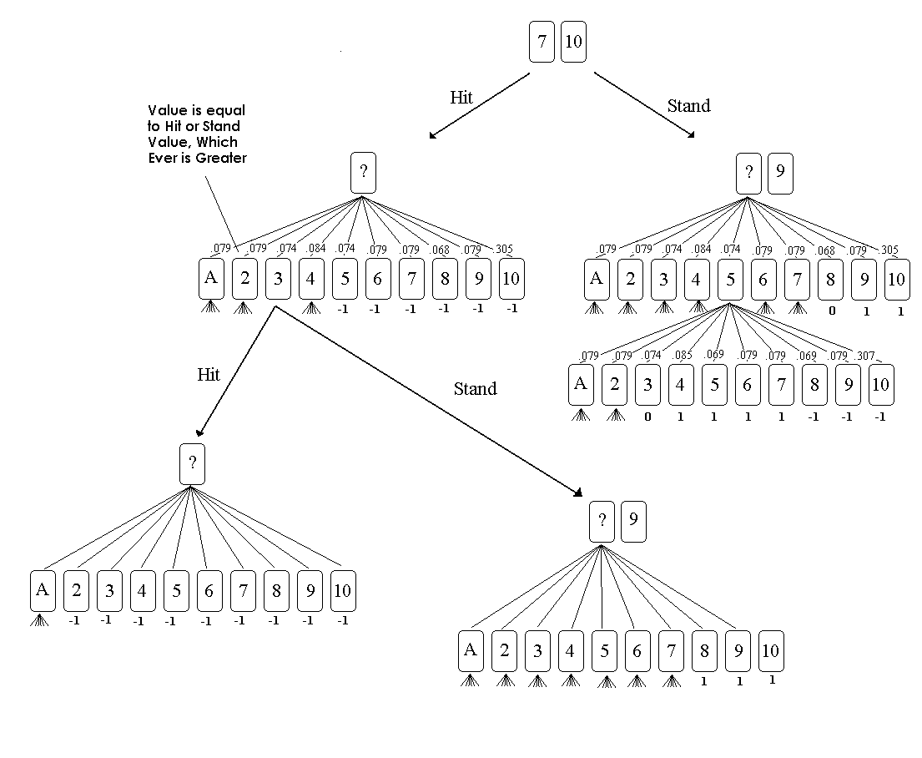busting or standing on a hand short of 17 (in this case not possible). Each move of the dealer must be expanded out until a win, loss, or push can be evaluated for each hand. Once these have been found the evaluation function will travel back up the tree assigning value to each hand based on the probabilities of reaching each child hand multiplied by the probability of being dealt that child hand. The value of hitting the hand is equal to the value of each resulting hand multiplied by the probability of it being drawn from the deck. Again we must expand each hand by looking at all the hitting and standing results and then choosing the more favorable gain.
Doubling down, which is not depicted in the graphic above, involves doubling the initial bet and drawing one more card to the hand. The evaluation of this must be handled a little differently since the bet is doubled. Doubling down will never produce a greater gain than hitting since drawing an ace or two on an eleven will most certainly cause the hitting evaluation function to draw additional cards. But since the bet is doubled, a gain of .30 when doubling down is better than a gain of .40 by hitting. In fact a gain of -.15 is better than a gain of -.35, since only 2 * -.15 = -.30 < -.35. So, to correctly evaluate a hand in such a circumstance, a weight equal to the factor of the bet increase should be multiplied to the gain. For all decisions among the options of standing, hitting, and doubling down, the simulation resolves these by the full evaluation of an exhaustive search.
A more complicated search involves a hand with the possibility of splitting, since with the branching factor of 10 different cards plus standing or doubling down or even splitting again, evaluating the gain of a one card hand becomes much more costly. Initially evaluating the value of a split ace against a dealer ace showing took 5:39 in C code. Running on the same Java platform as the simulator would have meant a very long time before a move could be recommended. This problem of cost is also compounded when we evaluate the value of a deck and look at 100 different possible hands that can be split. The first bit of pruning applied was to project the value of a second split based on the value of the current value of the hand. This trimmed the time of evaluation to 3:41 and caused a difference of only 0.000329 from the original evaluation. Since performance would still be a problem if the full search was implemented in Java code a neural network was used to evaluate the 1200 randomly generated examples of split hands.
The neural network accepts 12 inputs, one for each of the ten card counts, one for the card in the pair dealt, and one for the card the dealer is showing. The ten inputs for the cards represent (Actual Number Left / Expected Number Left) – 1 where:
Expected Number Left = Total Cards Left * Original Fraction of the Deck
The original fraction of the deck is 4/13 for the face cards and 1/13 for all others. The value of this number can be viewed as 0 means the exact number expected remain, > 0 means more than expected remain, and < 0 means fewer than expected remain.
Twos | Threes | Fours | Fives | Sixes | Sevens | Eights | Nines | Faces | Aces | Card | Dealer | Exp. Val.
0.04 | 0.04 | -0.133 | 0.04 | 0.213 | -0.48 | 0.213 | -0.307 | -0 | 0.387 | 3 | 10 | 0.37431

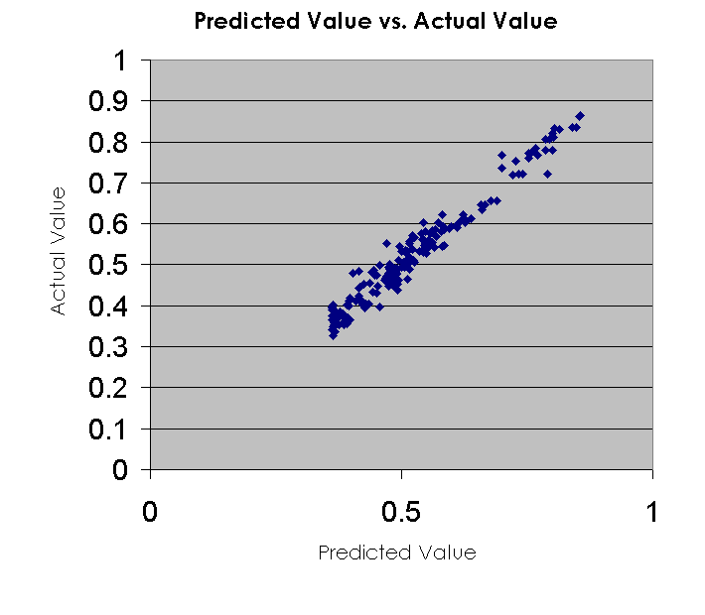
The expected value is the (expected gain + 1) / 2, thereby reducing the range from [+1, -1] to [+1, 0]. I enlisted the assistance of a friend, Geoff Crew, who has studied machine learning as when I undertook this project we had not yet covered neural networks in class. From a base, I was rewrote portions of neural network code to allow for a varied number of inputs along with a varying number of hidden nodes.
I broke the examples into three sets of 700 training examples, 300 stopping examples, and 200 testing examples. The neural network ran until the stopping set error began to show an increase in generalization error. Although the error is not as low as I would have liked, the graph to the right shows that there is a strong relationship between the value predicted by the neural network and the actual value.
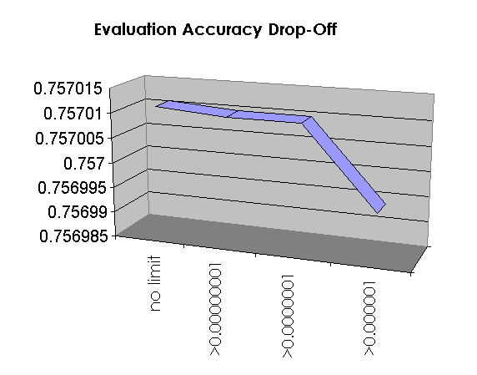
I used a similar technique in constructing a neural network to estimate the value of a deck of cards. The algorithm for creating examples starts by shuffling a random deck and then randomly cutting a group of cards from the top leaving between 35 and 208 cards in the deck. Then, all 10³ = 1000 possible hands are evaluated and used to calculate a deck value. It took a considerable amount of adjustment to obtain a deck evaluation function with a feasible cost that would generate over a thousand examples. To do this, I decided to keep track of the probability for reaching any point in the search tree.
Not much accuracy is lost when probabilities are constrained at early levels but the logarithmic scale eventually causes the expected larger drop-off in accuracy. The no limit evaluation took 8:04 seconds for a very complex hand; this cost is reduced to 0:54 by the greatest bounding shown in the graph.
The trade off here is a loss in accuracy. But, hopefully, this will be more than recovered by a great increase in the number of examples that can be generated for the neural network. Running 6 machines for 8 hours generated 1200 example decks and expected gains for each. I again used a training set with 700 examples, a stopping set with 300 examples, and test set with 200 examples. The ten inputs represent the ratio of variance in card counts the same way the inputs for the splitting worked. The expected value is again (Expected Gain + 1) / 2. This time we are most concerned with neural net predicted value being on the same side of .5 as the actual value. This is so because all we want to learn is whether or not the deck is favorable and in turn how we should bet.
Twos | Threes | Fours | Fives | Sixes | Sevens | Eights | Nines | Face | Ace | Expected Value
-0.03 | 0.0497 | -0.031 | 0.05 | -0.03 | -0.031 | 0.05 | -0.031 | -0.011 | 0.05 | 0.495031
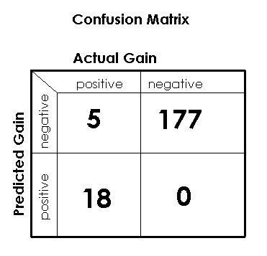
Recalling the fact that bets on a positive deck are ten times those on a negative deck means that false positive are roughly 10 times more damaging than false negatives. According to the resulting confusion matrix our bias towards false negatives will be advantageous when we eventually base betting on the predictions. Overall the predictions are 97.5 % accurate, which is a very good result.
I achieved most of my objectives in this project. I developed an artificially intelligent agent capable of earning money while playing blackjack, within the rules of the game. I was not able to account for the addition of other players to the game but this is more a function of programming than A.I. and does not disturb the fact the results in any case. The work with probability based expected outcomes and the use of neural networks in this project was a strong supplement to class. Given the time, I would have liked to experiment with decision trees for deciding whether or not to split by using attributes such as is pair split mod 10 greater than dealer?, is pair together mod 10 greater than dealer?, and possibly is eight?, and is ace?.

Manson, A. R., Barr, A. J., and Goodnight, J.H. Optimum Zero-Memory Strategy and Exact Probabilities for 4-Deck Blackjack. The American Statistician. Volume 29, Number 2, May 1975.

